Creating a Polygon Grid Shapefile with Rectangular Cells

February 5, 2010
Bongghi Hong and Dennis Swaney

In the previous document “17_Using_ASCII_Format_Files_in_ArcGIS.doc”, a global N deposition map from Frank Dentener, which has a rectangular grid cell of 5 by 3.75 degrees (ftp://daac.ornl.gov/data/global_climate/global_N_deposition_maps/comp/global_N_deposition_maps_readme.pdf), was imported into ArcGIS. Below is a summary of the procedure applied:

(1) Import the ASCII file into ArcGIS as a raster grid with the cell size of 1 by 1 (unitless)
(2) Georeference the imported raster using the “Warp” tool of the ArcToolbox
(3) Convert the georeferenced raster into a polygon shapefile
(4) Calculate the area-weighted average of N deposition for the area of interest using the Polygon In Polygon Analysis tool of the Hawth’s Analysis Tools

The second step using the “Warp” tool involves resampling of the original data (with rectangular grid cells) to the ArcGIS GRID raster (with square grid cells). The above procedure works well when the data grid cell size is much smaller than the areas of interest. If not (as in this example), the resampling of original data could generate differences in the results that are hard to ignore. In this document, we will describe an alternative procedure that does not involve the resampling of original data and thus preserves the original data as much as possible:

(1) Create a polygon grid shapefile with rectangular cells
(2) Assign each rectangular cell with the N deposition values extracted from the ASCII file
(3) Calculate the area-weighted average of N deposition for the area of interest using the Polygon In Polygon Analysis tool of the Hawth’s Analysis Tools

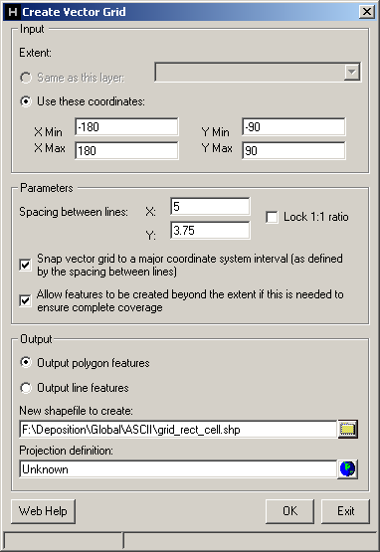
Note that this method does not involve handling the ArcGIS GRID raster at all. When the data grid cell size is small, it would be impractical to create a polygon grid shapefile, and thus a variation of the earlier method can be a preferred option.

A polygon grid shapefile can be created using the Create Vector Grid tool of the Hawth’s Analysis Tools. In our example, the tool can be specified as shown on the right (refer to the earlier document for the information of map extent and cell size of the original data):

Hit “OK” and the polygon grid “grid_rect_cell” with rectangular grid cells will be created:

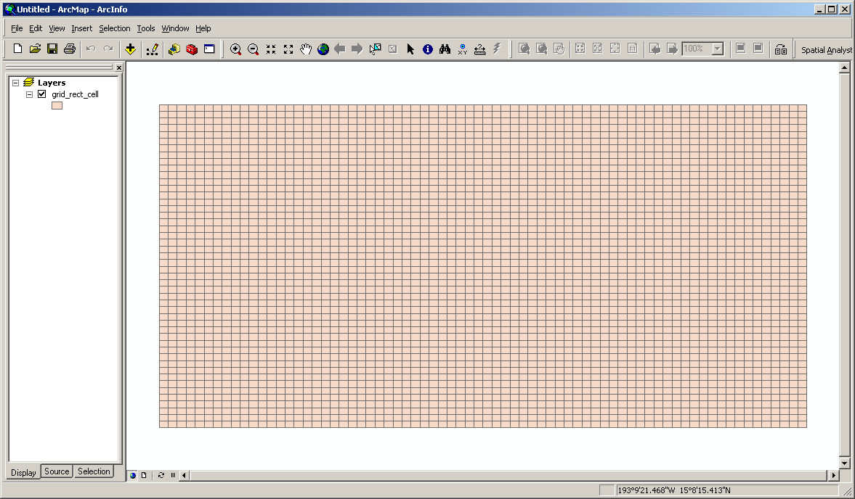

Now we should assign each polygon of this grid with the N deposition values extracted from the ASCII file. Opening and investigating the attribute table of the grid polygon, the unique identification number “FID” is arranged as shown in the below figure:

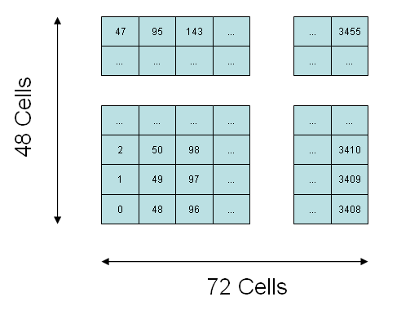
In this example, we will create a text table containing a column of unique identification numbers (from 0 to 3455) and columns of corresponding N deposition values, and join the table to the polygon grid shapefile (there may be other ways). First, open the ASCII files containing the N deposition values using Microsoft Excel (downloading the ASCII files is described in the earlier document):
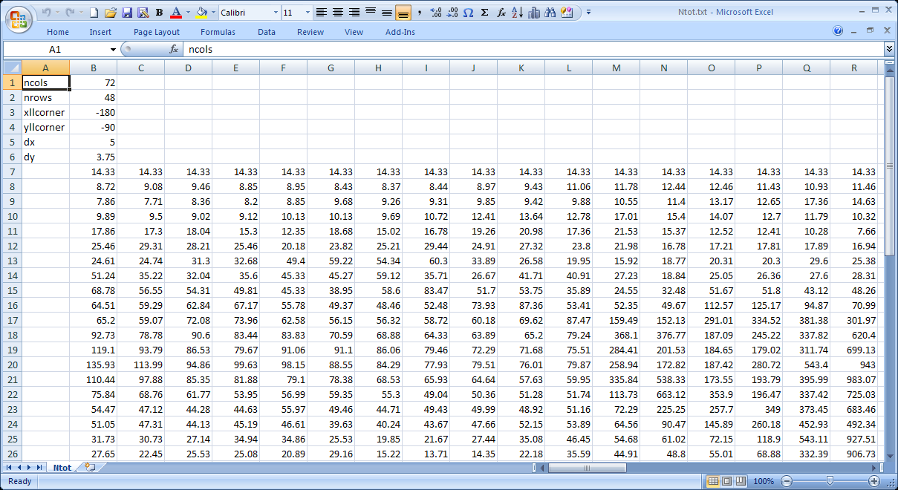

Open the Visual Basic Editor and paste the following code to a new module:

Option Explicit
Sub ASCII_to_Column()
Dim i As Long
Dim j As Long
Dim xoffset As Long
Dim yoffset As Long
Dim ncols As Long
Dim nrows As Long
Dim inputname As String
Dim outputname As String
Dim readvalue As Double
Dim countoutputrow As Long
inputname = "input"
outputname = "output"
xoffset = 1
yoffset = 6
ncols = Worksheets(inputname).Cells(1, 2).Value
nrows = Worksheets(inputname).Cells(2, 2).Value
Worksheets(outputname).Cells.Delete
Worksheets(outputname).Cells(1, 1).Value = "ID"
Worksheets(outputname).Cells(1, 2).Value = "Value"
countoutputrow = 0
For i = 1 To ncols
For j = 1 To nrows
readvalue = Worksheets(inputname).Cells( _
yoffset + nrows - j + 1, xoffset + i).Value
Worksheets(outputname).Cells(countoutputrow + 2, _
1).Value = countoutputrow
Worksheets(outputname).Cells(countoutputrow + 2, _
2).Value = readvalue
countoutputrow = countoutputrow + 1
Next j
Next i
End Sub
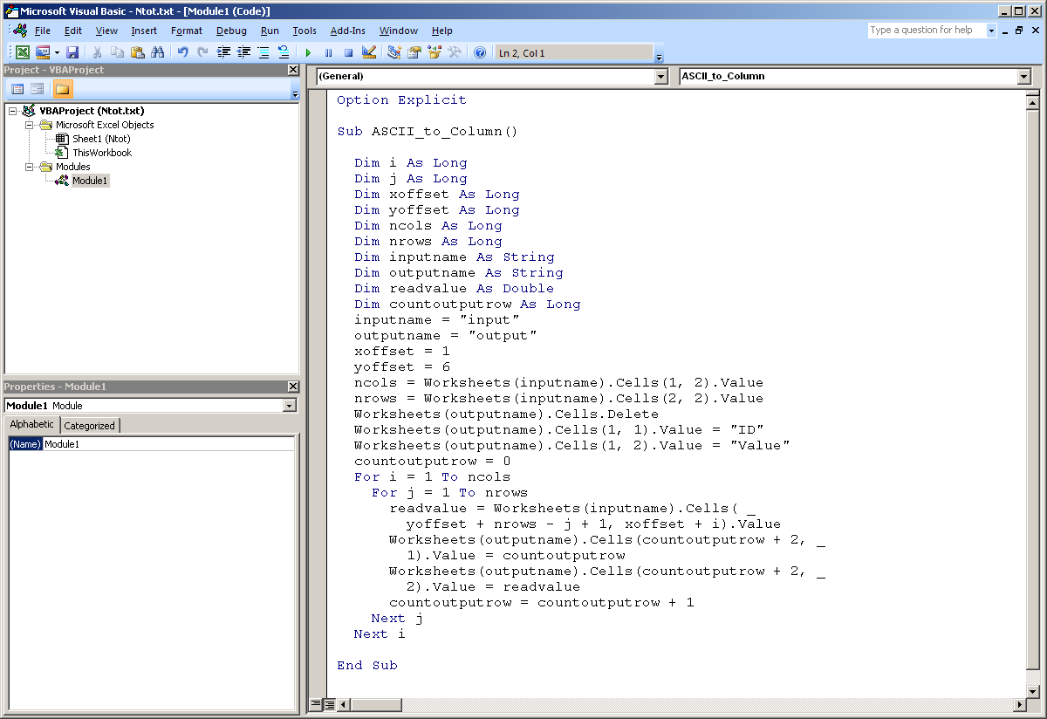

Specify the name of the worksheet containing the N deposition values as “input”, create a new worksheet and name it “output”, and run the VBA script (press F5 from Visual Basic Editor). The N deposition values will be extracted and stored as a table in the “output” worksheet:

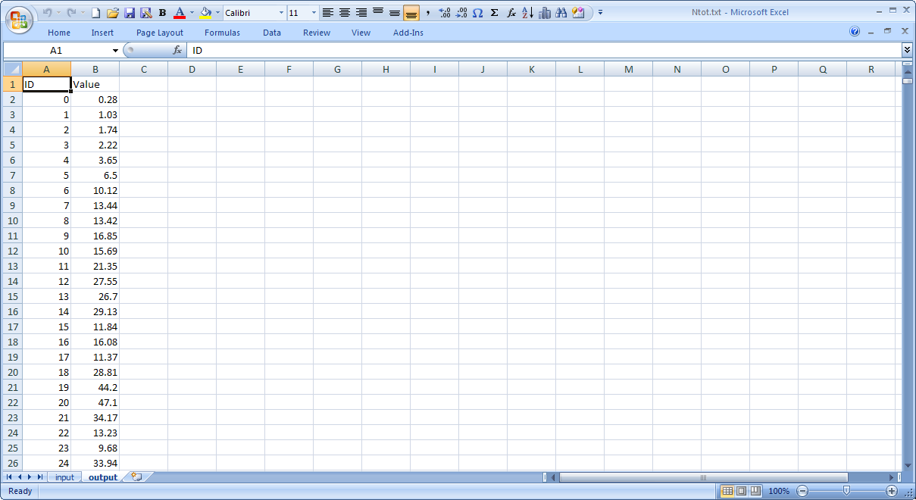

Repeat this procedure for all the variables of interest (in this example, total N deposition, oxidized N deposition, and reduced N deposition) and store the results as “N_dep_table.csv”:

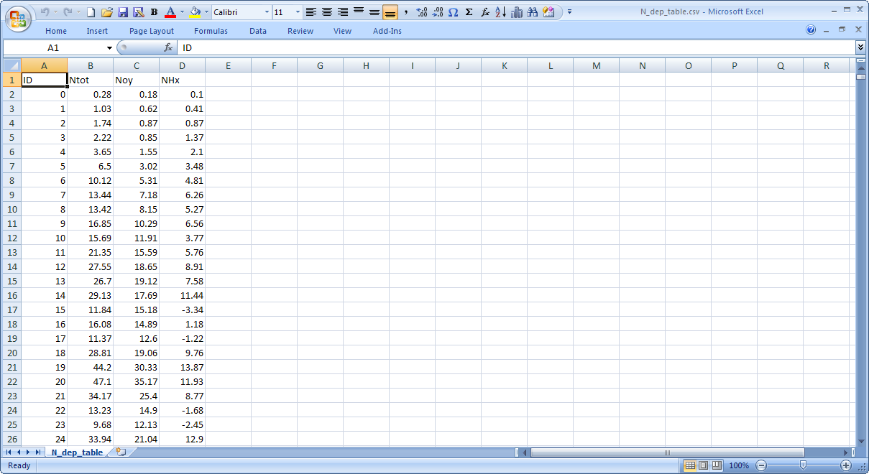

Now add the table to ArcGIS and join it to the grid shapefile “grid_rect_cell”:

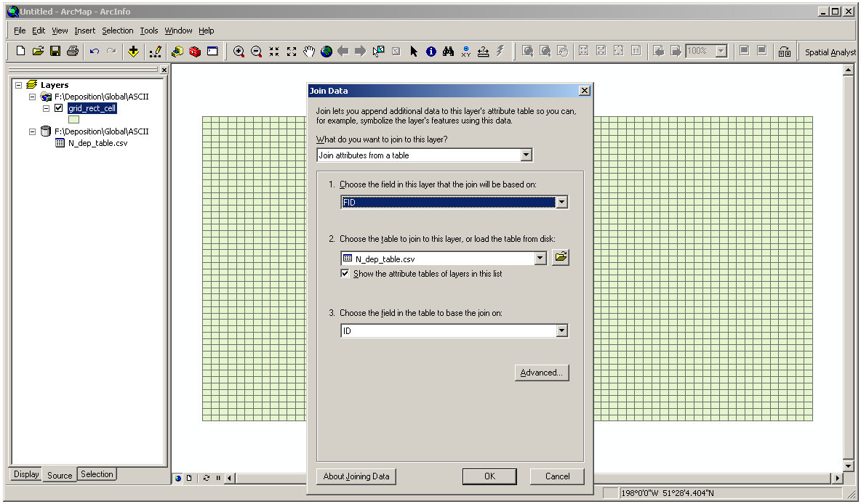

As an example, below map shows the total N deposition imported as an ArcGIS polygon shapefile (note that the grid has rectangular cells):

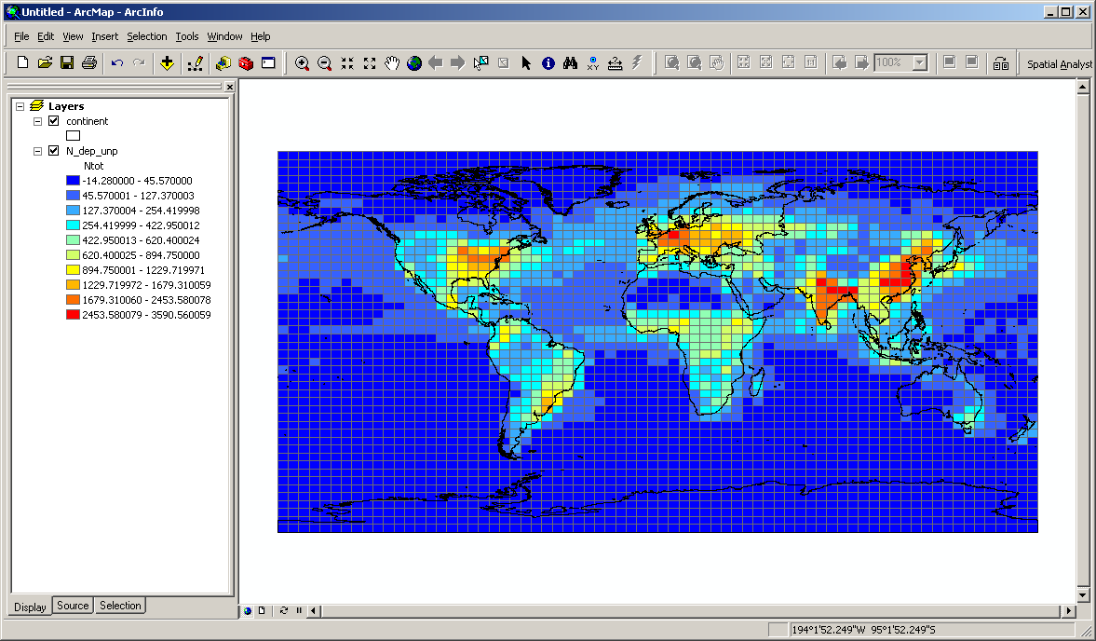

Once the grid shapefile with the N deposition data is obtained, the rest of the procedure involves projecting the shapefile using an equal-area coordinate system, and running the Polygon In Polygon Analysis tool from the Hawth’s Analysis Tools to calculate area-weighted averages of N deposition for the areas of interest (estuarine systems around the world in this example). They are described in detail in the “16_Using_NetCDF_Format_Files_in_ArcGIS.doc” available on the same webpage where this document is provided. The following figure compares the total N deposition obtained by applying the procedures described in the documentation of the previous method and by using the method described herein:

