Extracting pH and Depth of Surface Soil from STATSGO/SSURGO

March 11, 2008
Bongghi Hong and Dennis Swaney

The previous document “Extracting Soil Orders from STATSGO/SSURGO,” describes a procedure for extracting soil information (percent soil order as an example) that cannot be obtained using a USDA program “Soil Data Viewer.” Here, we provide another example of extracting soil information from the STATSGO database. As we will see, this task is somewhat more challenging, although the general approach applies in the same way. In this example, we will extract the surface layer soil pH and surface layer depth in eastern US watersheds (note that if only the surface soil pH is needed, it can be obtained using the Soil Data Viewer). In addition to ESRI software, MS Excel and Matlab are used in the example to view and extract data from the soil database.

As in the previous document, we begin by finding out where the soil pH information is stored in the soil database. This information can be found online in the metadata. Open the pdf file (containing description of available soil variables) at http://soildatamart.nrcs.usda.gov/documents/SSURGOMetadataTableColumnDescriptions.pdf and search for “pH”:

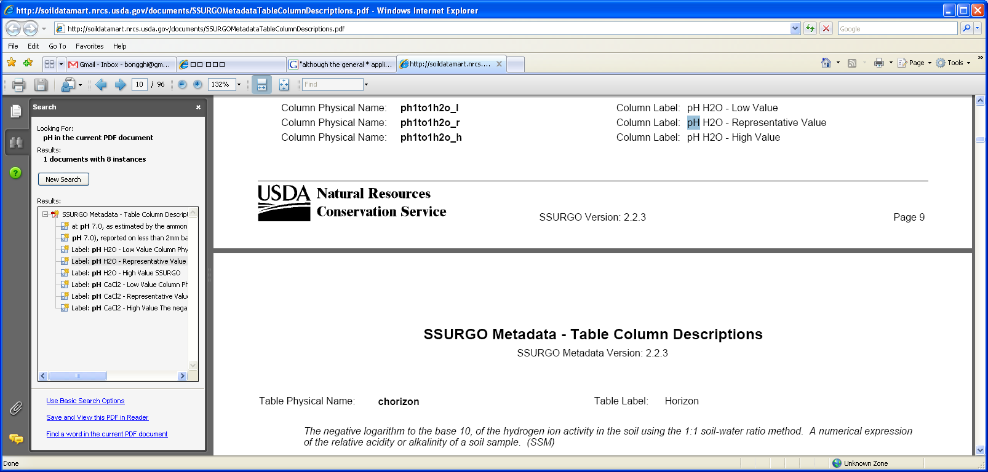

According to the search result, the name of the soil variable containing the soil pH information is “ph1to1h2o_r”. The actual location of the soil variable within the soil database can be found in another pdf file at http://soildatamart.nrcs.usda.gov/documents/SSURGOMetadataTableColumns.pdf. Open the pdf file and search for “ph1to1h2o_r”:

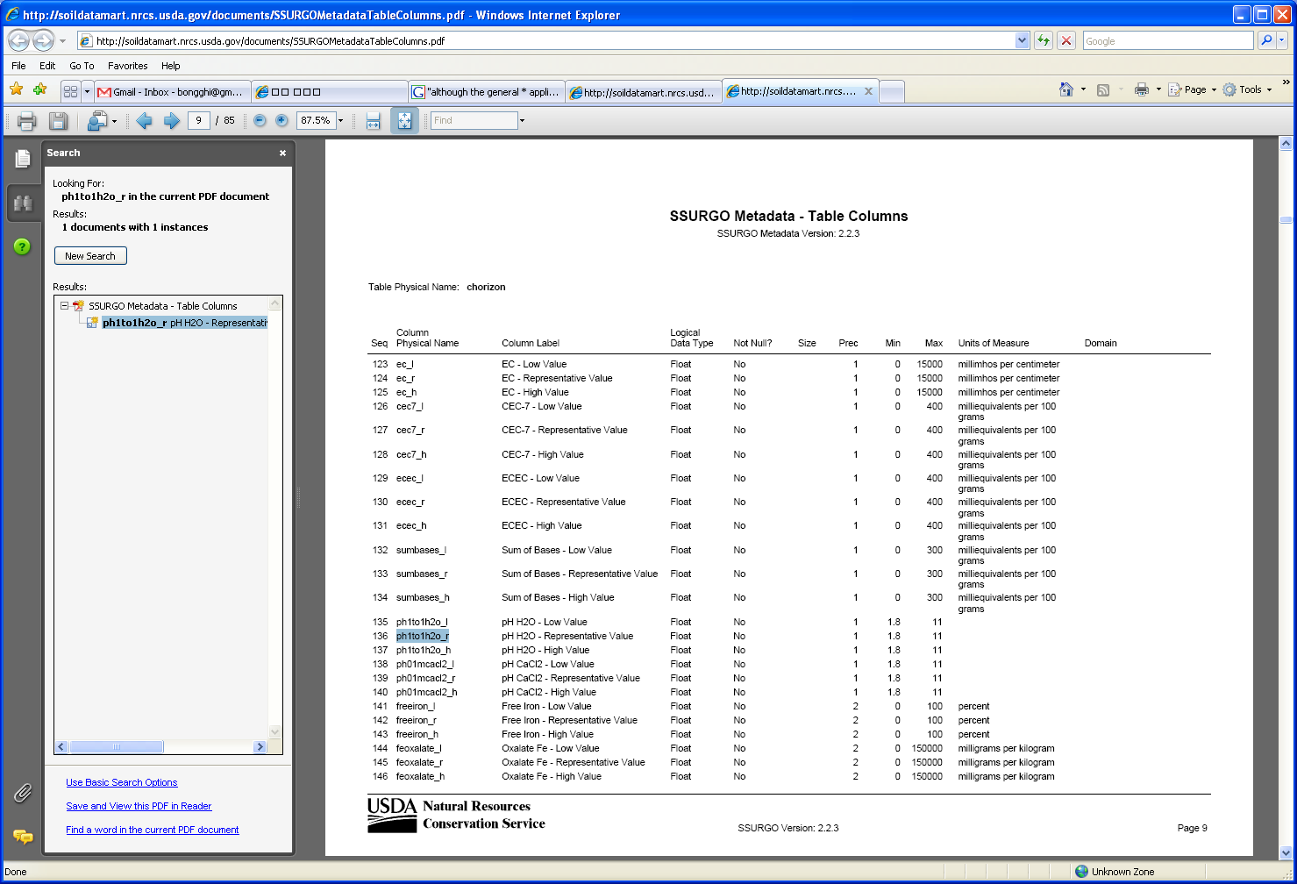

From the search result, we find that the “ph1to1h2o_r” is stored in the 136th column of the table “chorizon.” Accessing the soil horizon information is somewhat challenging, because each map unit (individual polygon shown on a soil map) is composed of “components,” and each component is composed of “layers (horizons)” (a detailed description of STATSGO/SSURGO data structure can be found at http://www.nrcs.usda.gov/technical/techtools/statsgo_db.pdf):

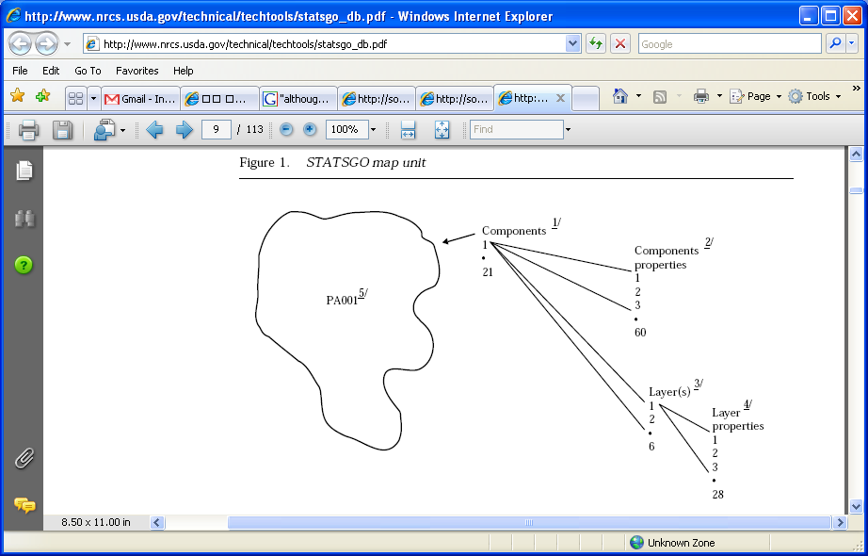

For clearer understanding, we will open the soil horizon data file “chorizon.txt” using Microsoft Excel (downloading the soil database from Soil Data Mart and the folder structure of the soil database are described in our previous document “Generating Map of Soil Topographic Index”):

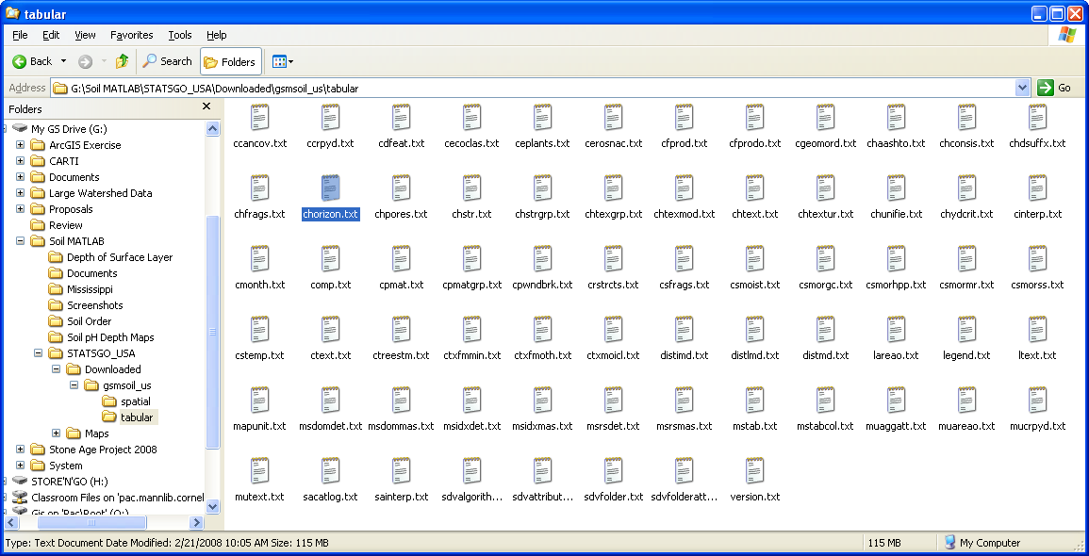

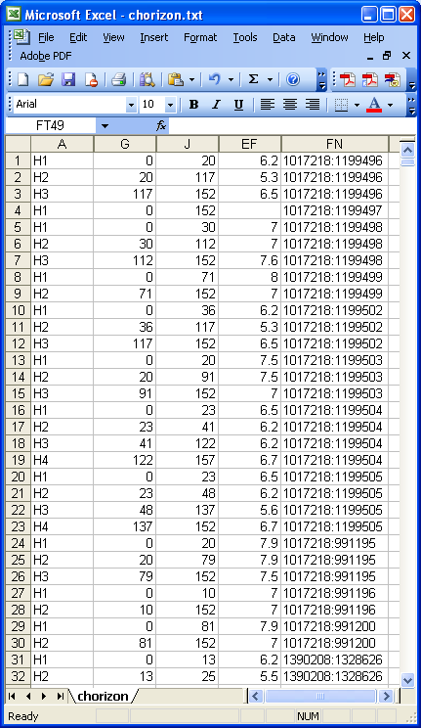

The “chorizon.txt” is a large file with 171 columns, but for this exercise the most interesting columns are the 1st (column A containing soil horizon names), the 7th (column G containing top depths in cm), the 10th (column J containing bottom depths in cm), the 136th (column EF containing pH), and the 170th (column FN containing “COKEY,” which is a unique identifier of each “component”).

The COKEY is used to relate the items in the soil horizon data file “chorizon.txt” to those in the component file “comp.txt” (shown below). Description of map unit component file is given in the previous document “Extracting Soil Orders from STATSGO/SSURGO.” Briefly, each map unit (individual polygon shown on a soil map) is composed of “components” stored in the “comp.txt” file, and each component is composed of “layers (horizons)” stored in the “chorizon.txt” file. For example, from the figure below we can see that the map unit “1017218” (see column DD) is composed of 13
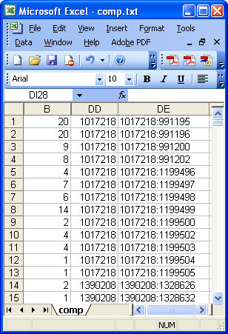
components with percent compositions stored in column B, and the component with the COKEY “1017218:991195” (see column DE) is composed of three horizons H1, H2, and H3 with the bottom depth of 20, 79, and 152cm, respectively (see the previous figure).

What we want to do in this example is to find the pH and the bottom depth of the surface horizon (horizon with the top depth of 0cm) of the dominant component (component with the highest percent composition) of each map unit. When there is more than one dominant component (as an example, the map unit “1017218” in the figure has two dominant components “1017218:991195” and “1017218:991196” with the same percent composition of 20), the component with the higher surface pH will be selected (i.e., the component “1017218:991195” with surface pH of 7.9 will be selected instead of “1017218:991196” with surface pH of 7). (This is called a “tie-break rule,” and is discussed in detail in Soil Data Viewer documentation available at http://soildataviewer.nrcs.usda.gov/documents/Soil_Data_Viewer_5_2_User_Guide.pdf.)

As in the previous document “Extracting Soil Orders from STATSGO/SSURGO,” we will now write a MATLAB program that:
(1) reads the component data file “comp.txt,”
(2) finds the dominant components (components with the highest percent composition) from the component data,
(3) reads the soil horizon data file “chorizon.txt,” and
(4) finds the pH and the bottom depth of the surface horizon (horizon with the top depth of 0cm) of the dominant components from the soil horizon data.

Open any text editor (e.g., Notepad) and save the code below as “MakeDepthTable.m”:

% Open comp.txt Text File
clear
readData = textread('comp.txt','%s','whitespace','\n');

% Initialize Output Variables
rowNum = size(readData, 1);
comppct = zeros(rowNum,1);
mukey = cell(rowNum,1);
cokey01 = cell(rowNum,1);

for j = 1:rowNum

% Read Each Row of the Text File
getRow = char(readData(j));
colNum = size(getRow, 2);
startCol = 0;
endCol = 0;
countDel = 0;

for i = 1:colNum

% Check for Delimiter
if getRow(i) == '|'
endCol = startCol;
startCol = i;
countDel = countDel + 1;

% Read Percent Composition
if countDel == 2
if startCol - 1 == endCol
comppct(j) = 0;
else
comppct(j) = str2num(getRow((endCol + 1):(startCol - 1)));
end
end

% Read Mukey
if countDel == 108
if startCol - 1 == endCol
mukey(j) = cellstr('');
else
mukey(j) = cellstr(getRow((endCol + 2):(startCol - 2)));
end
end
end

% Read Cokey
if i == colNum
if getRow(i) == '|'
error('Error processing data...')
else
cokey01(j) = cellstr(getRow((startCol + 2):(i - 1)));
end
end
end
end

% Open chorizon.txt Text File
readData = textread('chorizon.txt','%s','whitespace','\n');

% Initialize Output Variables
rowNum = size(readData, 1);
hzdept_r = zeros(rowNum,1);
hzdepb_r = zeros(rowNum,1);
ph1to1h2o_r = zeros(rowNum,1);
cokey02 = cell(rowNum,1);

for j = 1:rowNum

% Read Each Row of the Text File
getRow = char(readData(j));
colNum = size(getRow, 2);
startCol = 0;
endCol = 0;
countDel = 0;

for i = 1:colNum

% Check for Delimiter
if getRow(i) == '|'
endCol = startCol;
startCol = i;
countDel = countDel + 1;

% Read Top Depth
if countDel == 7
if startCol - 1 == endCol
hzdept_r(j) = 0;
else
hzdept_r(j) = str2num(getRow((endCol + 1):(startCol - 1)));
end
end

% Read Bottom Depth
if countDel == 10
if startCol - 1 == endCol
hzdepb_r(j) = 0;
else
hzdepb_r(j) = str2num(getRow((endCol + 1):(startCol - 1)));
end
end

% Read pH
if countDel == 136
if startCol - 1 == endCol
ph1to1h2o_r(j) = 0;
else
ph1to1h2o_r(j) = str2num(getRow((endCol + 1):(startCol - 1)));
end
end

% Read Cokey
if countDel == 170
if startCol - 1 == endCol
cokey02(j) = cellstr('');
else
cokey02(j) = cellstr(getRow((endCol + 2):(startCol - 2)));
end
end
end
end
end

% Initialize Output Table
uniqueMukey = unique(mukey);
rowNum = size(uniqueMukey, 1);
surfaceph = zeros(rowNum, 1);
surfacedepth = zeros(rowNum, 1);

for i = 1:rowNum

% Find Percent Composition of Components
findMukey = find(strcmp(mukey,uniqueMukey(i)));
pctMukey = comppct(findMukey);
if sum(pctMukey) ~= 100
fprintf('Warning: mukey %s has total composition of %f percent\n', ...
char(uniqueMukey(i)), sum(pctMukey));
end

% Find Dominant Component (Highest Percent Composition)
maxMukey = find(pctMukey == max(pctMukey));
numMax = size(maxMukey, 1);
if numMax == 0
error('Error: dominant component cannot be found for mukey %s\n', ...
char(uniqueMukey(i)));
end

for j = 1:numMax

% Find Cokey for the Dominant Component
findCokey01 = cokey01(findMukey(maxMukey(j)));
findCokey02 = find(strcmp(cokey02, findCokey01));
if isempty(findCokey02)
fprintf('Warning: cokey %s is not found in chorizon\n', ...
char(findCokey01));
else

% Get Surface Layer
topdepth = hzdept_r(findCokey02);
bottomdepth = hzdepb_r(findCokey02);
soilph = ph1to1h2o_r(findCokey02);
findsurface = find(topdepth == 0);

% Check for Errors
if size(findsurface, 1) ~= 1
error('Error: cokey %s does not have one surface layer\n', ...
char(findCokey01));
end
if findsurface ~= 1
fprintf('Warning: first layer is not surface for cokey %s\n', ...
char(findCokey01));
end
if size(topdepth, 1) ~= 1
if size(find(topdepth == bottomdepth(findsurface)), 1) ~= 1
error('Error: top and bottom depths are not matching for %s\n', ...
char(findCokey01));
end
end

% Get Surface pH and Depth
if surfaceph(i) <= soilph(findsurface)
surfaceph(i) = soilph(findsurface);
surfacedepth(i) = bottomdepth(findsurface);
end
end
end
end

% Open Output Table
fid = fopen('DepthTable.txt','w');

% Write Column Headings
fprintf(fid,'Mukey,SDepth,SpH\n');

% Write Output Table Values
for j = 1:rowNum
fprintf(fid,'%s,',char(uniqueMukey(j)));
fprintf(fid,'%f,',surfacedepth(j));
fprintf(fid,'%f\n',surfaceph(j));
end

% Close Output Table
fclose(fid);

The text file “MakeDepthTable.m” containing this code should be saved in the same folder where the “comp.txt” and “chorizon.txt” are stored. Open MATLAB, move to the folder where these files are stored, and run the code by typing “MakeDepthTable” in the command window:

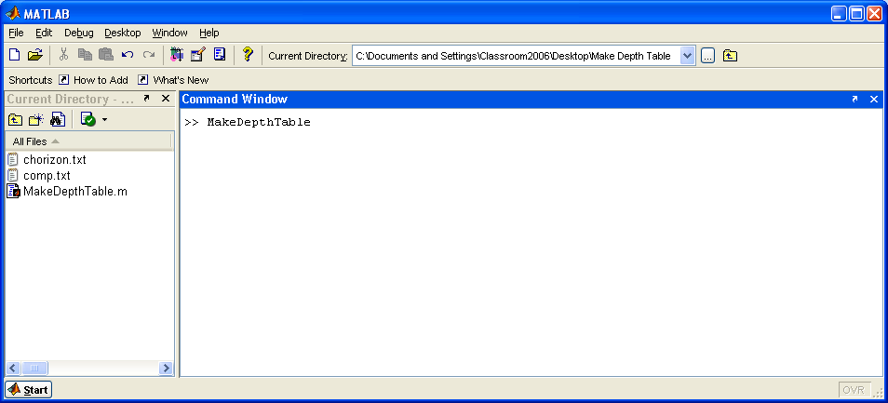

After running the code, you will find a text file “DepthTable.txt” created in the same folder. Opening the file using Excel, you can see that the surface soil pH and the surface soil depth are calculated for each map unit “Mukey”:

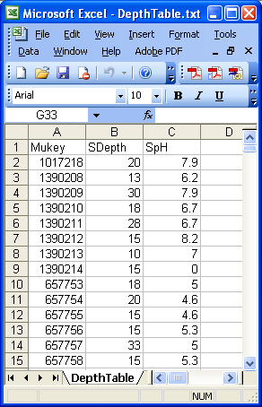

Joining the soil map of your interest (in this example, eastern US watersheds soil map) with the text table containing “Mukey” is described in the previous document “Extracting Soil Orders from STATSGO/SSURGO.” As an example, the map (below, left) shows the depth of the surface soil at the level of resolution of the map unit, obtained by joining the “MUKEY_NUM” column of the soil map with the “Mukey” column of the text file “DepthTable.txt”

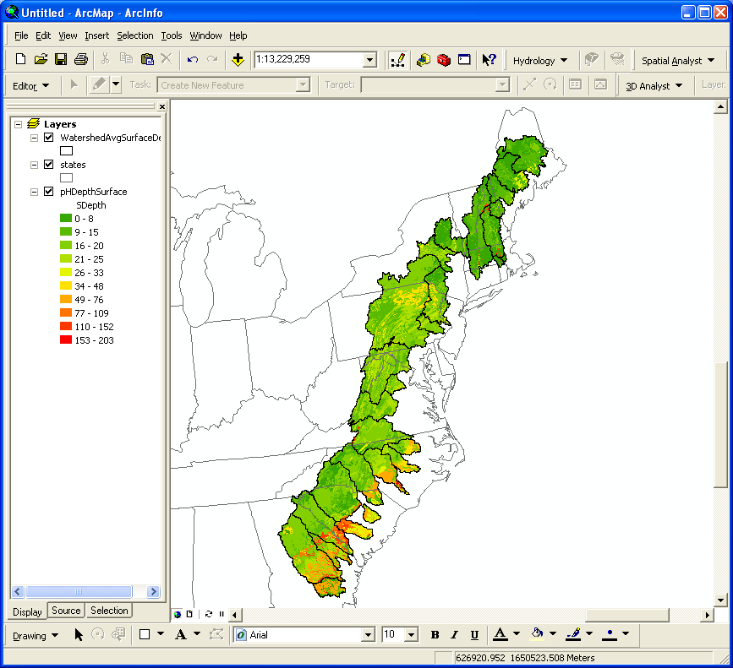
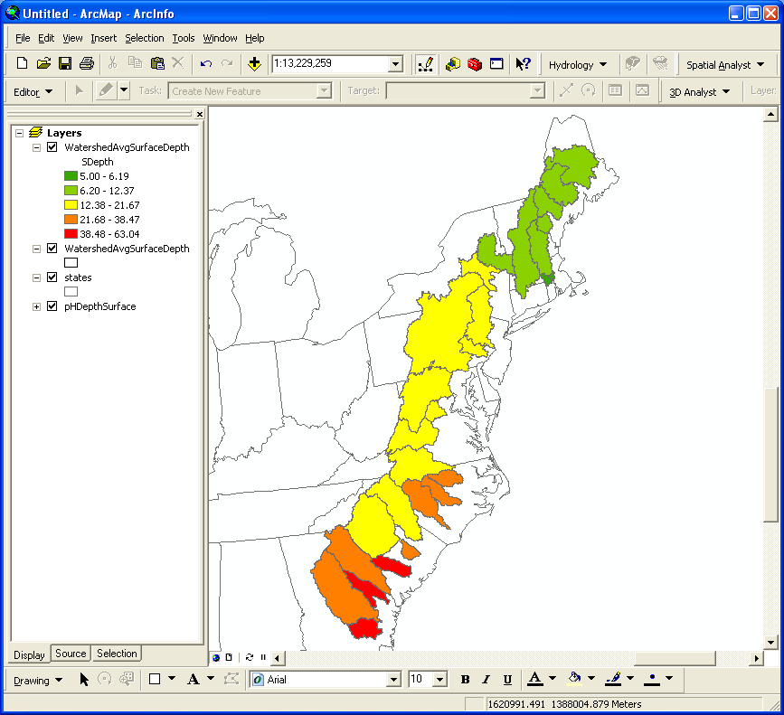
If you have a watershed boundary map, you can calculate area-weighted averages of surface soil depth (below, right) using Hawth’s Analysis Tools (the tool is described in the previous document “Calculating Area-weighted Means”)

