Extracting Soil Orders from STATSGO/SSURGO

March 10, 2008
Bongghi Hong and Dennis Swaney

Here, we describe an approach to the problem of extracting information that resides in the STATSGO or SSURGO soil databases, but that is not available using the standard procedures in “Soil Data Viewer”. The example makes use of MS Excel, to view information about components of map units in the database, and MATLAB, to perform the aggregation and extraction of the desired data. Note that the approach could be adapted to other software packages.
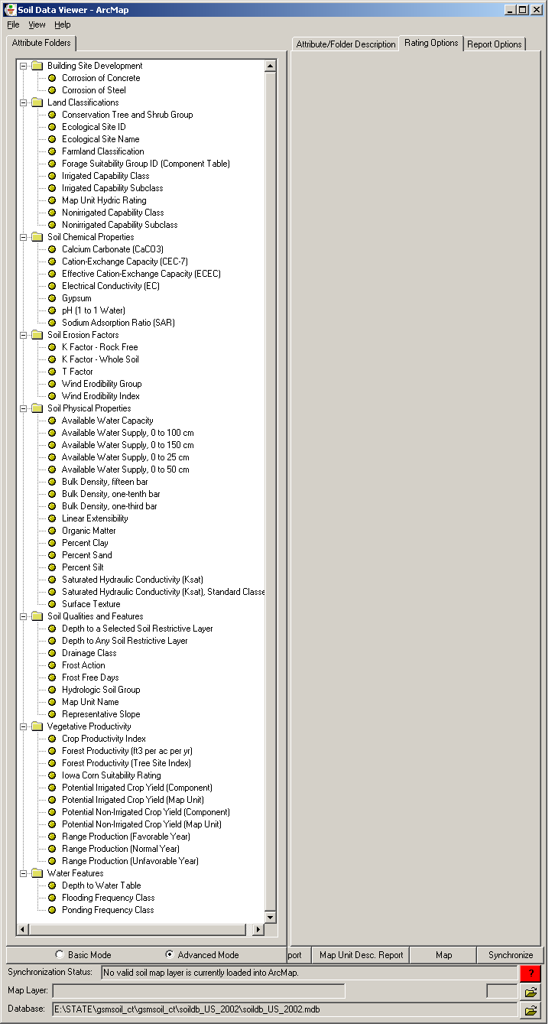
In our previous document “Generating Map of Soil Topographic Index,” we described how the STATSGO/SSURGO data can be downloaded, and how soil variables of interest (e.g., saturated hydraulic conductivity and depth to any soil restrictive layer) can be extracted using a USDA program “Soil Data Viewer.” The figure on the right is the graphic user interface of Soil Data Viewer showing all the soil variables that can be extracted using the program:

If the soil variable of interest is not listed in the Soil Data Viewer, an alternative way of extracting the information from the STATSGO/SSURGO database is needed. In this example, we will describe extracting taxonomic soil order information in eastern US watersheds that cannot be extracted using the Soil Data Viewer.

Description of the twelve orders of soil taxonomy can be found at http://www.soils.usda.gov/technical/soil_orders/:

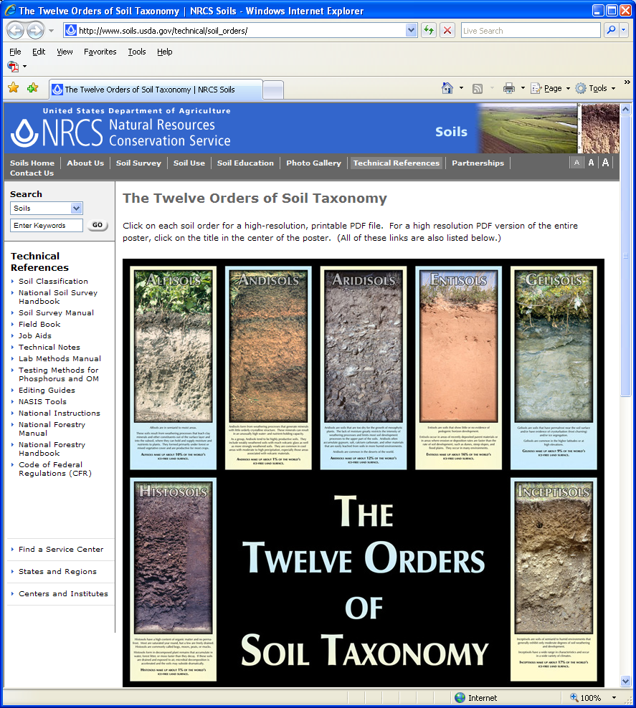

First, let’s find out where in the soil database the soil order information is stored. The soil variables of STATSGO/SSURGO data are described in a pdf file provided by Soil Data Mart at http://soildatamart.nrcs.usda.gov/documents/SSURGOMetadataTableColumnDescriptions.pdf. Open the pdf file and search for “soil taxonomy”:

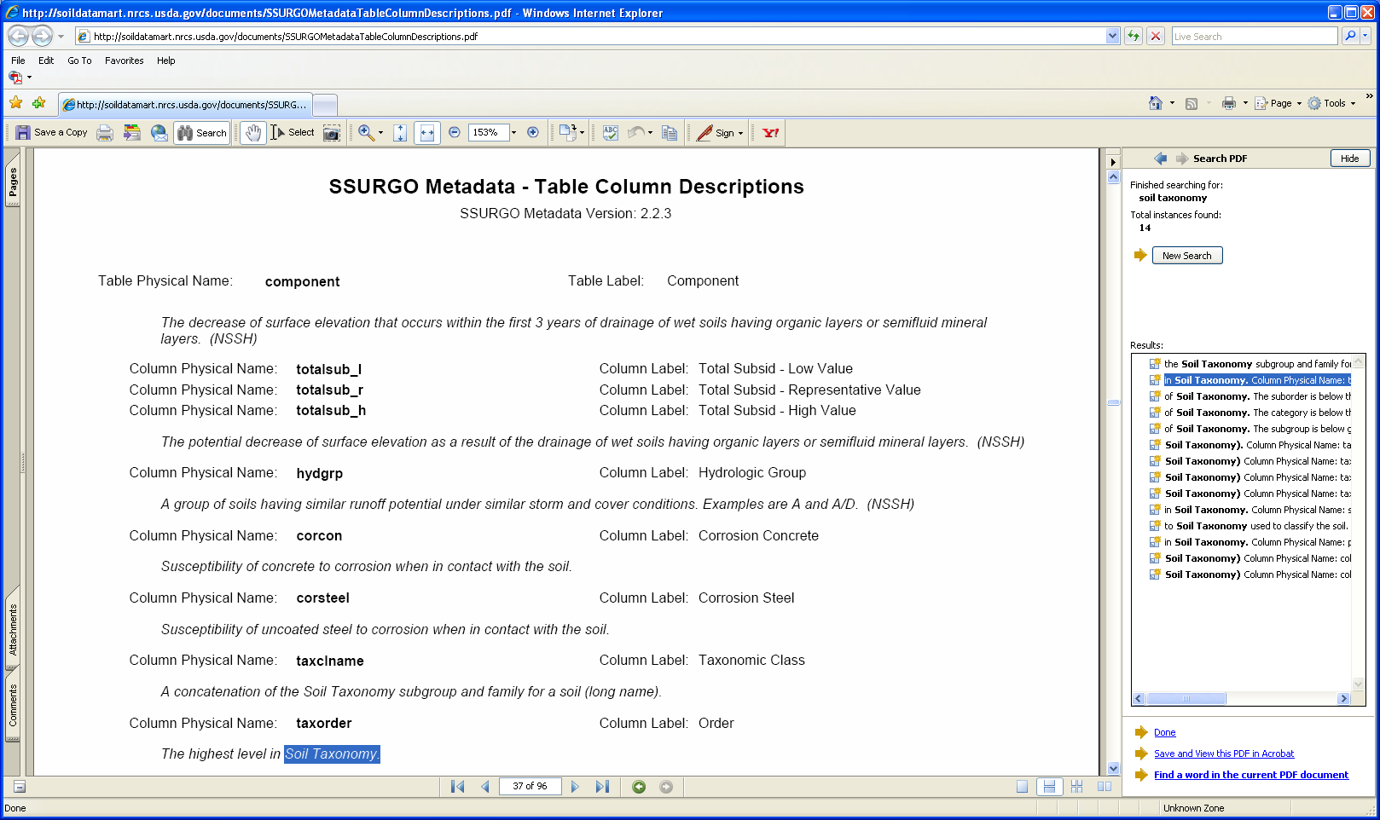

According to the search result, the name of the soil variable containing the soil order information is “taxorder”. The actual location of the soil variable within the soil database can be found in another Soil Data Mart pdf file at http://soildatamart.nrcs.usda.gov/documents/SSURGOMetadataTableColumns.pdf. Open the pdf file and search for “taxorder”:

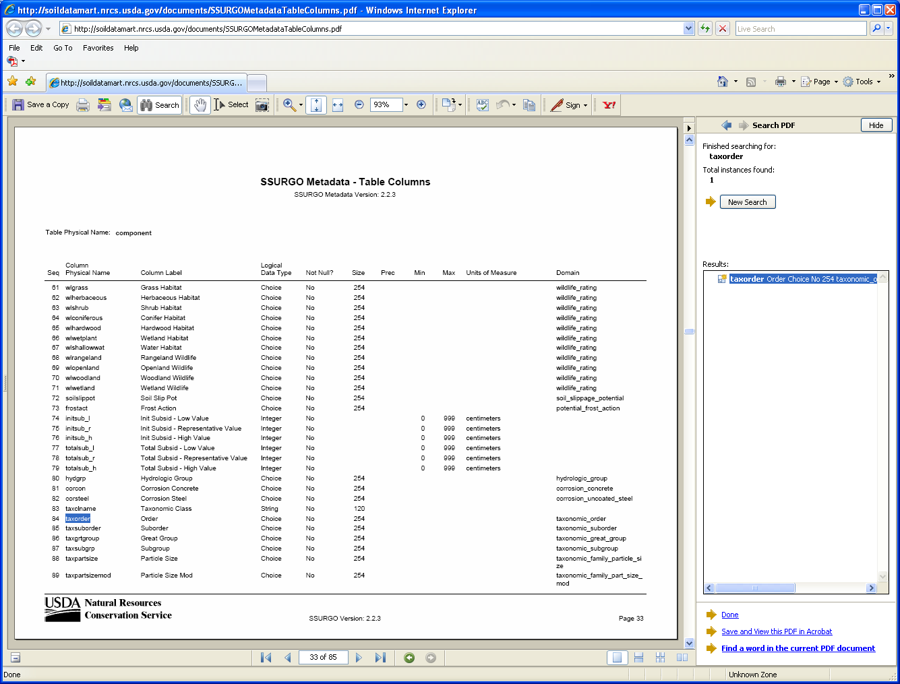

From the search result, we find that the “taxorder” is stored in the 84th column of the table “component.” The structure of the STATSGO/SSURGO database is quite complicated, and a detailed description can be found at http://www.nrcs.usda.gov/technical/techtools/statsgo_db.pdf. From the document (see page 9), you will find that each map unit (individual polygon shown on a soil map) is composed of “components” stored in the “comp” table:

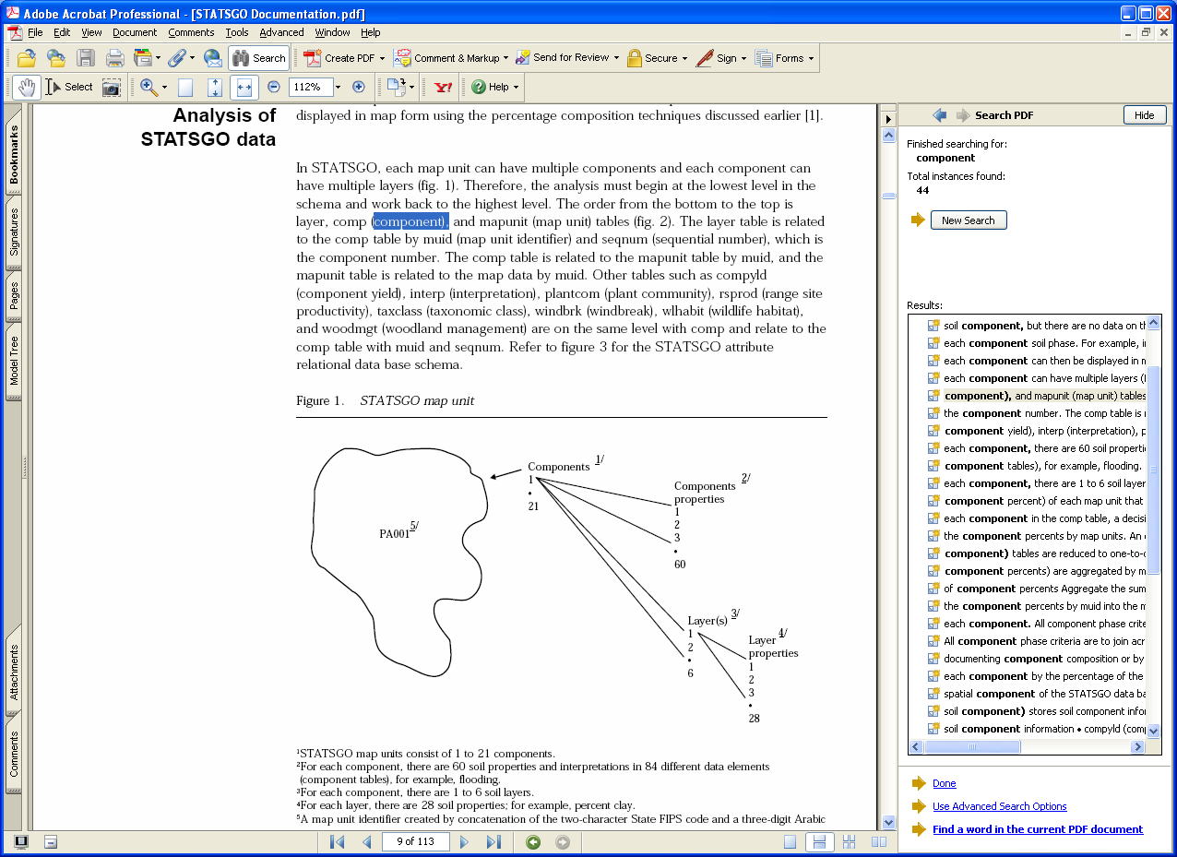

For a clearer understanding of this relationship, let’s open the table “comp.txt” using Microsoft Excel (downloading the soil database from Soil Data Mart and the folder structure of the soil database are described in our previous document “Generating Map of Soil Topographic Index”):

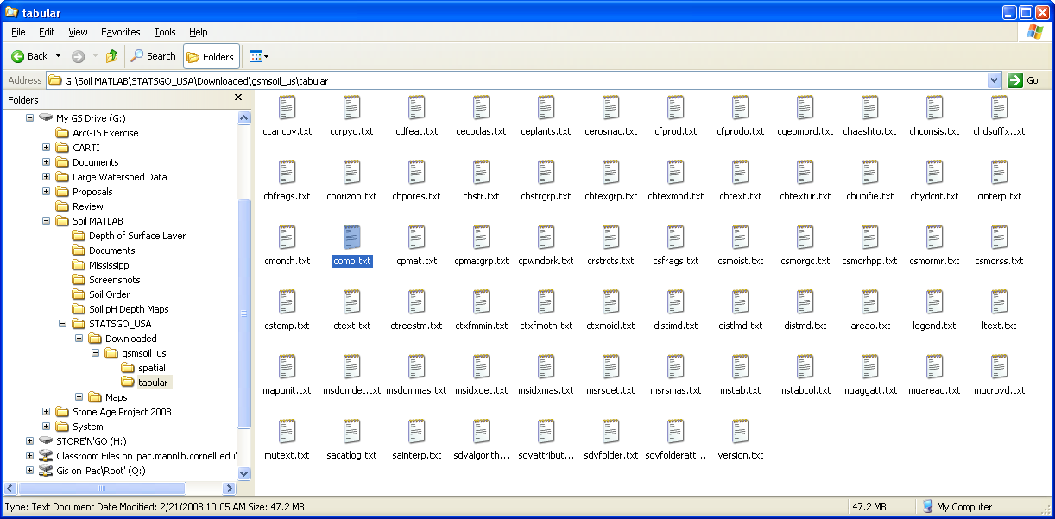

Note that you have to specify the pipe character (“|”) as the delimiter when opening the text files containing the STATSGO/SSURGO tables using Microsoft Excel:

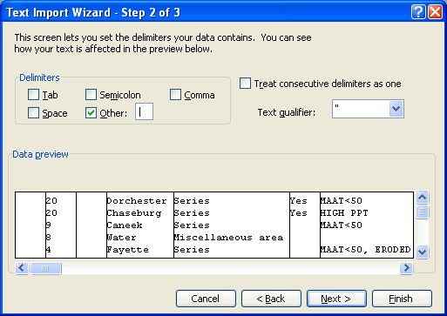

Opening the component table “comp.txt,” you will find that the soil order information is stored in the 84th column (column CF) of the table, here shown in red:

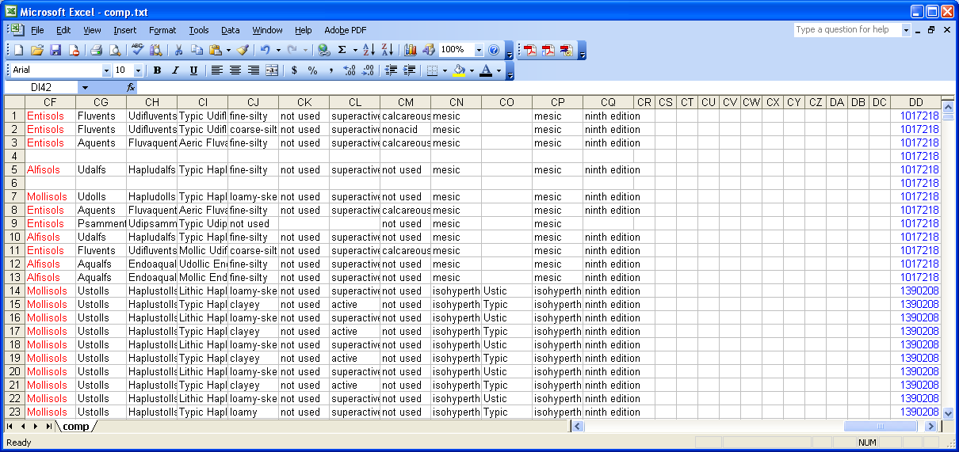

Another relevant column of the “comp.txt” table is the 108th column (column DD) shown in blue, containing the map unit key (“MUKEY”). Again, the map unit is the individual polygon shown on a soil map. As an example, the map unit “1017218” found at rows 1 to 13 above is selected from the soil map using ArcGIS:

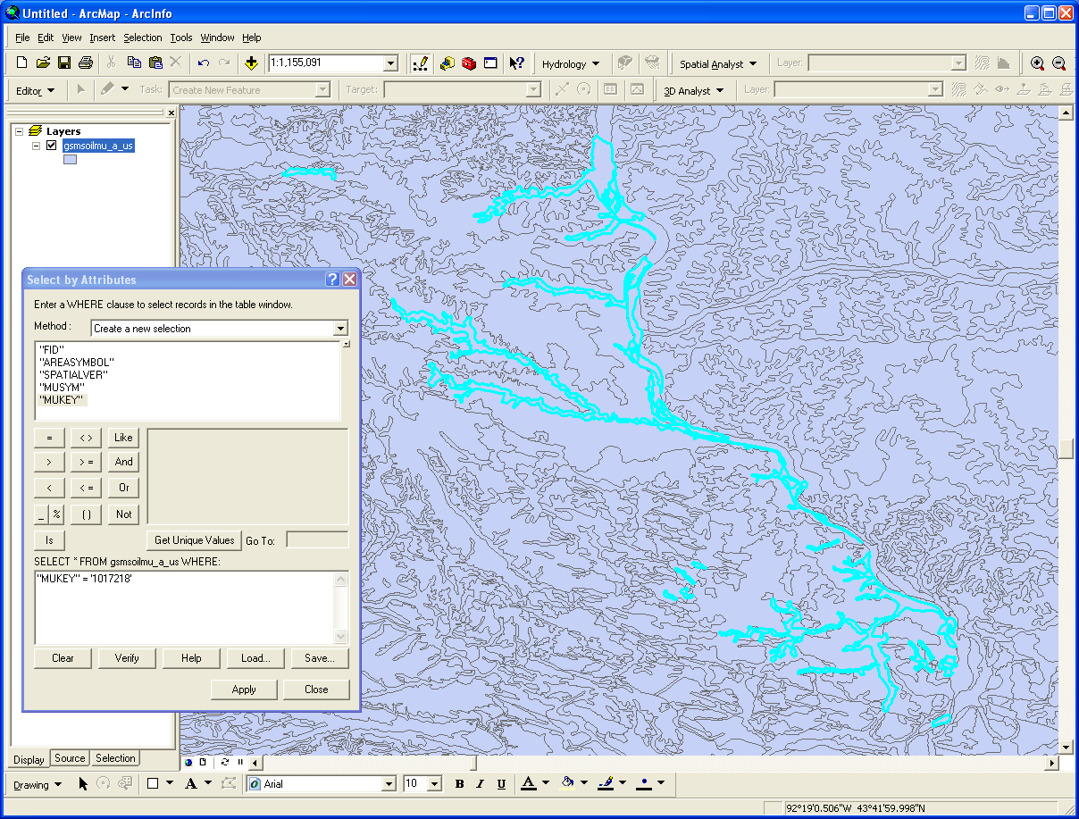

What we want to do eventually is to assign values (in this example, the soil order information) for each of the map units on the soil map. The problem is somewhat complicated because each map unit may be composed of more than one “component”. The percentage of the component of the map unit is stored in the second column (column B) of the “comp.txt” table, here shown in pink:

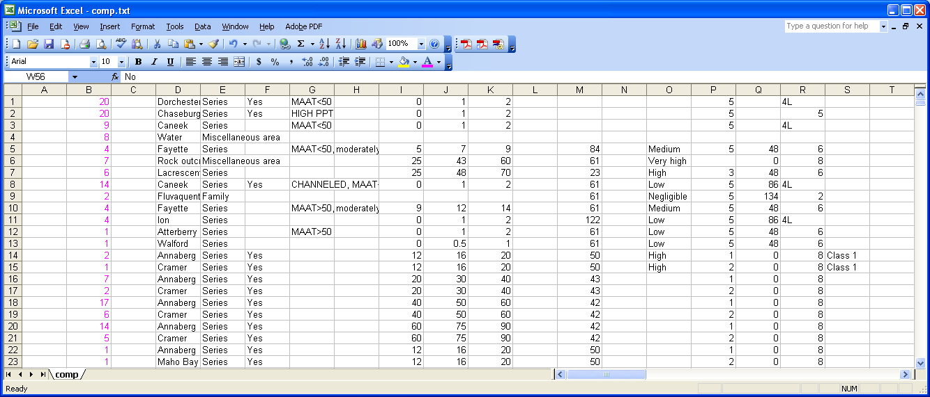

As an example, you will find that summing over rows 1 to 13 of the column B (map unit “1017218”) gives 100. Now we will write a MATLAB program that calculates percent soil order for each map unit using the information stored in the “comp.txt” file. MATLAB is appropriate for this problem because the “comp.txt” file contains too much data to be handled by other programs like Excel. Note that there may be other (simpler) ways of solving this specific problem (e.g., joining/relating tables using Microsoft Access or ArcGIS). Writing a MATLAB program is somewhat time-consuming at the initial stage, but it will give us reusable code with more flexibility to extract and process various kinds of soil data. (We will examine a more challenging case in the next document.) Open any text editor (e.g., Notepad) and save the code below as “MakeOrderTable.m,” which reads the soil order, map unit key, and percent composition from the text file “comp.txt,” calculates percent soil orders for each map unit, and writes a text file “SoilOrder.txt” containing this information:

% Open comp.txt Text File
clear
readData = textread('comp.txt','%s','whitespace','\n');

% Initialize Output Variables
rowNum = size(readData, 1);
comppct = zeros(rowNum,1);
taxorder = cell(rowNum,1);
mukey = cell(rowNum,1);

for j = 1:rowNum

% Read Each Row of the Text File
getRow = char(readData(j));
colNum = size(getRow, 2);
startCol = 0;
endCol = 0;
countDel = 0;

for i = 1:colNum

% Check for Delimiter
if getRow(i) == '|'
endCol = startCol;
startCol = i;
countDel = countDel + 1;

% Read Percent Composition
if countDel == 2
if startCol - 1 == endCol
comppct(j) = 0;
else
comppct(j) = str2num(getRow((endCol + 1):(startCol - 1)));
end
end

% Read Soil Order
if countDel == 84
if startCol - 1 == endCol
taxorder(j) = cellstr('');
else
taxorder(j) = cellstr(getRow((endCol + 2):(startCol - 2)));
end
end
% Read Mukey
if countDel == 108
if startCol - 1 == endCol
mukey(j) = cellstr('');
else
mukey(j) = cellstr(getRow((endCol + 2):(startCol - 2)));
end
end
end
end
end

% Initialize Output Table
uniqueMukey = unique(mukey);
rowNum = size(uniqueMukey, 1);
uniqueOrder = unique(taxorder);
colNum = size(uniqueOrder, 1);
orderTable = zeros(rowNum, colNum);
iterNum = size(mukey, 1);

% Calculate Percent Composition by Soil Order
for i = 1:iterNum
rowIndex = find(strcmp(uniqueMukey,mukey(i)));
colIndex = find(strcmp(uniqueOrder,taxorder(i)));
orderTable(rowIndex, colIndex) = orderTable(rowIndex, colIndex) + comppct(i);
end

% Open Output Table
fid = fopen('SoilOrder.txt','w');

% Write Column Headings
fprintf(fid,'Mukey,');
for i = 1:colNum
if strcmp(uniqueOrder(i),'')
varName = 'Noname';
else
varName = char(uniqueOrder(i));
end
fprintf(fid,'%s',varName);
if i == colNum
delimChar = char(13);
else
delimChar = ',';
end
fprintf(fid,'%s',delimChar);
end

% Wtire Output Table Values
for j = 1:rowNum
fprintf(fid,'%s,',char(uniqueMukey(j)));
for i = 1:colNum
fprintf(fid,'%f',orderTable(j,i));
if i == colNum
delimChar = char(13);
else
delimChar = ',';
end
fprintf(fid,'%s',delimChar);
end
end

% Close Output Table
fclose(fid);
The text file “MakeOrderTable.m” containing this code should be saved in the same folder where the “comp.txt” is stored. Open MATLAB, move to the folder where these files are stored, and run the code by typing “MakeOrderTable” in the command window:

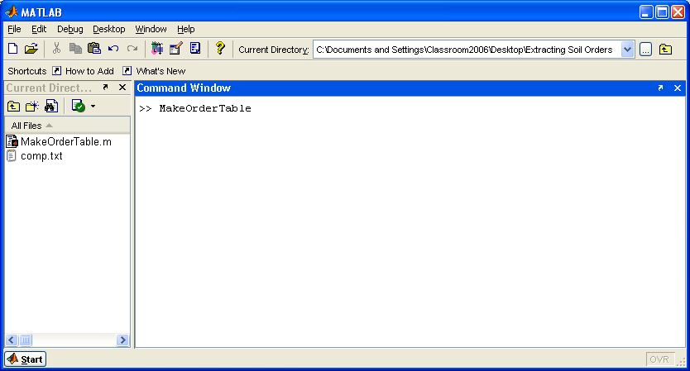

After running the code, you will find a text file “SoilOrder.txt” created in the same folder. Opening the file using Excel, you can see that the percent soil orders are calculated for each map unit “Mukey” (the “Noname” column shows the percent of map unit components without soil order information):

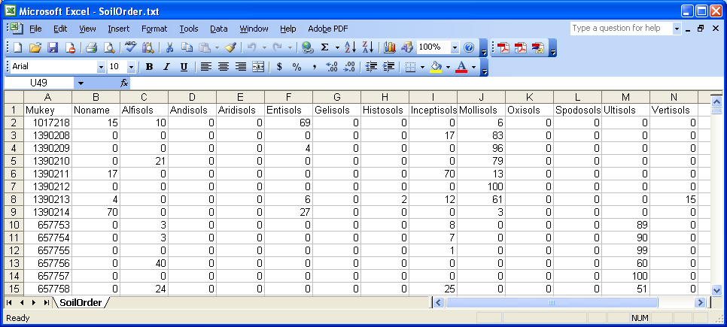

Now we will join this table with a soil map containing “MUKEY” using ArcGIS. Add the soil map of interest to ArcGIS, in this example for the eastern US watersheds (downloading and processing the soil map are described in the previous document “Generating Map of Soil Topographic Index”):

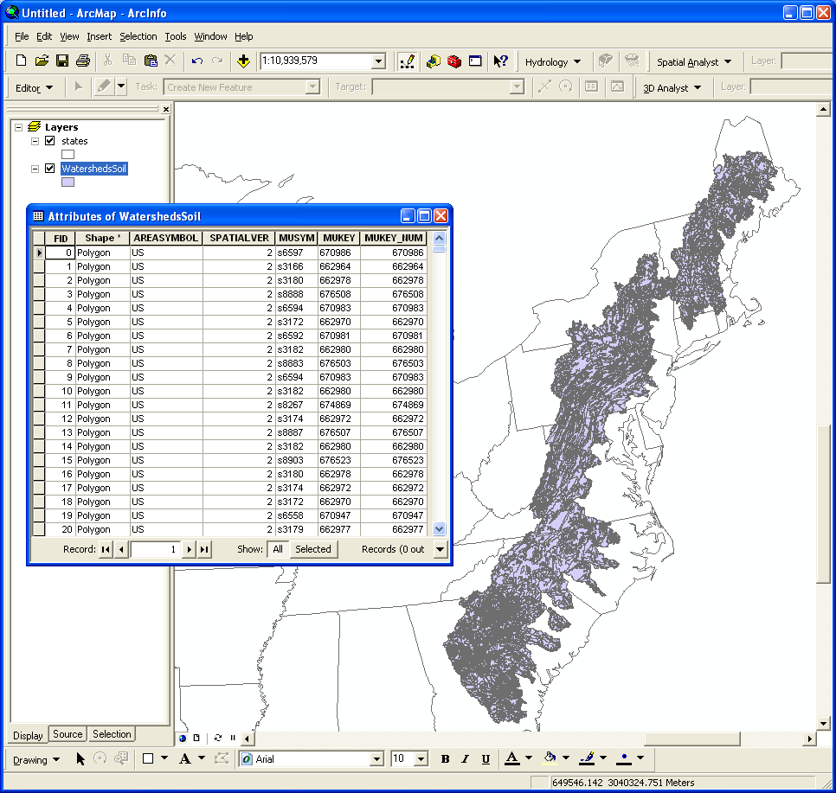

The attribute table for the soil map containing “MUKEY” (text variable) and “MUKEY_NUM” (long integer variable containing the same values as “MUKEY”) are also shown above. To join the soil order table, add the text file “SoilOrder.txt,” right-click on the soil map name, and click on “Joins and Relates > Join…”. You should join the “MUKEY_NUM” column of the soil map with the “Mukey” column of the text file “SoilOrder.txt”:

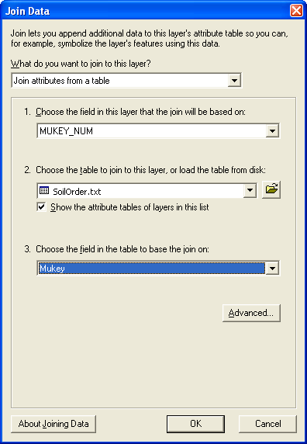

Exporting the joined map will create a soil map with percent soil order information. Below are the attribute table of the soil order map and a map of percent Ultisols as an example:

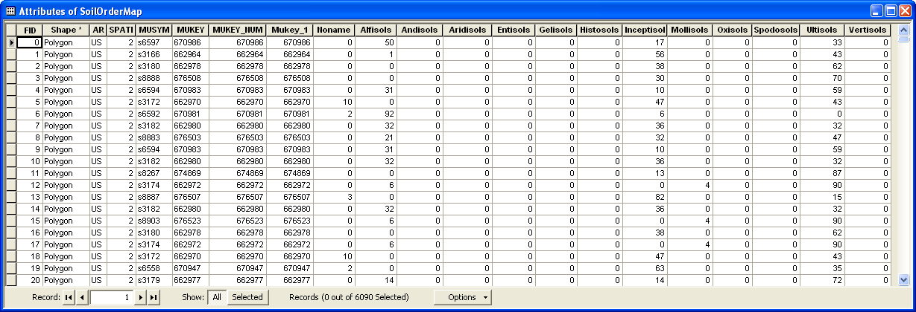

The map below shows the percentage of the Ultisol soil order at the level of resolution of the map unit (i.e., within each map unit, the soil orders are assumed to be distributed uniformly, so resolution of the spatial distribution of soil below this level is not available). To obtain watershed-level percentages of soil order, the map unit information must be aggregated over the watershed.

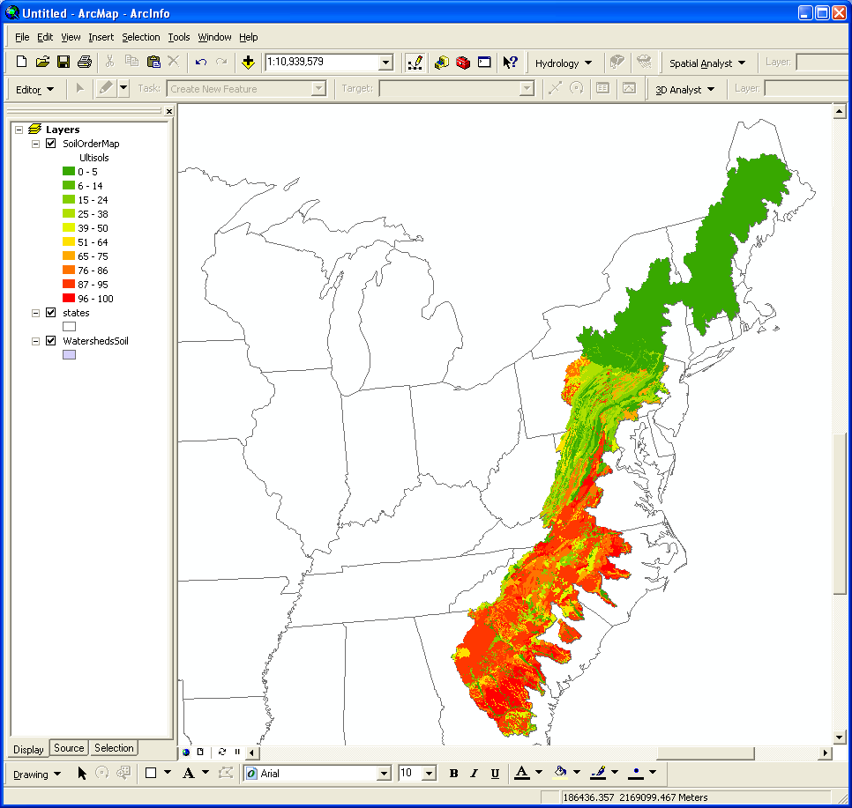

If you have a watershed boundary map, you can calculate area-weighted averages of percent soil order using Hawth’s Analysis Tools (the tool is described in the previous document “Calculating Area-weighted Means”). Note that the result, an area-weighted average of the areal percentages of a soil of given order in each soil map unit in the watershed, is equivalent to the percentage of the soil order in the watershed, at the level of resolution of the map unit.

Below is an example of a map of watershed-average percent Ultisols generated using the above technique:

