Creating a map of sites and extracting mapped values
corresponding to the site coordinates

Bongghi Hong and Dennis Swaney
January 10, 2008

This document describes how to create a map of site locations (point coverage) and then obtain corresponding values of a map (polygon coverage) at the set of point locations. As an example, we will use the CMAQ model atmospheric deposition estimates as a polygon map (total N deposition in kg/km²/year shown with a map of 16 Northeast US watersheds):

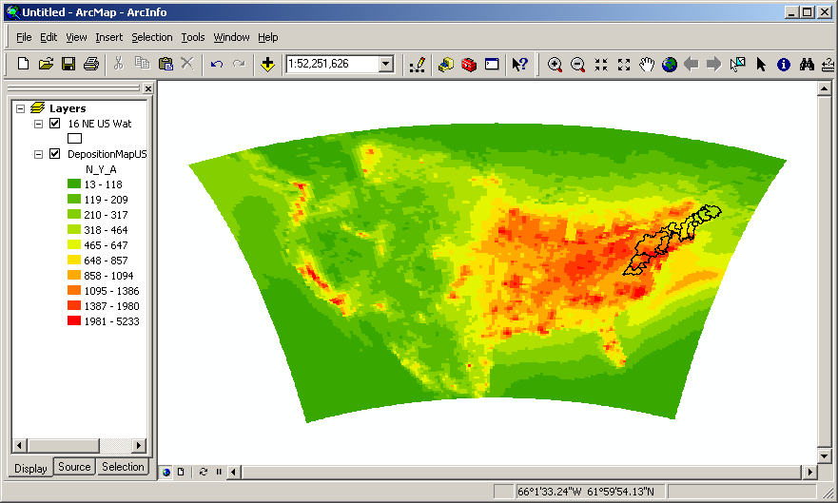

We will extract CMAQ deposition values at a number of locations where observation stations are located.

First, we need to create a gis coverage containing the point locations. The location information is provided as an Excel file (“LAT” and “LONG” columns contain latitude and longitude values, respectively) which can also contain other fields (eg station ids, etc):

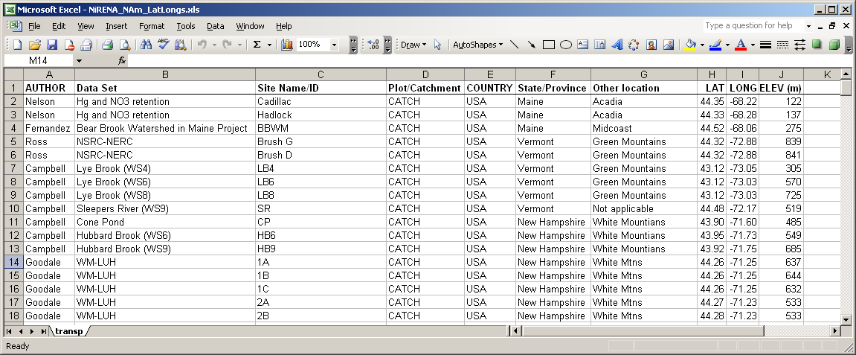

First, save the Excel file in a database (dbf) format, so that the table can be read and added to ArcGIS. Below shows the table saved as “StationLocation.dbf” and added to ArcGIS:

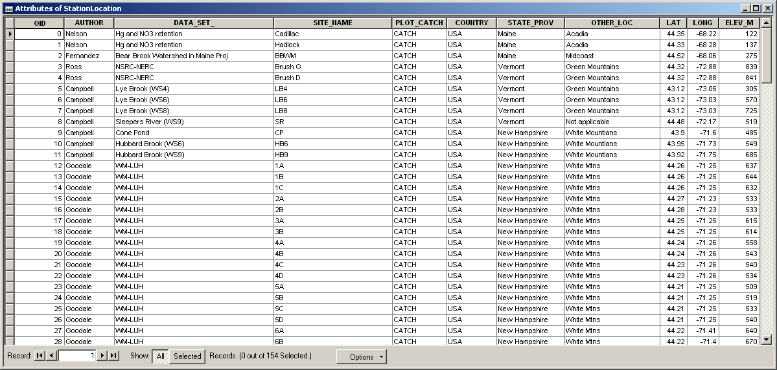

Next, create a point map showing observation stations from latitude and longitude information by clicking “Tools > Add XY Data...” and the “Add XY Data” window will be open. Select “StationLocation” for the location table, and “LONG” and “LAT” as longitude and latitude, as x and y data respectively. Specify coordinate system by clicking “Edit...” and importing the coordinate system of the CMAQ deposition map:

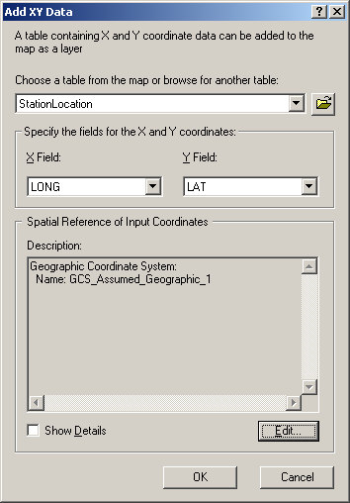

Note that, in order to perform this analysis, the point (station) and polygon (deposition) maps should have the same coordinate system. Since the locations in this example are recorded in degrees, it is appropriate to use the polygon map having the same unit. If, for example, the locations were recorded in meters or feet, it would be appropriate to use a polygon map having the corresponding unit. Clicking “OK” will add the points to ArcGIS as a point map:

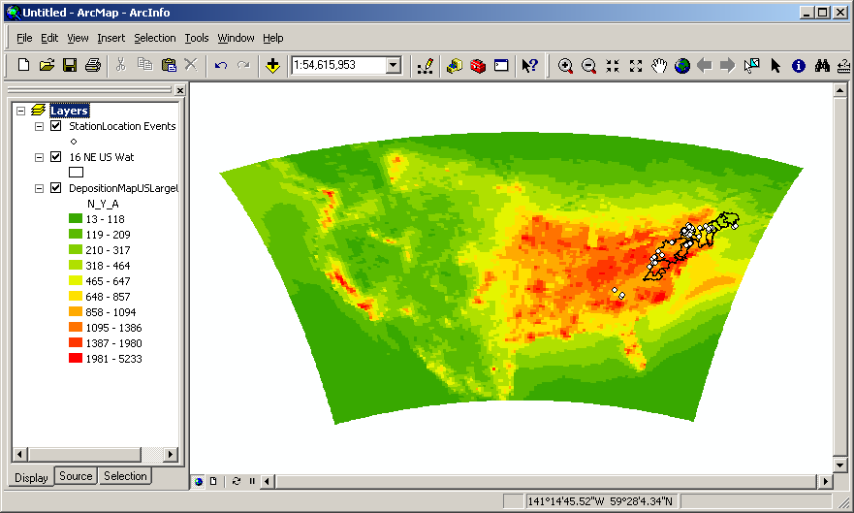

The point map needs to be saved in a shapefile format. Right-click on the point map name “StationLocation Events” on the left window, select “Data > Export Data...”, and save the map as “Stations.shp”. To extract the CMAQ deposition estimates at these points, we will use the “Intersect Point Tool” feature of the Hawth’s Analysis Tools (downloading and running the Hawth’s Analysis Tools is described in detail in the earlier document “Calculating Area Weighted Means”):

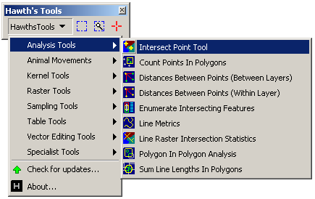

Clicking on “HawthTools > Analysis Tools > Intersect Point Tool” opens the “Intersect Point Tool” window. Select the point map “Stations” for “point file to intersect” and the CMAQ deposition map for the polygon layer:

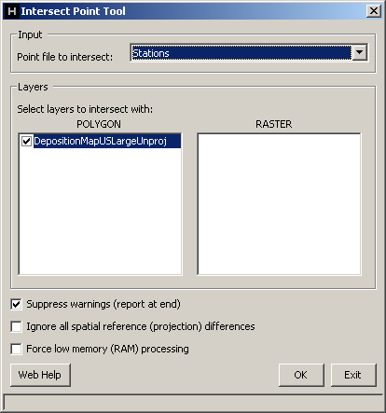

Clicking “OK” will open another window for selecting the fields in the CMAQ deposition map to be estimated:

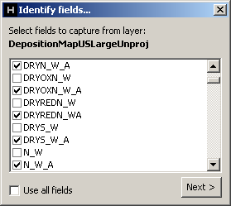

In this example, the following fields are selected (all in kg/km²/year):

DRYN_W_A: dry N deposition in winter
DRYOXN_W_A: dry oxidized N deposition in winter
DRYREDN_WA: dry reduced N deposition in winter
DRYS_W_A: dry S deposition in winter
N_W_A: N deposition in winter
OXN_W_A: oxidized N deposition in winter
REDN_W_A: reduced N deposition in winter
S_W_A: S deposition in winter
WETN_W_A: wet N deposition in winter
WETOXN_W_A: wet oxidized N deposition in winter
WETREDN_WA: wet reduced N deposition in winter
WETS_W_A: wet S deposition in winter
DRYN_Sp_A: dry N deposition in spring
DRYOXN_SpA: dry oxidized N deposition in spring
DRYREDNSpA: dry reduced N deposition in spring
DRYS_Sp_A: dry S deposition in spring
N_Sp_A: N deposition in spring
OXN_Sp_A: oxidized N deposition in spring
REDN_Sp_A: reduced N deposition in spring
S_Sp_A: S deposition in spring
WETN_Sp_A: wet N deposition in spring
WETOXN_SpA: wet oxidized N deposition in spring
WETREDNSpA: wet reduced N deposition in spring
WETS_Sp_A: wet S deposition in spring
DRYN_Su_A: dry N deposition in summer
DRYOXN_SuA: dry oxidized N deposition in summer
DRYREDNSuA: dry reduced N deposition in summer
DRYS_Su_A: dry S deposition in summer
N_Su_A: N deposition in summer
OXN_Su_A: oxidized N deposition in summer
REDN_Su_A: reduced N deposition in summer
S_Su_A: S deposition in summer
WETN_Su_A: wet N deposition in summer
WETOXN_SuA: wet oxidized N deposition in summer
WETREDNSuA: wet reduced N deposition in summer
WETS_Su_A: wet S deposition in summer
DRYN_F_A: dry N deposition in fall
DRYOXN_F_A: dry oxidized N deposition in fall
DRYREDN_FA: dry reduced N deposition in fall
DRYS_F_A: dry S deposition in fall
N_F_A: N deposition in fall
OXN_F_A: oxidized N deposition in fall
REDN_F_A: reduced N deposition in fall
S_F_A: S deposition in fall
WETN_F_A: wet N deposition in fall
WETOXN_F_A: wet oxidized N deposition in fall
WETREDN_FA: wet reduced N deposition in fall
WETS_F_A: wet S deposition in fall
DRYN_Y_A: annual dry N deposition
DRYOXN_Y_A: annual dry oxidized N deposition
DRYREDN_YA: annual dry reduced N deposition
DRYS_Y_A: annual dry S deposition
N_Y_A: annual N deposition
OXN_Y_A: annual oxidized N deposition
REDN_Y_A: annual reduced N deposition
S_Y_A: annual S deposition
WETN_Y_A: annual wet N deposition
WETOXN_Y_A: annual wet oxidized N deposition
WETREDN_YA: annual wet reduced N deposition
WETS_Y_A: annual wet S deposition

Clicking “Next” and then “OK” will start the computation. After the calculation is finished, check the “Processing results” window and make sure that there was no error:

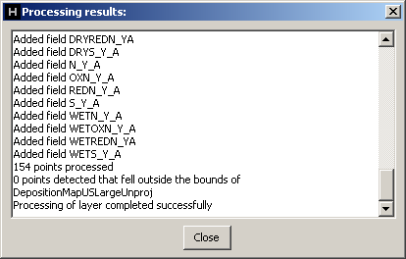

Now the point map “Stations” contains the selected fields from the CMAQ deposition map. You can show any of the field information in a map (e.g., total annual N deposition in kg/km²/year), or export the attribute file for further analysis:

