Calculating Centroid Position, Area, and Perimeter

Bongghi Hong
August 30, 2007

This document describes how the centroid position, area, and perimeter of polygons can be calculated. Detailed description and related information can be obtained by searching “making field calculations” from the ArcGIS Desktop Help (click on “Help > ArcGIS Desktop Help” to open the help window):

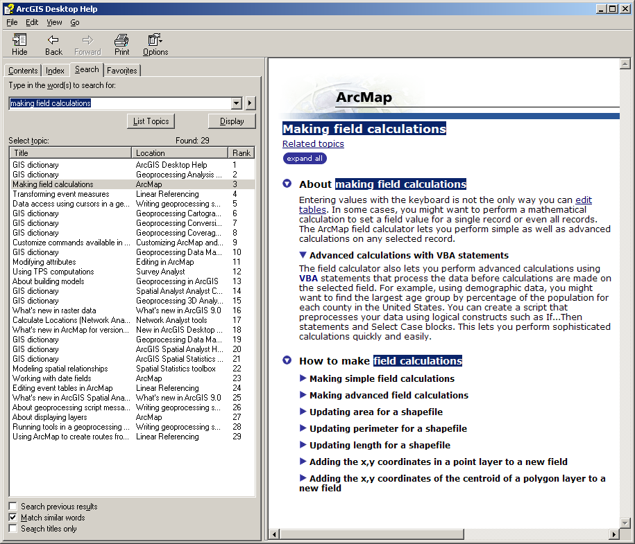

Note that the results of these calculations depend on the unit of the map and may have different meanings. For example, when a map is unprojected, the result of centroid position calculation will be latitudes and longitudes of polygons. If the map unit is in meters, the result of area calculation will be in square meters. As an example, we will use a map of eastern US watersheds (unprojected) to calculate latitude of each polygon:

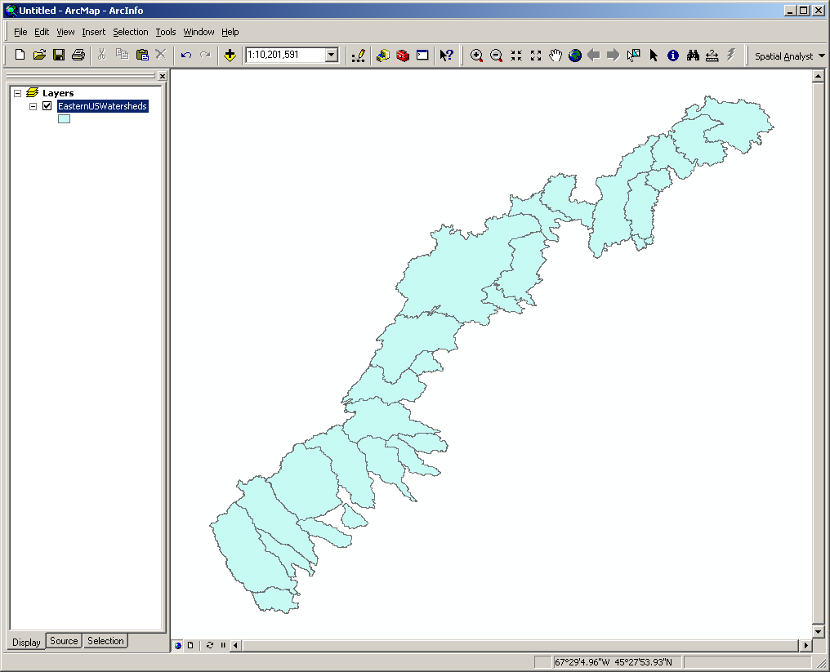

First, open the attribute table of the map by right-clicking the map name (“EasternUSWatersheds”) and selecting “Open Attribute Table”:

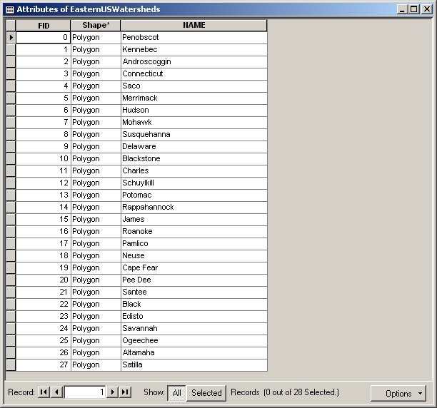

Next, create a new field that will contain latitudes of polygons by clicking on “Options > Add Field...”. Specify field name as “Latitude” and type as “Double”:

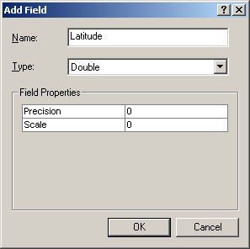

Clicking “OK” will create a new field in the attribute table:

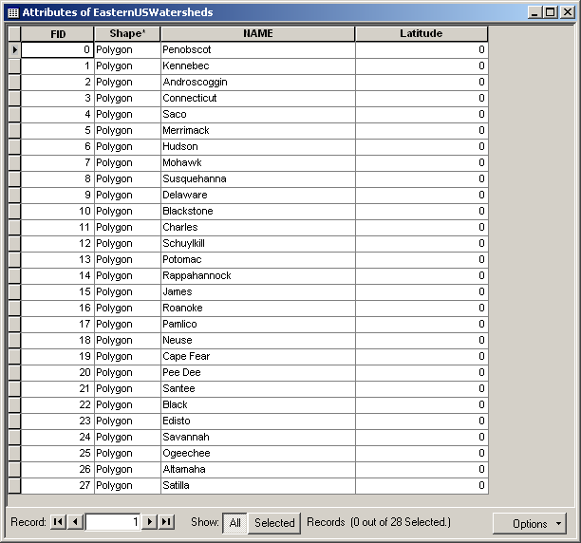

Right-click on the field name “Latitude” and select “Calculate Values...”. A warning message will be shown. Clicking “Yes” will open the field calculator:

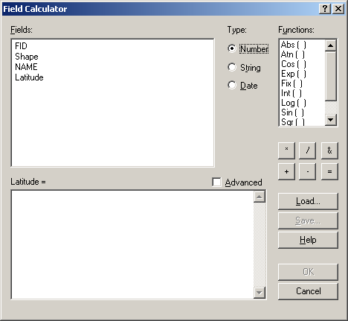

Check the “Advanced” checkbox and type in the following VBA code to obtain the vertical position of the polygon centroid:

Dim dblY As Double
Dim pArea As IArea
Set pArea = [Shape]
dblY = pArea.Centroid.Y

Type “dblY” in the bottom text box (“Latitude=”):

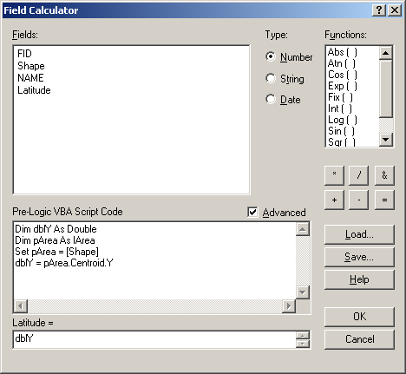

Clicking “OK” will fill the “Latitude” column with latitudes of polygon centroids.

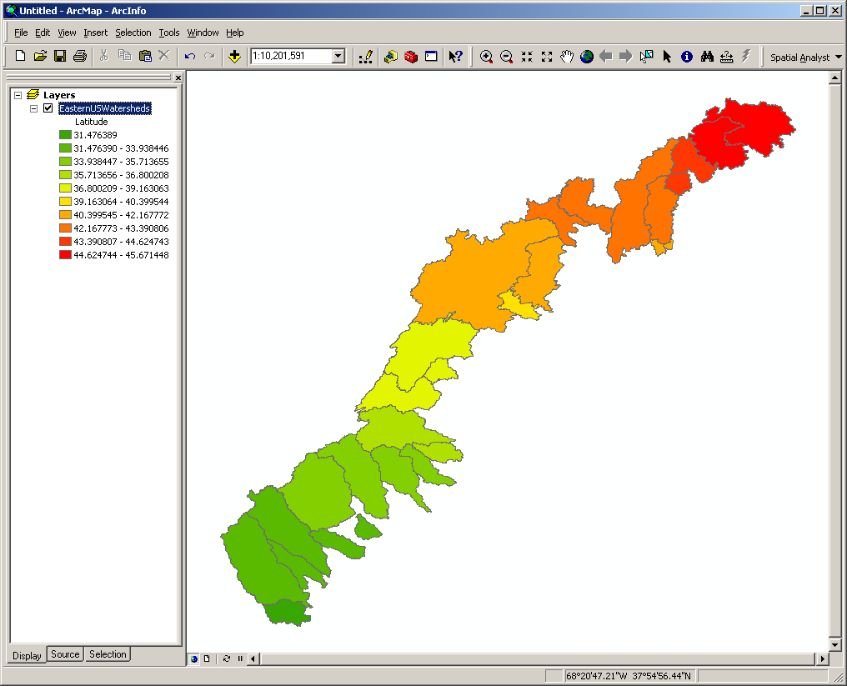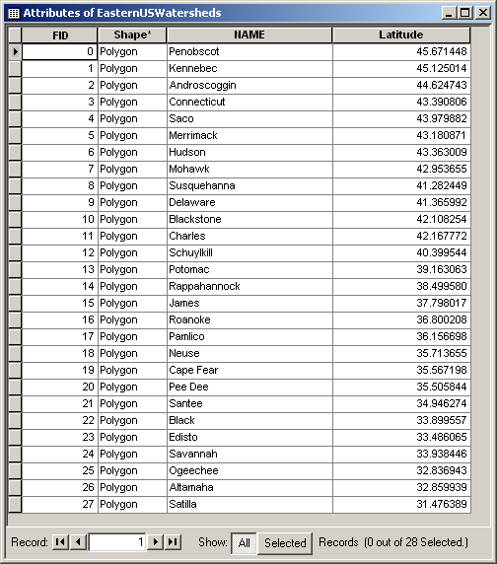

Below are the VBA codes that should be used when longitude, area, and perimeter are calculated:

< Longitude >

Dim dblX As Double
Dim pArea As IArea
Set pArea = [Shape]
dblX = pArea.Centroid.X

< Area >

Dim dblArea as double
Dim pArea as IArea
Set pArea = [shape]
dblArea = pArea.area

< Perimeter >

Dim dblPerimeter as double
Dim pCurve as ICurve
Set pCurve = [shape]
dblPerimeter = pCurve.Length

Make sure to type in right variable names (“dblX”, “dblArea”, and “dblPerimeter”, respectively) in the bottom text box and that a map appropriately projected for the purpose is used.

