Generating N Deposition Maps for SE US Watersheds

Bongghi Hong and Dennis Swaney
August 17, 2007

This document describes how the area-weighted N deposition maps are generated for the eleven SE US Watersheds:

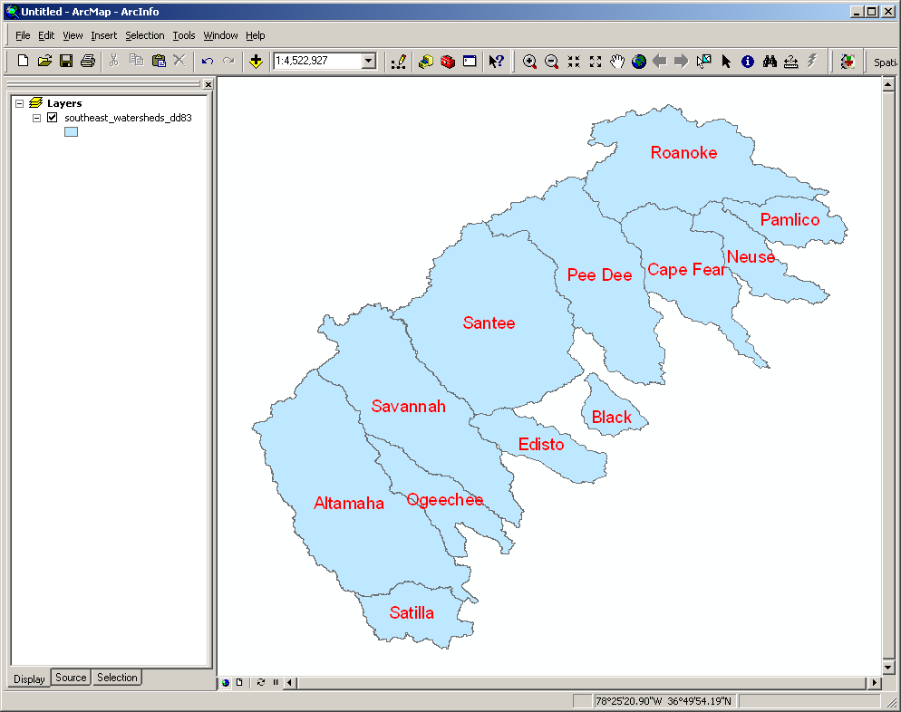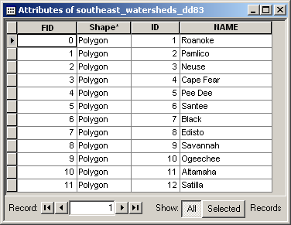

The deposition estimates are obtained from CMAQ model, downloadable from http://www.epa.gov/asmdnerl/Multimedia/depositionMapping.html:

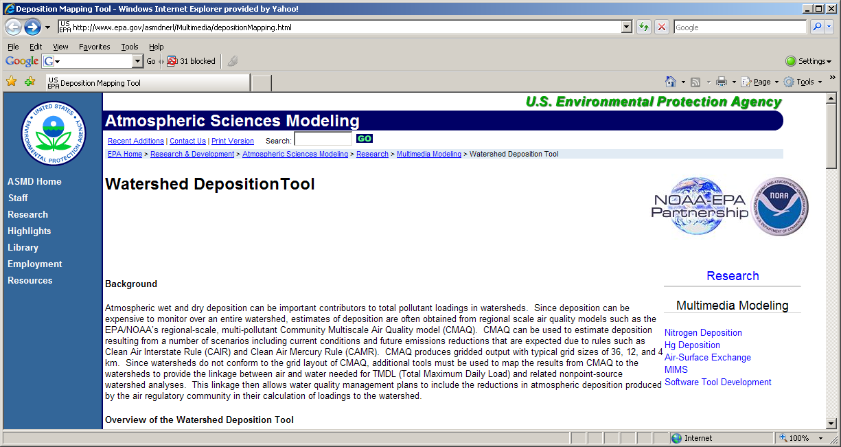

Scroll down and click on the “Download the Watershed Deposition Tool” to download the model installation file “Watershed_Deposition_Tool_1.4.4_Installer.exe”. Opening the file will install the Watershed Deposition Tool:

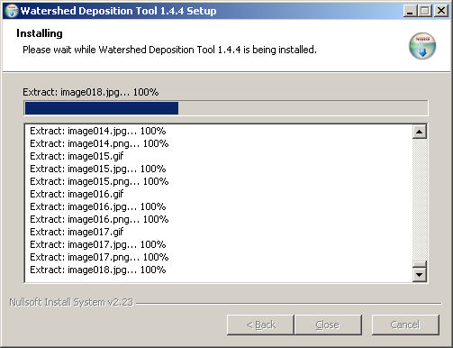

We also need to download some CMAQ files (available on the same webpage) containing deposition estimates. Five CMAQ files appropriate for our purpose are:

(1) “NS.agg.36con.cctmJ4f.sp99.b312.nh3c1.dep_na.annual.2001base” (2001 annual N & S)
(2) “NS.agg.36con.cctmJ4f.sp99.b312.nh3c1.dep_na.autumn.2001base” (2001 autumn N & S)
(3) “NS.agg.36con.cctmJ4f.sp99.b312.nh3c1.dep_na.spring.2001base” (2001 spring N & S)
(4) “NS.agg.36con.cctmJ4f.sp99.b312.nh3c1.dep_na.summer.2001base” (2001 summer N & S)
(5) “NS.agg.36con.cctmJ4f.sp99.b312.nh3c1.dep_na.winter.2001base” (2001 winter N & S)

Below describes how the annual deposition estimates can be obtained. We will need to repeat this procedure a total of five times to get all annual and seasonal maps. First, start the Watershed Deposition Tool by clicking on “Start > All Programs > Watershed Deposition Tool > Watershed Deposition Tool:

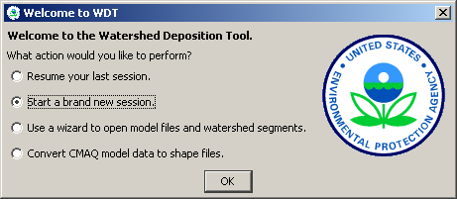

Select “Start a brand new session” and click OK. This will open the Watershed Deposition Tool window with an entire US map:

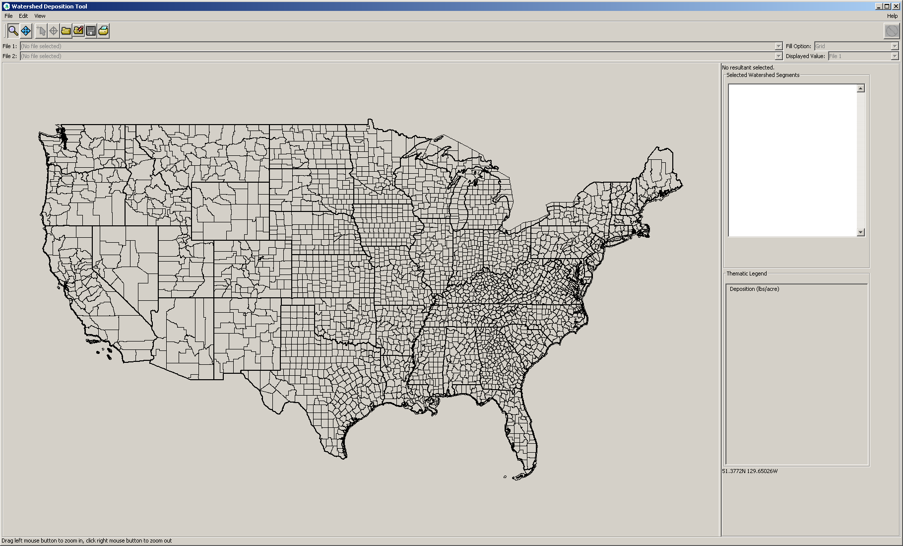

Click on “File > Open Model Data Files...” and select the annual CMAQ file “NS.agg.36con.cctmJ4f.sp99.b312.nh3c1.dep_na.annual.2001base” (note that when we want seasonal estimates we will select other appropriate CMAQ files). Next, select “Total Nitrogen” to be displayed and click “Finish”. This will display the annual total N deposition map:

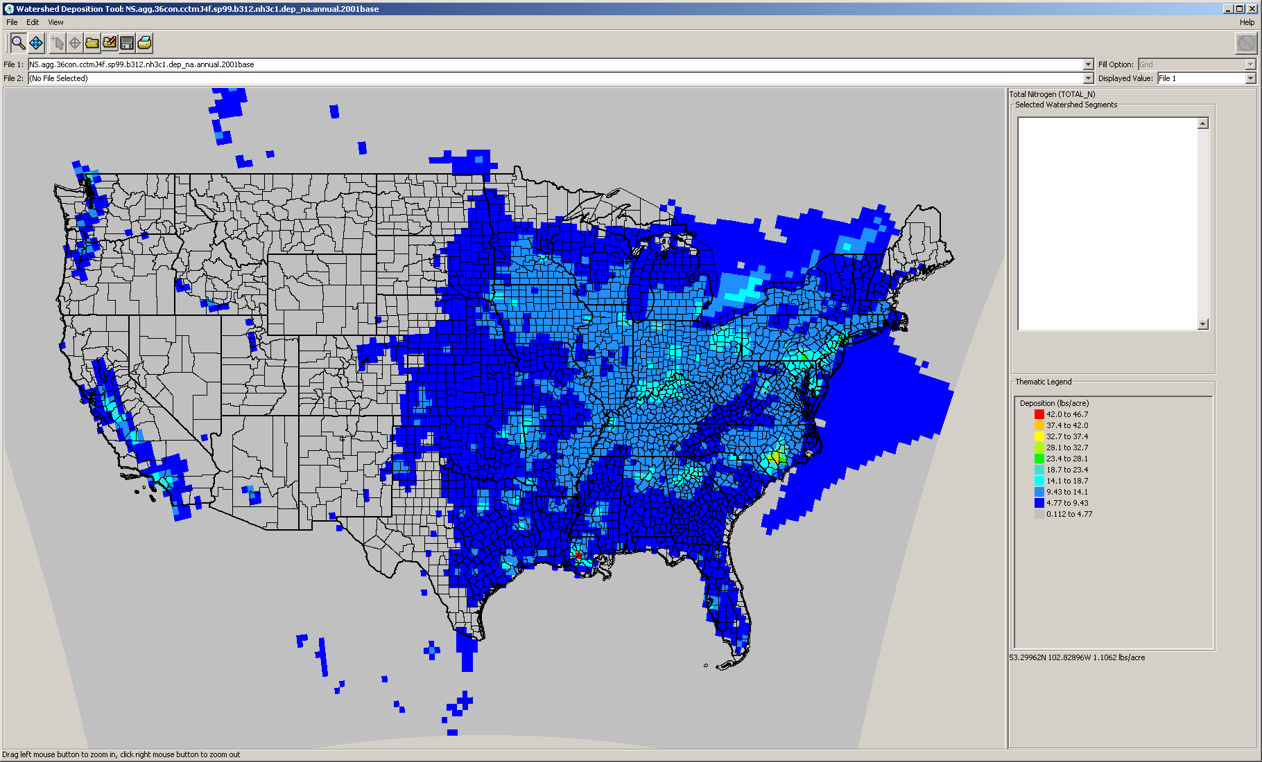

The eleven SE US Watersheds are within the “huc03” region. Click on “File > Open Watershed Segments...” and select “huc250Regions > huc03.shp”. Click on “Next > Finish” and you will see “huc03” regions in green lines:
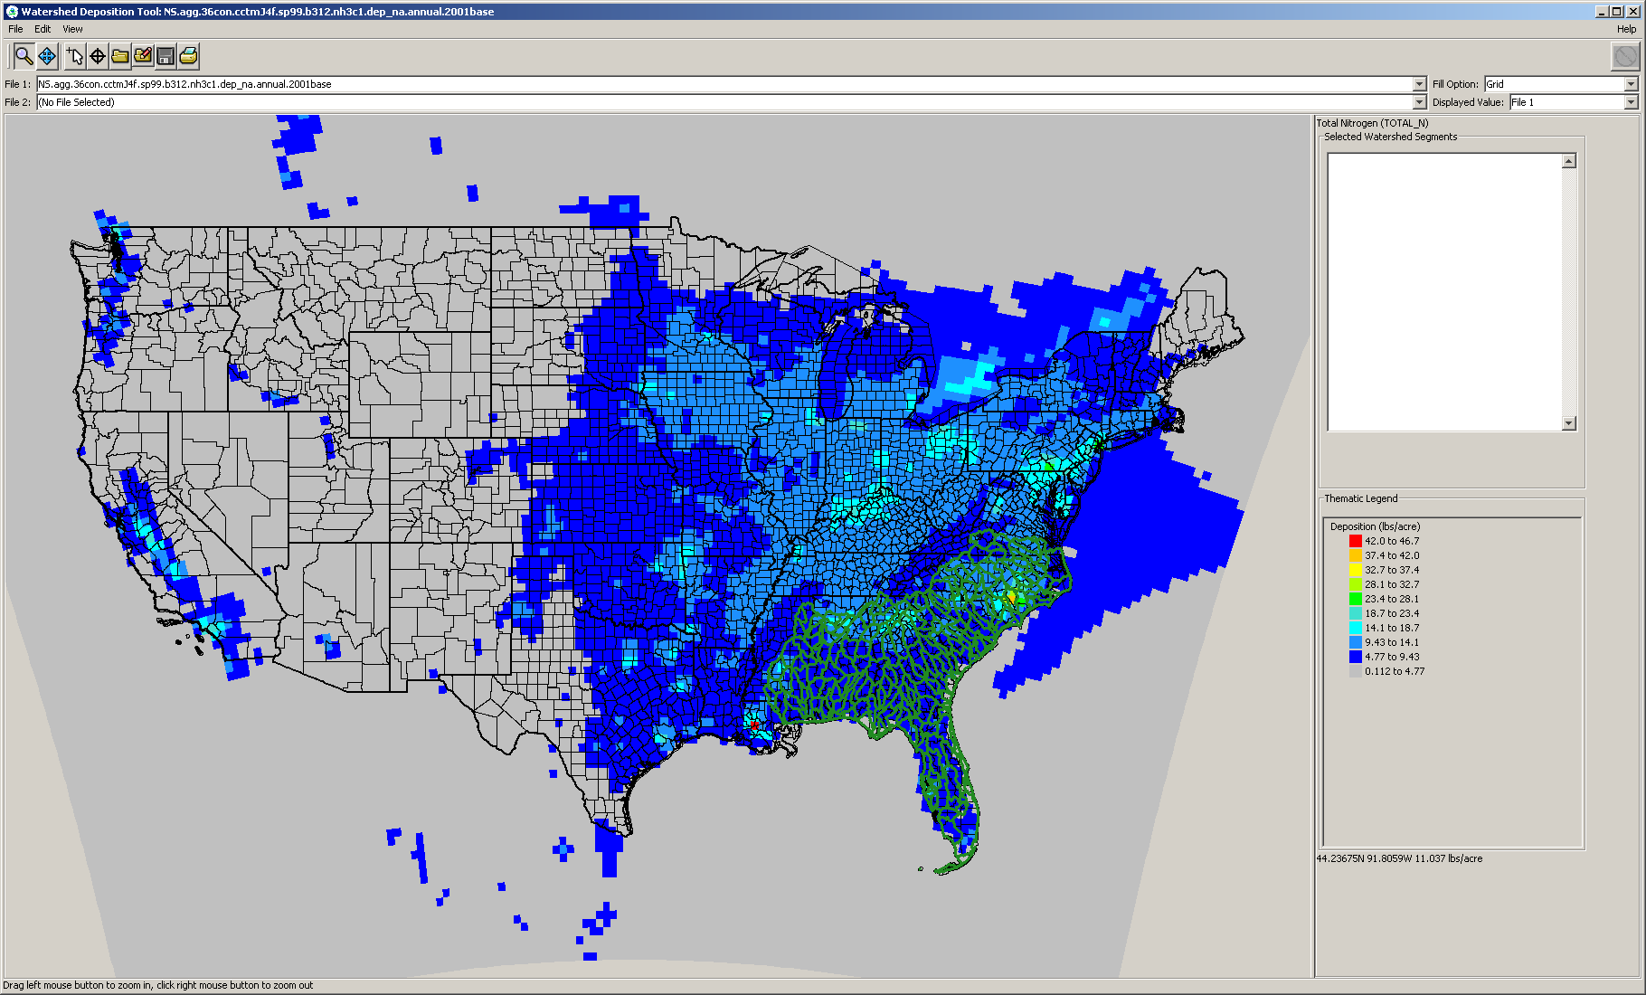

Before exporting this map, we need to specify some options. Click on “Edit > Options...” and Options window will be opened. Check the “Watershed Segment Files” checkbox on the “Data Files” tab, and specify units as “kg” and “km2” on the “Units” tab. Clicking “OK” will update the map with desired unit:

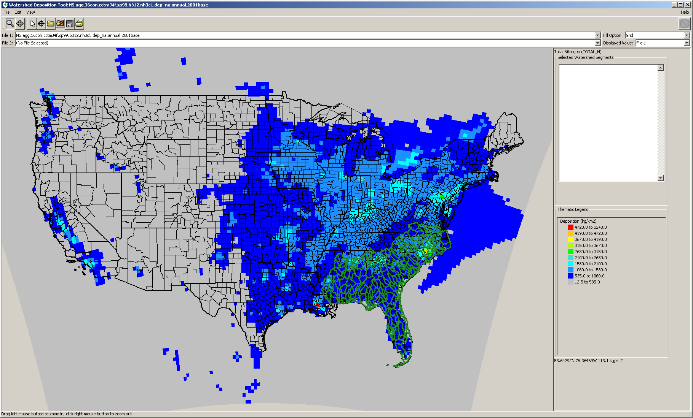
Now we are ready to export this map. Click on “File > Export to SHP Files...” and select a folder that will contain the exported map (e.g., “Huc03Annual”). Open the exported map “huc03Grid_pg” with ArcGIS:

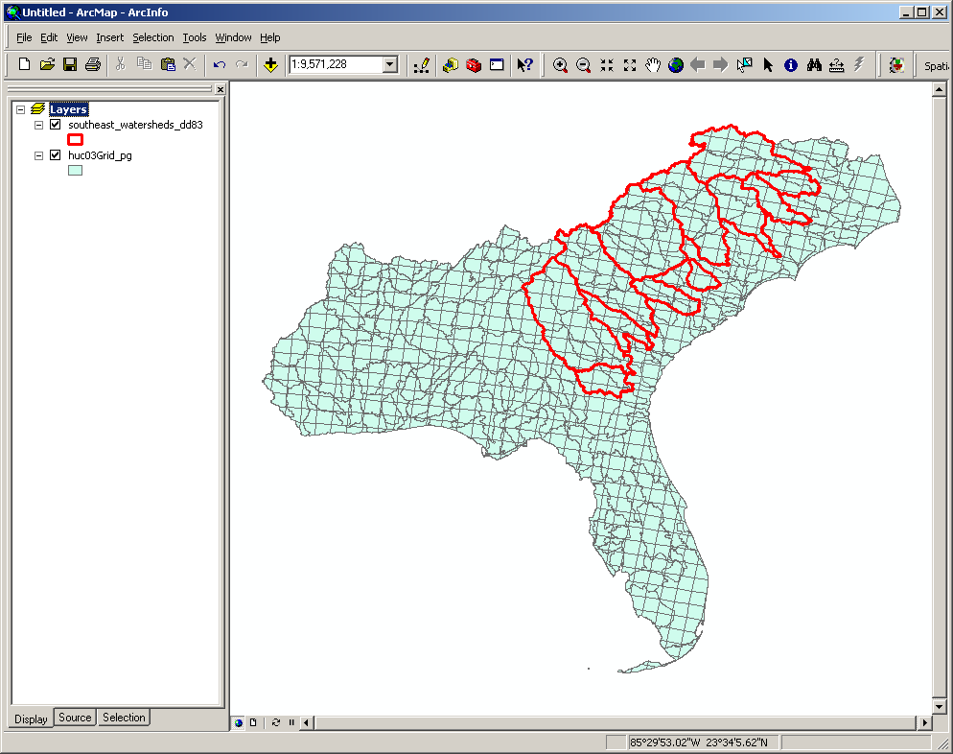

Repeating this procedure four more times will produce all annual and seasonal deposition maps. The resulting five maps need to be refined because (1) they all have the same names and (2) deposition fields have a “string” format, not the “numeric” format. These problems can be resolved using a “Merge” tool in the ArcToolbox. Click on “ArcToolbox > Data Management Tools > General > Merge” to open the Merge tool. Modify output map name to indicate its season (e.g., huc03Grid_pg_summer.shp). All field names should also be modified to indicate corresponding seasons (e.g., DRYN_SU). When a field should have a numeric format, change the type from “text” to “double” (right-clicking the field name will open a property window):

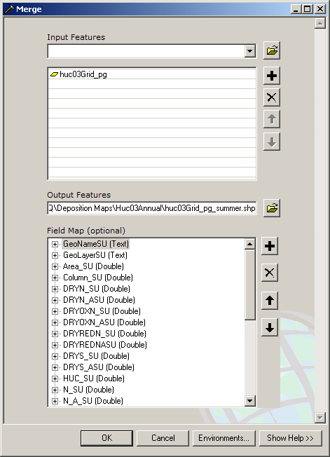

Now we have five maps ready to be combined into a single map. Combining maps can be done using the ArcToolbox “Union” tool (click on “ArcToolbox > Analysis Tools > Overlay > Union”):

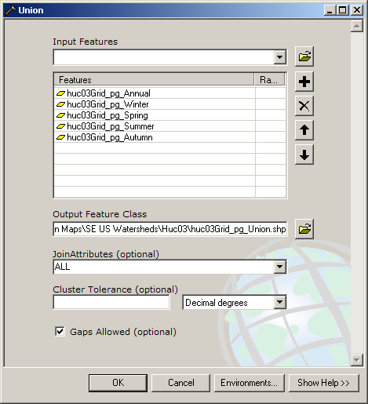

After combining the maps, you will have a single map containing all the deposition estimates in numeric format (so that you can display the value):

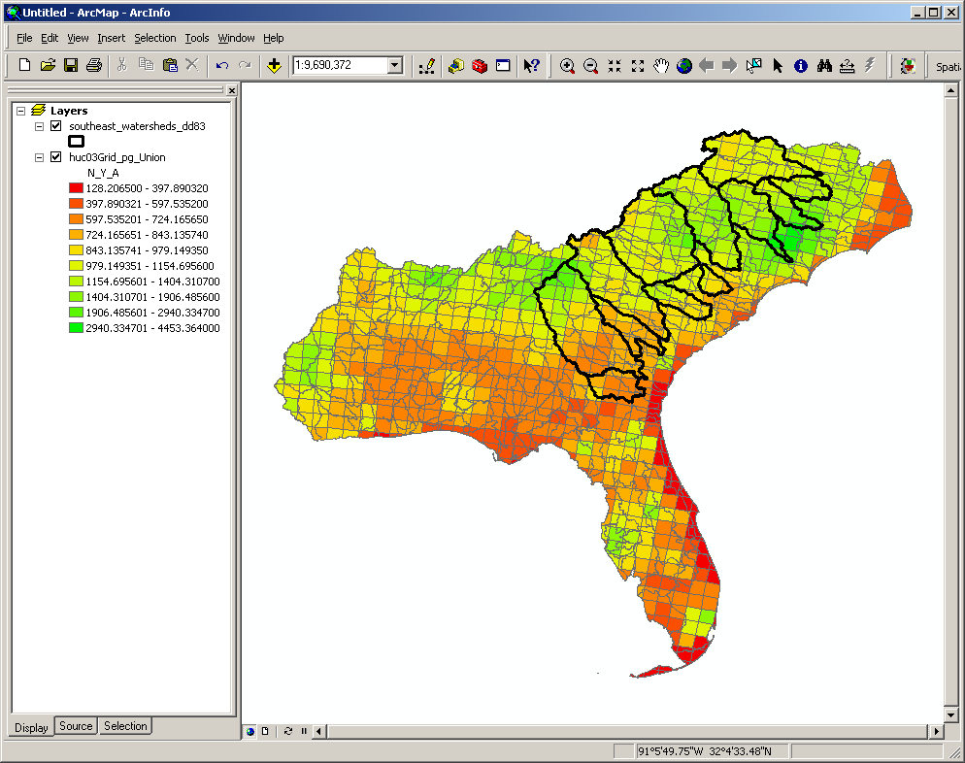

Both the deposition maps and watershed boundaries are not projected. It is a good time to project them before calculating the area-weighted average. Here we will project the maps using the “USA_Contiguous_Albers_Equal_Area_Conic_USGS_version” projection. This projection was used to project the 16 NE US watersheds. Open the ArcToolbox “Project” tool by clicking on “ArcToolbox > Data Management Tools > Projections and Transformations > Feature > Project”:

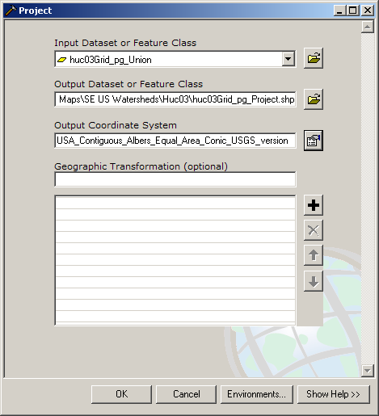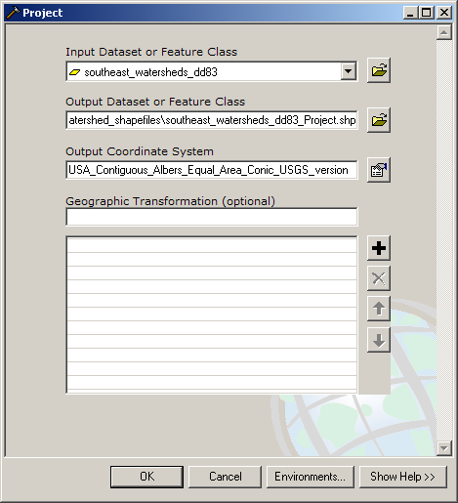

Note that the output coordinate system can be specified by importing the projection of existing maps (e.g., NE US watershed boundary map), instead of specifying it from scratch:

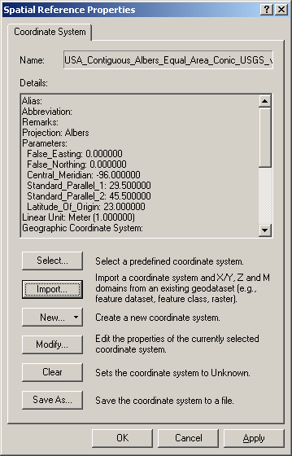

Below are the projected maps:

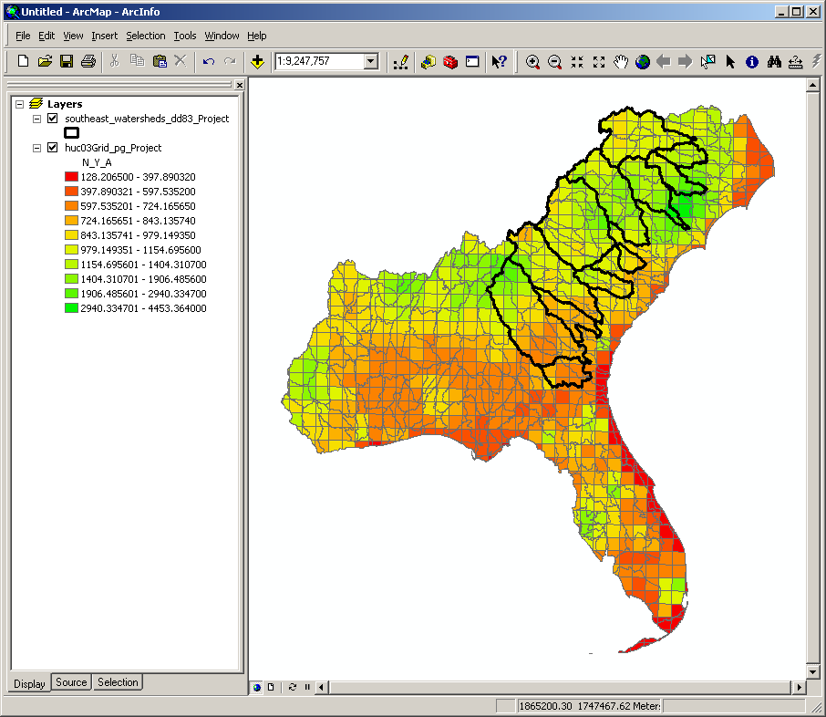

Now we are ready to run the Hawth’s Analysis Tools to calculate the area-weighted average of deposition estimates (downloading and running the Hawth’s Analysis Tools is described in detail in earlier document “Calculating Area Weighted Means”):

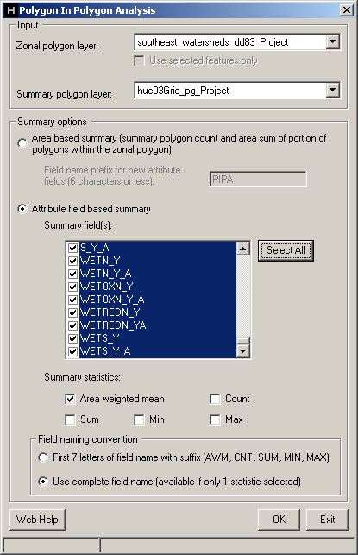

After running the Hawth’s Analysis Tools, the watershed boundary map will contain area-weighted averages of deposition estimates:

