Calculating the Agricultural Proportion of County Covered by Watershed

September 21, 2007
Bongghi Hong

The earlier document “Calculating Proportion of County Covered by Watershed” described calculation of (total area of watershed) / (total area of county). This document describes somewhat more sophisticated calculation: (agricultural area of watershed) / (agricultural area of county). The procedure is very similar to the previous calculation, except that we replace total areas with agricultural areas. We will use 1992 NLCD (National Land Cover Data) for estimation of agricultural area:

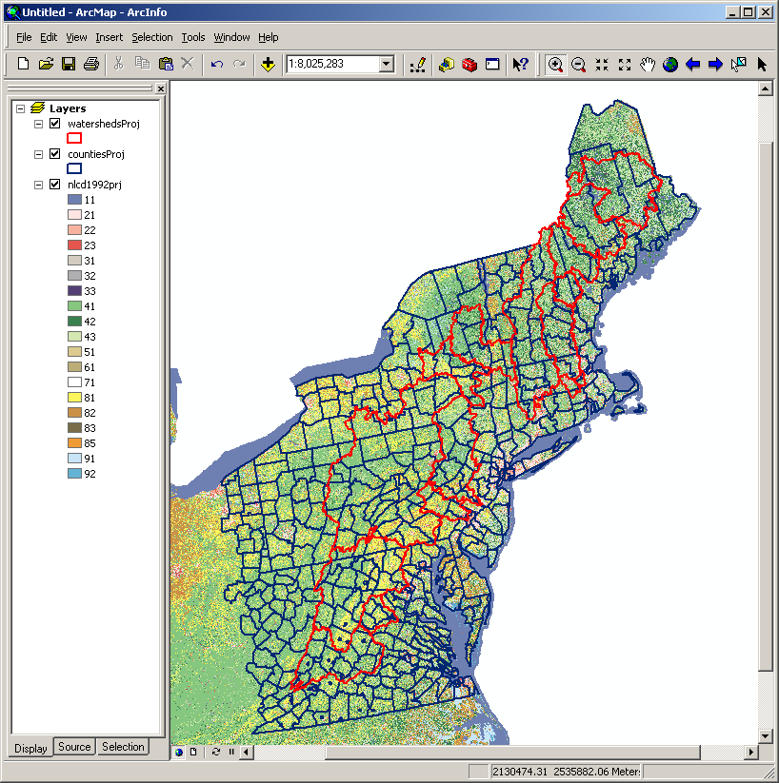

First, we will recode the NLCD map so that the agricultural cells (81, 82, 83, and 85) will be coded as “1” and other cells as “0”:

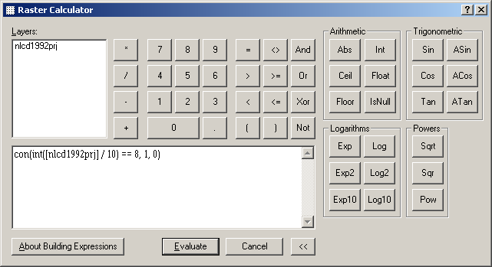

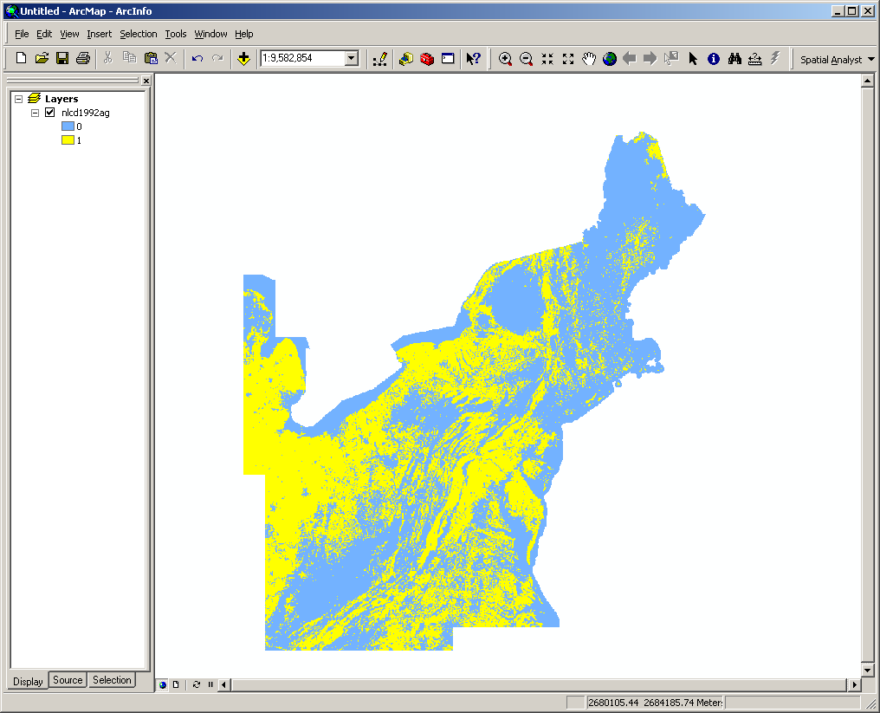
Calculation of agricultural area can be done using “Zonal Statistics” tool in Spatial Analyst:

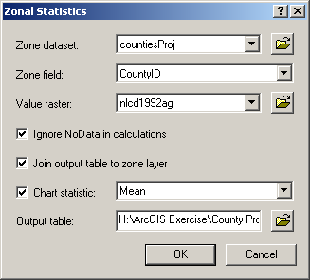

Note that the zone field “CountyID” contains unique identification number for each county polygon. After running the tool, keep only the “SUM” field, which contains the total number of agricultural cells within each county. This will be used as a surrogate for the total area of county. Next, perform an intersection with the watershed map as described in the previous document:

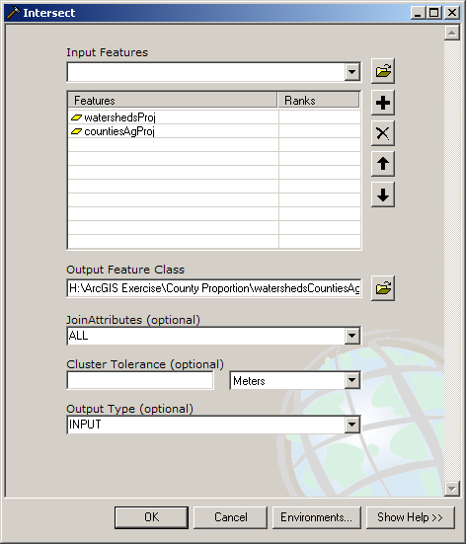

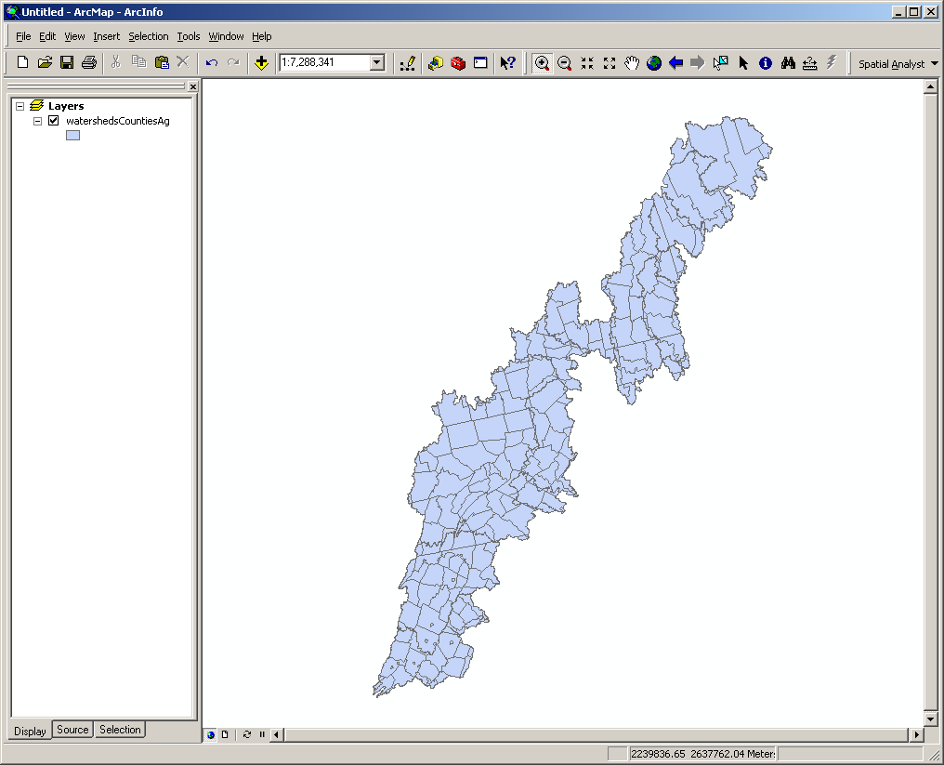

Calculate agricultural area again using the “Zonal Statistics” tool. This will be used as a surrogate for the total area of watershed. Below attribute table shows areas of counties (“AgAreaC”) and watersheds (“AgAreaCW”) calculated from these total cell numbers:

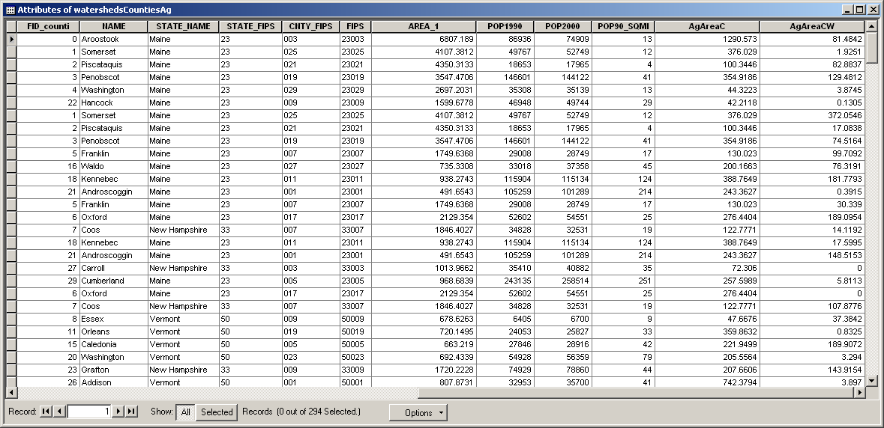

This table can be exported as a text file, which then can be imported by Microsoft Excel to calculate agricultural proportions. Detailed procedure, as well as the VBA code for Excel Macro, is given in the previous document:

