Calculating Proportion of County Covered by Watershed

April 3, 2007
Bongghi Hong

This document describes how to calculate proportion of county covered by watershed. As an example, suppose that we have maps of watersheds and counties:

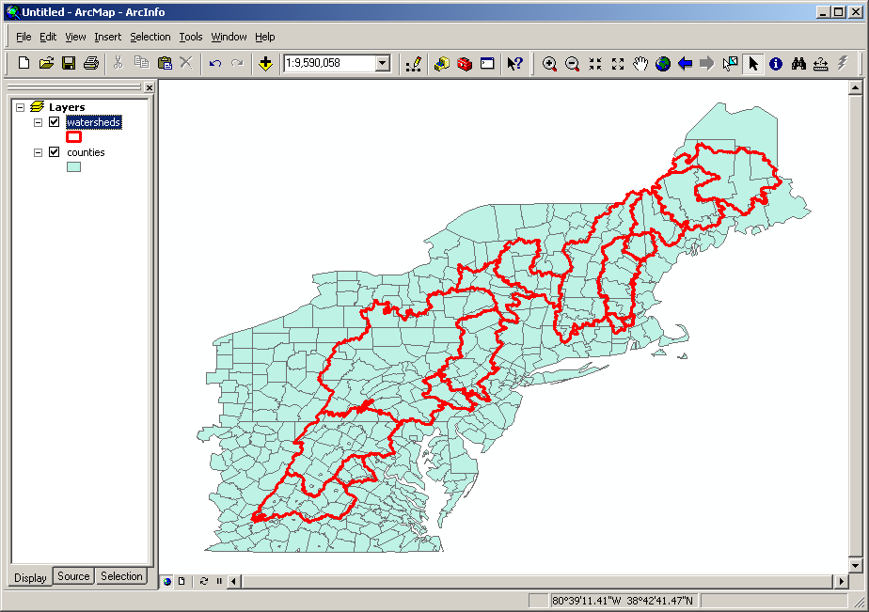

The watershed map has the following attribute table:

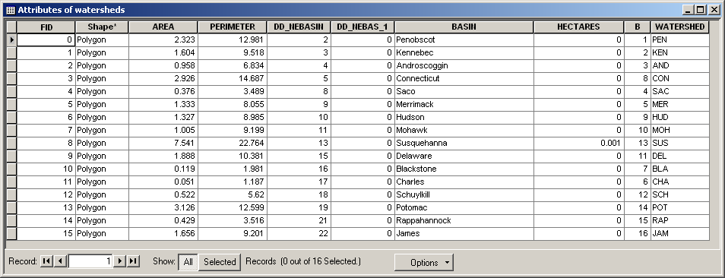

The county map has the following attribute table:
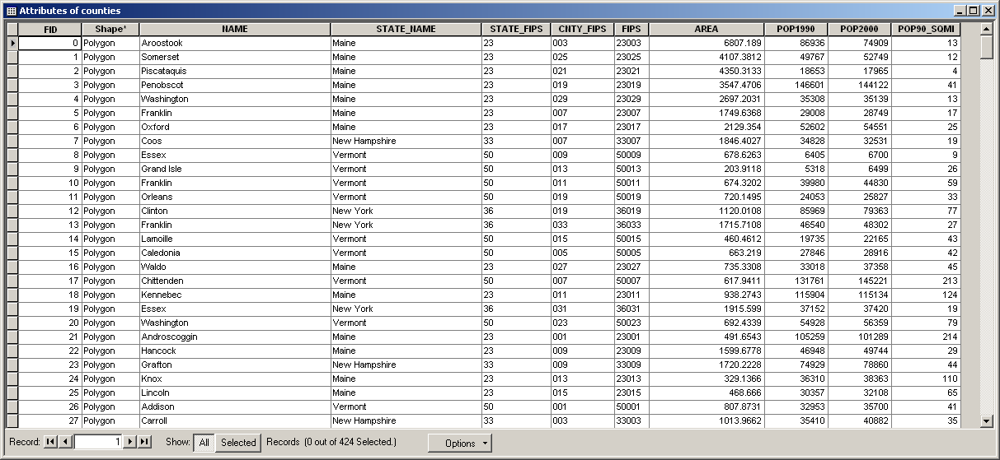

First, we need to project these maps appropriately if they are not projected. The map projection can be found by right-clicking the layer name, selecting “properties”, and clicking on the “Source” tab:

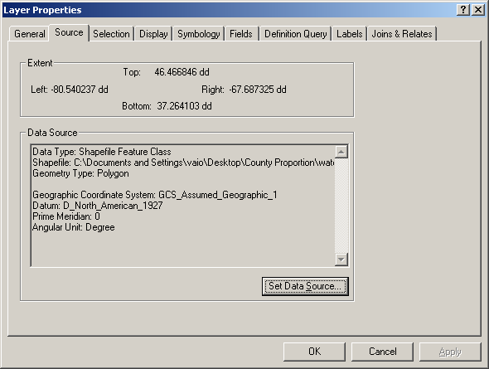

Open the ArcToolbox and select “Data Management Tools > Projections and Transformations > Feature > Project”, and the “Project” window will be displayed:

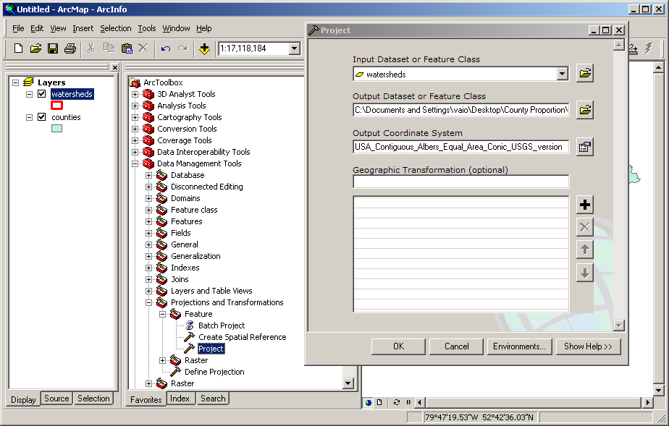

We will use “USA Contiguous Albers Equal Area Conic USGS” projection, which is located in “Projected Coordinate Systems > Continental > North America”. The following shows the projected maps:

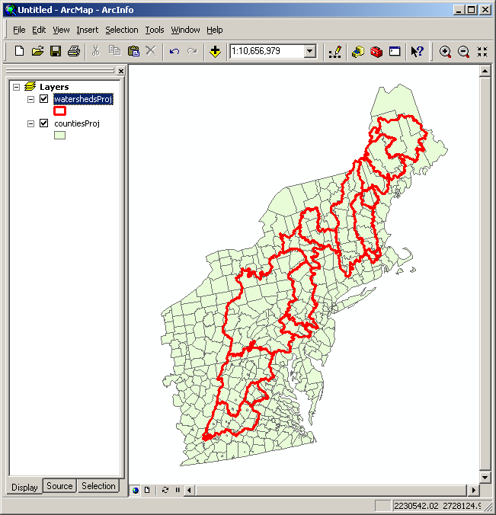

After making the projection, we need to calculate total county area (calculation of total watershed area is not needed). In general, it is a good idea to manually calculate the polygon areas rather than using the values provided by ArcGIS (if any). From the county map attribute table, click on “Options > Add Field...” and the “Add Field” window is displayed. Create a new field “AreaKm2C” (double precision):

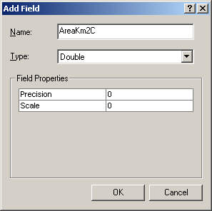

Right-click the new field heading “AreaKm2C”, select “Calculate Values...”, check “Advanced” check box in the “Field Calculator” window, and type in the following VBA code:

Dim dblArea as double
Dim pArea as IArea
Set pArea = [shape]
dblArea = pArea.area / 1000 / 1000

Make sure to enter “dblArea” in the “AreaKm2C =” edit box:

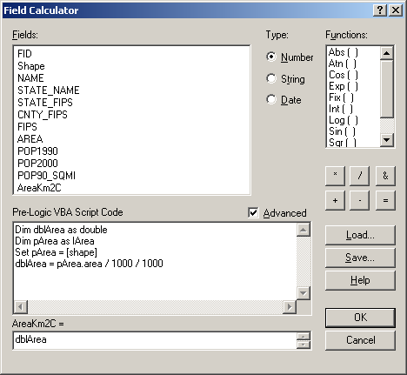

Clicking “OK” will calculate the polygon area in square kilometers:

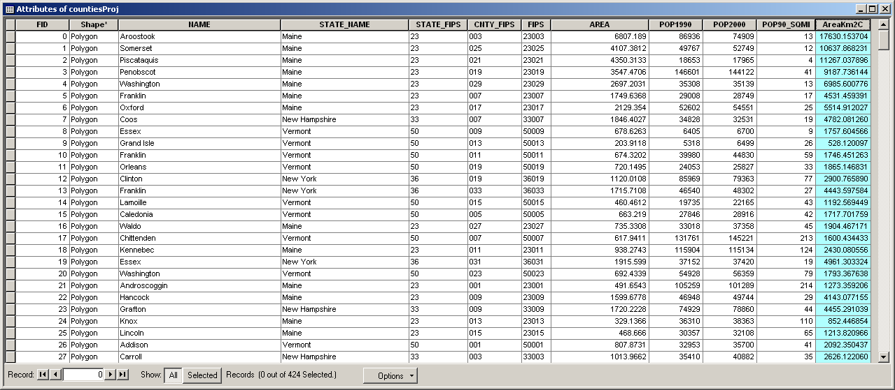

Now, the watershed and county maps should be combined using the “intersect” tool available in ArcToolbox (select “Analysis Tools > Overlay > Intersect):

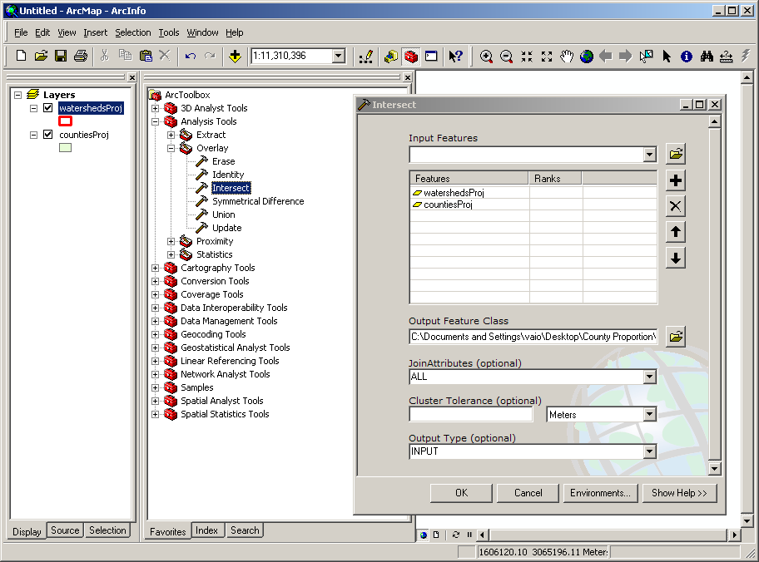

The following map is created after performing the intersection:

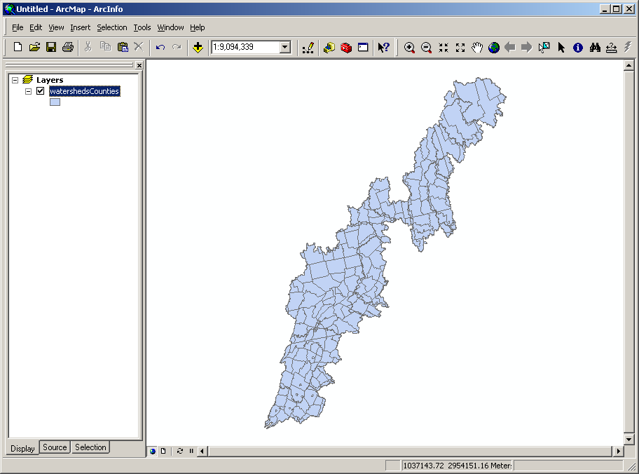

The area of each intersected polygon should be calculated in the same way as described above. Below shows the attribute table of the combined map, with the added field of “AreaKm2CW” containing each intersected polygon area.

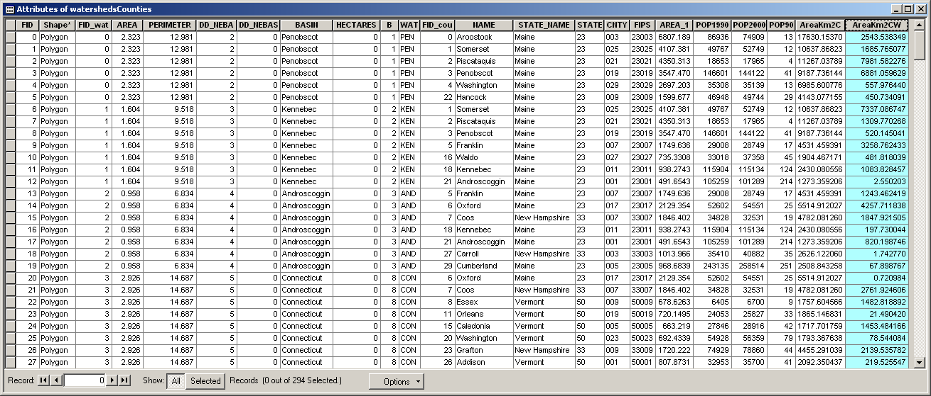

We will export this attribute table as a text file. Click on “Options > Export...” and “Export Data” window will be displayed. Make sure to export the data as a text file, not a database file (click on the folder icon to change format):

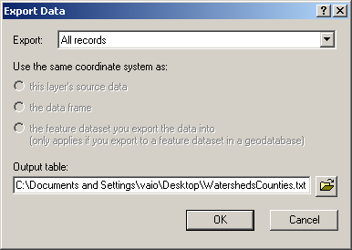

Open Microsoft Excel and import the text file “WatershedCounties.txt”:

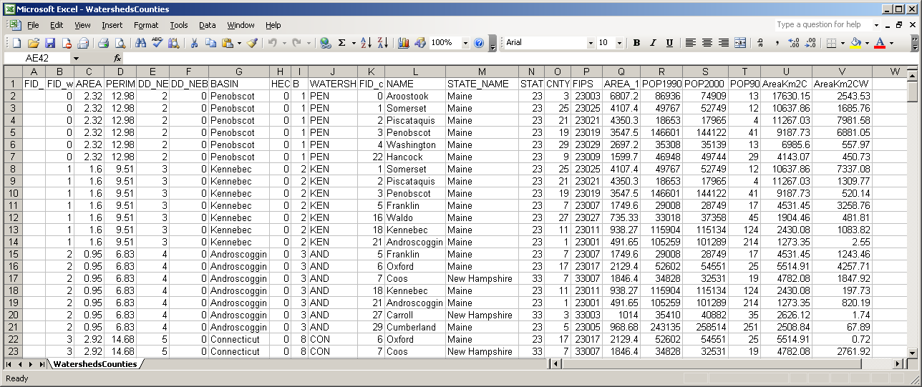

In this example, key columns useful for our analysis are “BASIN” (Column G) containing the watershed name, “NAME” (Column L) containing the county name, “STATE_NAME” (Column M) containing the state name, “AreaKm2C” (Column U) containing total county area, and “AreaKm2CW” (Column V) containing the intersected polygon area. We will use Excel VBA macro to create a table containing proportion of county covered by watershed. Click on “Tools > Macro > Macros...” and the Macro window will be displayed. Type “CalculateProportion” in the macro name edit box and click “Create”:

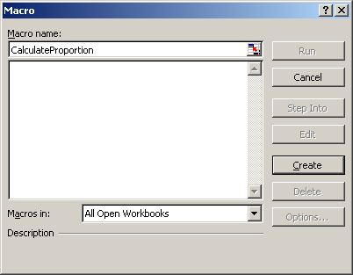

The Microsoft Visual Basic Editor will be opened. Copy and paste the following code:

Sub CalculateProportion()

' Define Column Numbers and Data Sheet Name
WatershedColumn = 7
CountyColumn = 12
StateColumn = 13
CountyAreaColumn = 21
WatershedCountyAreaColumn = 22
DataSheetName = "WatershedsCounties"

' Get Number and Name of Watersheds
ColNum = Sheets(DataSheetName).UsedRange.Columns.Count
RowNum = Sheets(DataSheetName).UsedRange.Rows.Count

' Get Watershed Names
Dim WatershedName() As String
ReDim WatershedName(1 To RowNum) As String
WatershedNum = 0
For i = 2 To RowNum
GetWatershedName = Sheets(DataSheetName).Cells(i, WatershedColumn)
NewWatershed = True
For j = 1 To WatershedNum
If WatershedName(j) = GetWatershedName Then
NewWatershed = False
End If
Next j
If NewWatershed = True Then
WatershedNum = WatershedNum + 1
ReDim Preserve WatershedName(1 To WatershedNum)
WatershedName(WatershedNum) = GetWatershedName
End If
Next i

' Get County Name, State Name, and County Area
Dim CountyName() As String
Dim StateName() As String
Dim CountyArea() As Double
ReDim CountyName(1 To RowNum) As String
ReDim StateName(1 To RowNum) As String
ReDim CountyArea(1 To RowNum) As Double
CountyNum = 0
For i = 2 To RowNum
GetCountyName = Sheets(DataSheetName).Cells(i, CountyColumn)
GetStateName = Sheets(DataSheetName).Cells(i, StateColumn)
GetCountyArea = Sheets(DataSheetName).Cells(i, CountyAreaColumn)
NewCounty = True
For j = 1 To CountyNum
If CountyName(j) = GetCountyName And StateName(j) = GetStateName Then
NewCounty = False
End If
Next j
If NewCounty = True Then
CountyNum = CountyNum + 1
ReDim Preserve CountyName(1 To CountyNum) As String
ReDim Preserve StateName(1 To CountyNum) As String
ReDim Preserve CountyArea(1 To CountyNum) As Double
CountyName(CountyNum) = GetCountyName
StateName(CountyNum) = GetStateName
CountyArea(CountyNum) = GetCountyArea
End If
Next i

' Initialize Area Matrix
Dim WatershedCountyArea() As Double
ReDim WatershedCountyArea(1 To CountyNum, 1 To WatershedNum) As Double
For i = 1 To CountyNum
For j = 1 To WatershedNum
WatershedCountyArea(i, j) = 0
Next j
Next i

' Get Watershed Name, County Name, and Area
For i = 2 To RowNum
GetWatershedName = Sheets(DataSheetName).Cells(i, WatershedColumn)
GetCountyName = Sheets(DataSheetName).Cells(i, CountyColumn)
GetStateName = Sheets(DataSheetName).Cells(i, StateColumn)
GetWatershedCountyArea = Sheets(DataSheetName).Cells(i, WatershedCountyAreaColumn)

' Find Watershed Index Number
WatershedIndexNum = 0
For j = 1 To WatershedNum
If WatershedName(j) = GetWatershedName Then
WatershedIndexNum = j
End If
Next j
If WatershedIndexNum = 0 Then
MsgBox "Cannot Find Watershed"
End
End If

' Find County Index Number
CountyIndexNum = 0
For j = 1 To CountyNum
If CountyName(j) = GetCountyName And StateName(j) = GetStateName Then
CountyIndexNum = j
End If
Next j
If CountyIndexNum = 0 Then
MsgBox "Cannot Find County"
End
End If

' Update Area Matrix
WatershedCountyArea(CountyIndexNum, WatershedIndexNum) = _
WatershedCountyArea(CountyIndexNum, WatershedIndexNum) + GetWatershedCountyArea

Next i

' Calculate County Proportion
Dim WatershedCountyProportion() As Double
ReDim WatershedCountyProportion(1 To CountyNum, 1 To WatershedNum) As Double
For i = 1 To CountyNum
For j = 1 To WatershedNum
WatershedCountyProportion(i, j) = WatershedCountyArea(i, j) / CountyArea(i)
Next j
Next i

' Report County Proportion
ActiveWorkbook.Sheets.Add
Cells(1, 1) = "County"
Cells(1, 2) = "State"
For i = 1 To CountyNum
Cells(i + 1, 1) = CountyName(i)
Cells(i + 1, 2) = StateName(i)
Next i
For i = 1 To WatershedNum
Cells(1, i + 2) = WatershedName(i)
Next i
Cells(1, WatershedNum + 3) = "Total"
For i = 1 To CountyNum
SumProportion = 0
For j = 1 To WatershedNum
Cells(i + 1, j + 2) = WatershedCountyProportion(i, j)
SumProportion = SumProportion + WatershedCountyProportion(i, j)
Next j
Cells(i + 1, WatershedNum + 3) = SumProportion
Next i

End Sub

Below is the Microsoft Visual Basic Editor window after pasting the code:

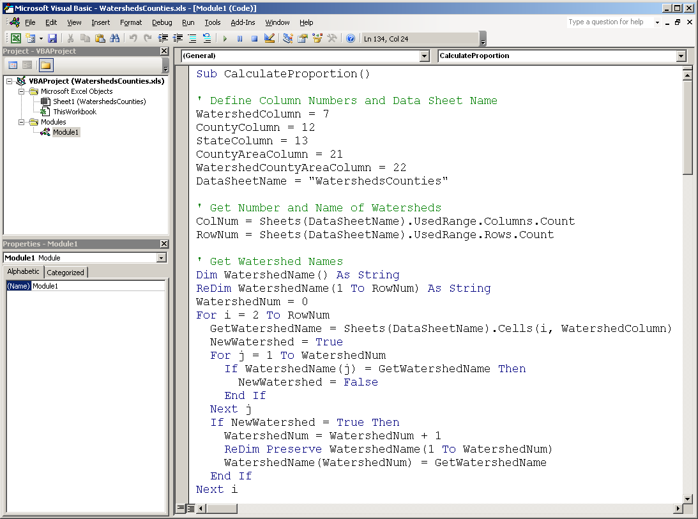

Note that the variables specifying column numbers (e.g., WatershedColumn, CountyColumn, etc.) may be changed when different dataset is used. Press F5 to run the macro. A new worksheet containing the desired table will be created:

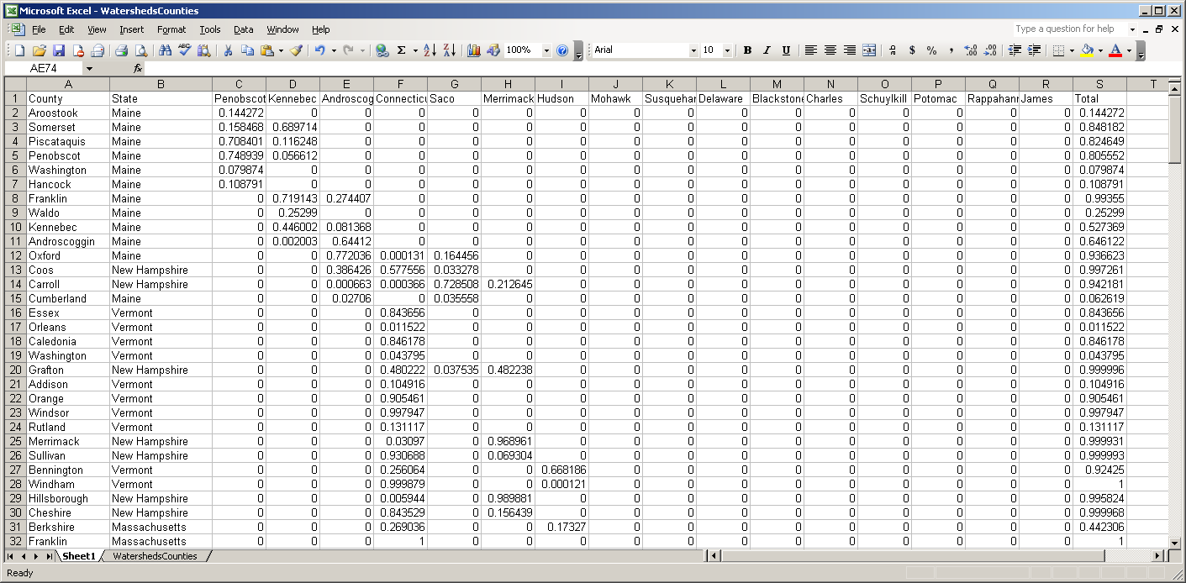

This table may be sorted (click on “Data > Sort...”) by state and/or county for examination.

