Generating Maps of Soil Topographic Index

Bongghi Hong and Dennis Swaney

June 14, 2007

This document describes a procedure for generating maps of soil topographic index (STI) from TI maps and soil data. The procedure for generating a topographic index (TI) map from DEM is described in “Creating TI map”. The STI is one of the variants of TI, defined as:

${\text{STI}}_{i}=\text{ln}\left(\frac{A_{i}}{T_{i}s_{i}}\right)={\text{TI}}_{i}−\text{ln}\left(T_{i}\right)$ (1)

where: STI_{i} = soil topographic index of grid cell i of the watershed
T_{i} = soil transmissivity of the soil surface layer of grid cell i of the watershed

Soil transmissivity is defined as the product of soil depth and saturated hydraulic conductivity of the soil. Another version considers the value of T_{i} scaled to the watershed-average value (Sivapalan et al., 1987):

${\text{STI}}_{i}=\text{ln}\left(\frac{\bar{T}A_{i}}{T_{i}s_{i}}\right)={\text{TI}}_{i}−\text{ln}\left(\frac{T_{i}}{\bar{T}}\right)={\text{TI}}_{i}−\text{ln}\left(T_{i}\right)+\text{ln}\left(\bar{T}\right)$ (2)

where: $\bar{T}$= average soil transmissivity of the watershed

Note that if $\bar{T}$is the geometric mean of T_{i} over the watershed (i.e., equivalent to the arithmetic mean of log(T_{i})), then the average value of STI is the same as the average value of TI (without transmissivity). We will use the TI map of Androscoggin watershed as an example:

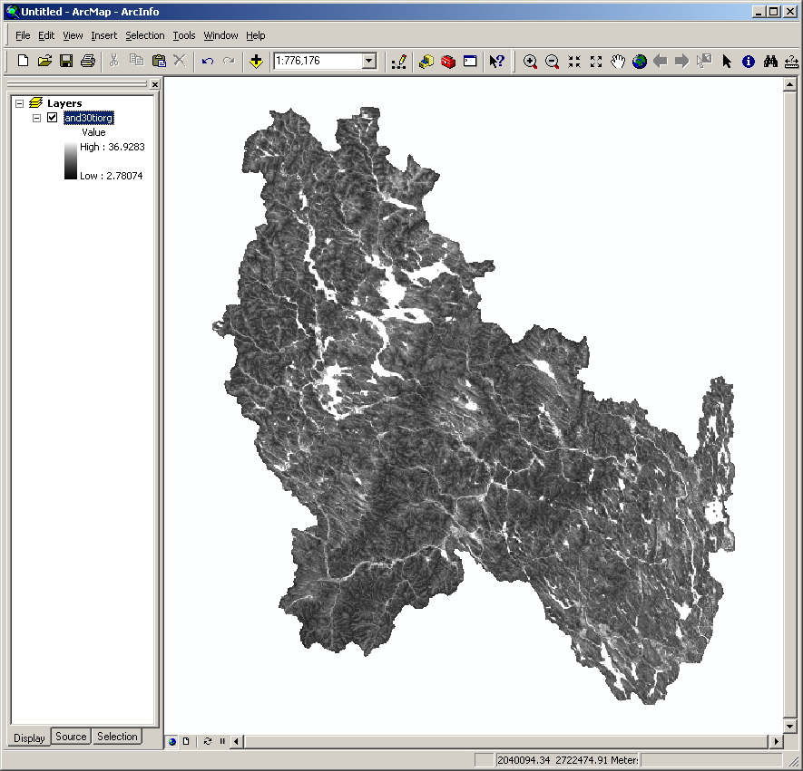

First, we need to download the soil data from the USDA-NRCS Soil Data Mart website (http://soildatamart.nrcs.usda.gov/):

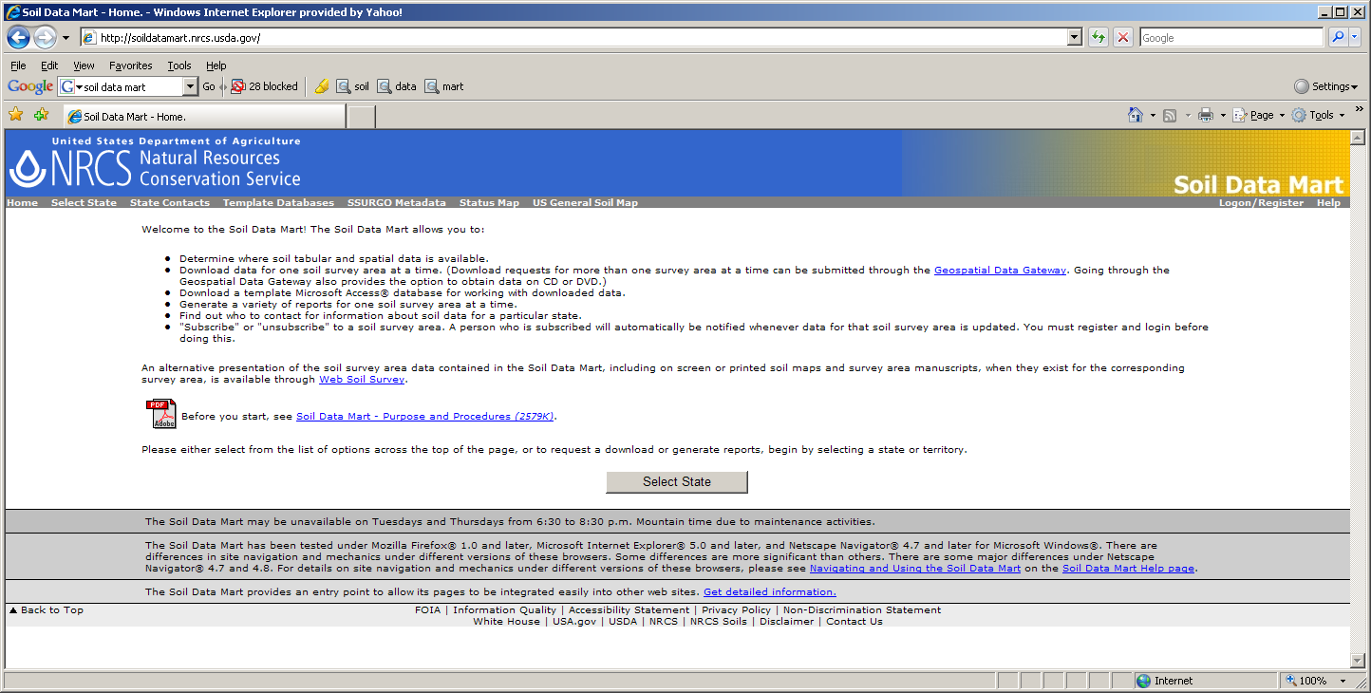

To download the STATSGO soil data, click on “US General Soil Map”, enter email address, and click on “Submit Request”. A FTP address for downloading the requested soil data will be sent to the email address. To download the SSURGO soil data, click on “Select State”, select desired state, click on “Select Survey Area”, select desired survey area, and click on “Download Data”. Since SSURGO data are distributed on the county basis, downloading all the desired soil data may take a long time if the watershed is large. Another website for downloading soil data is USDA Geospatial Data Gateway (http://datagateway.nrcs.usda.gov/):

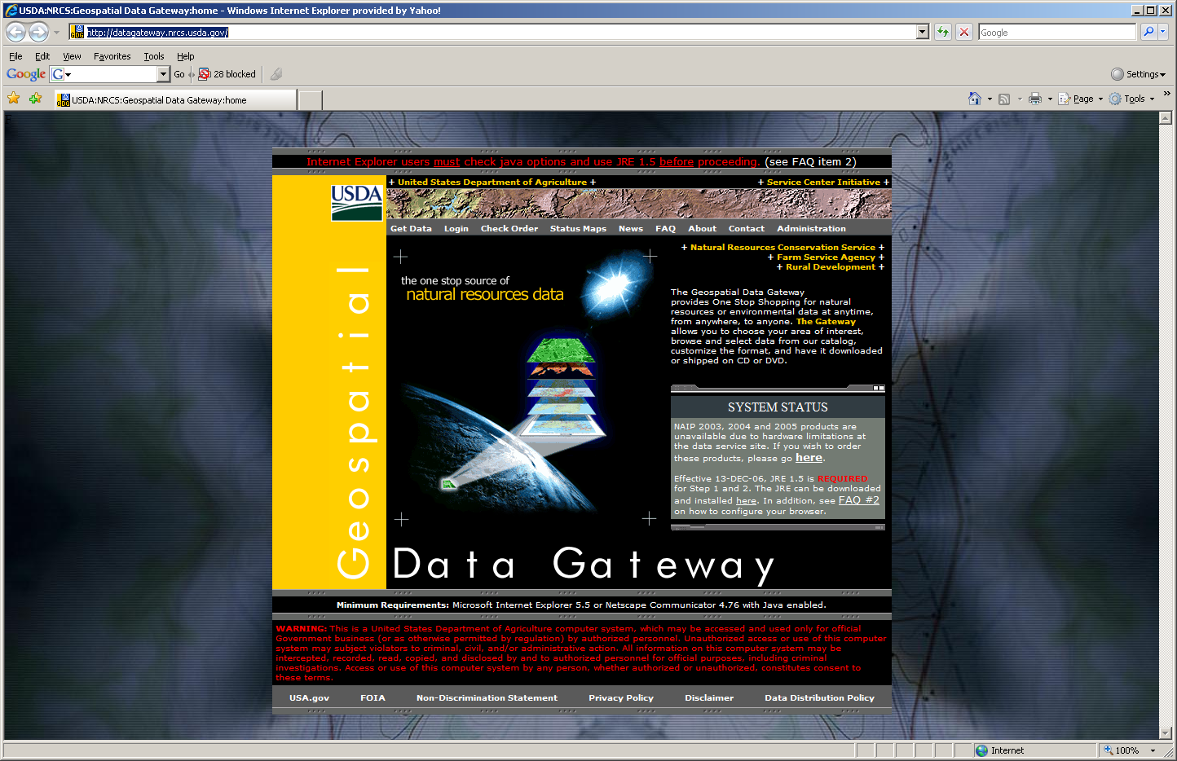

We need to extract two soil parameters, soil depth and saturated hydraulic conductivity, from downloaded soil data. This can be done through Soil Data Viewer, which can be downloaded from http://soildataviewer.nrcs.usda.gov/download51.aspx:

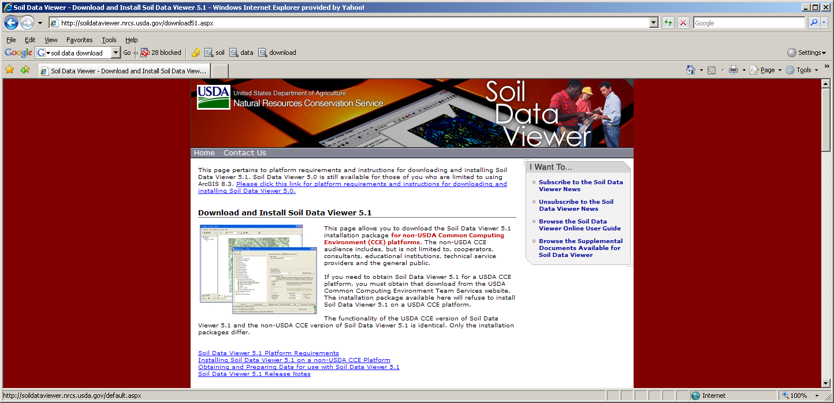

This program is installed as an ArcGIS extension, and you will see a new menu button after it is installed:

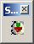

Clicking on the button will open the Soil Data Viewer. Before opening the Soil Data Viewer, however, a soil database for the downloaded soil data needs to be constructed using Microsoft Access. The downloaded soil data have (1) a “spatial” folder containing spatial dataset such as ArcGIS shapefiles, (2) a “tabular” folder containing tables of soil parameters such as soil depth and saturated hydraulic conductivity, and (3) a Microsoft Access template file (such as “soildb_US_2002.mdb”), which is used to create a soil database. Clicking on the template file will open the Microsoft Access with a warning message:

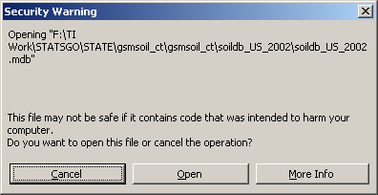

Click the “Open” button and the “SSURGO Import” window will be opened (even if the STATSGO data are used):

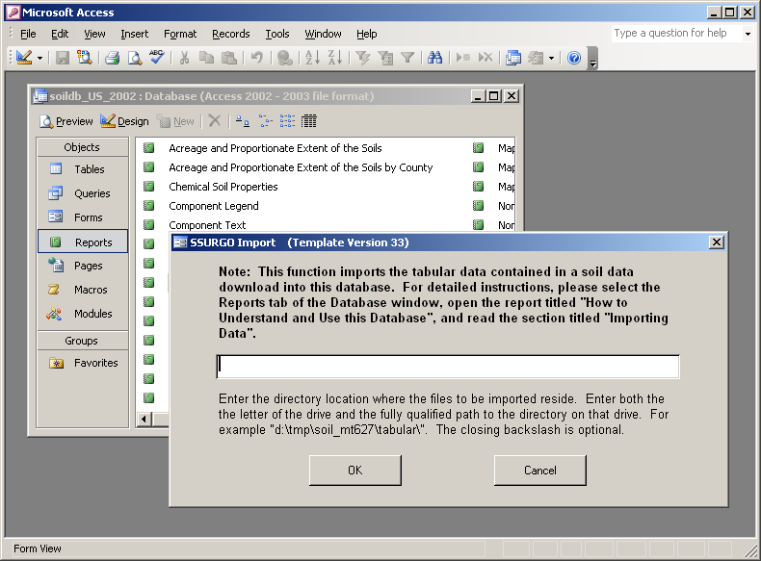

You need to enter the path name for the folder containing the tabular data, e.g., “F:\STATSGO\gsmsoil_ct\tabular”. After the soil database will be constructed, close the Microsoft Access. Now you are ready to open the Soil Data Viewer. First start the ArcGIS program and open the soil map stored in the “spatial” folder (e.g., “gsmsoilmu_a_ct”):

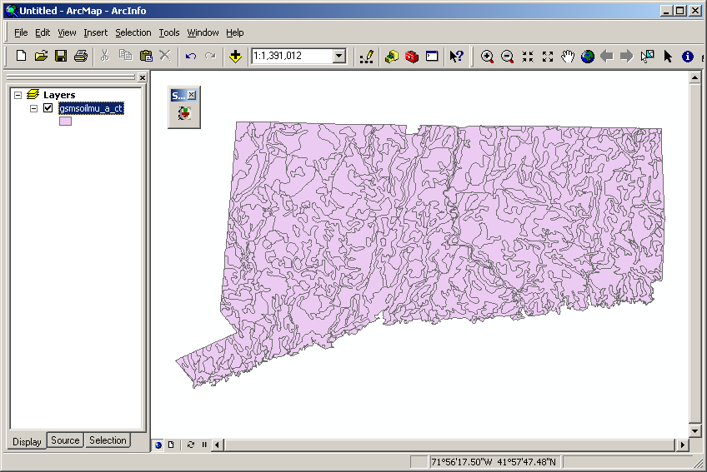

Clicking on the Soil Data Viewer button will open the Soil Data Viewer:

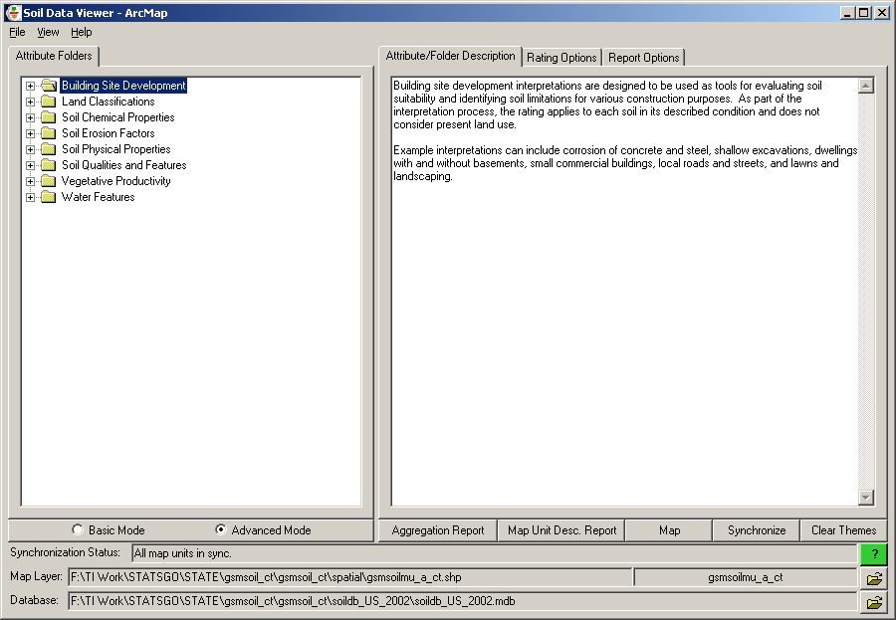

Note that the “Database” should be selected as the soil database created using the Microsoft Access (see above). To create a map of saturated hydraulic conductivity, click on “Soil Physical Properties” and select “Saturated Hydraulic Conductivity (Ksat)” at the surface layer with the “weighted average” aggregation method:

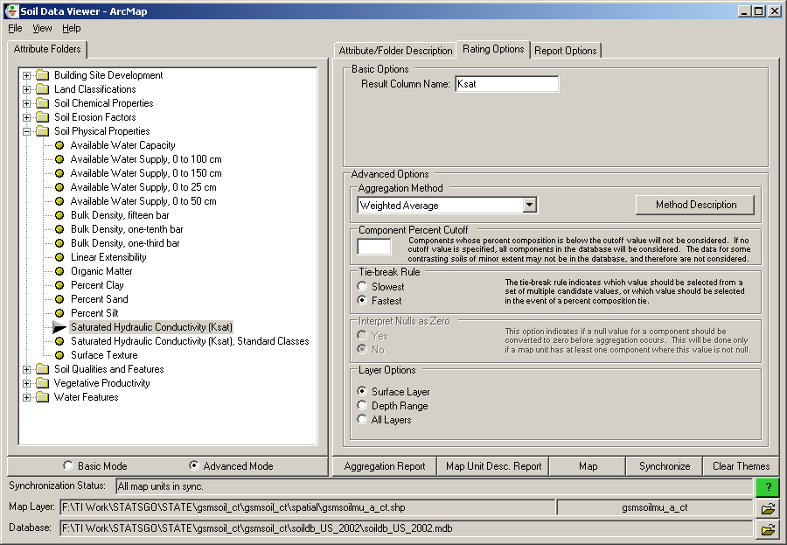

Clicking on “Map” will create the map of saturated hydraulic conductivity (in μm/s):

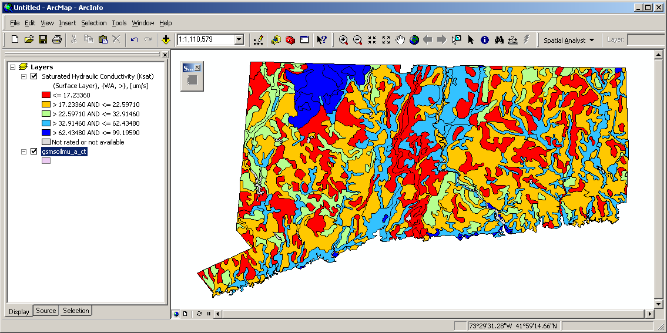

The map of soil depth can be created in a similar way, by clicking on “Soil Qualities and Features” and selecting “Depth to Any Soil Restrictive Layer” with the “weighted average” aggregation method:

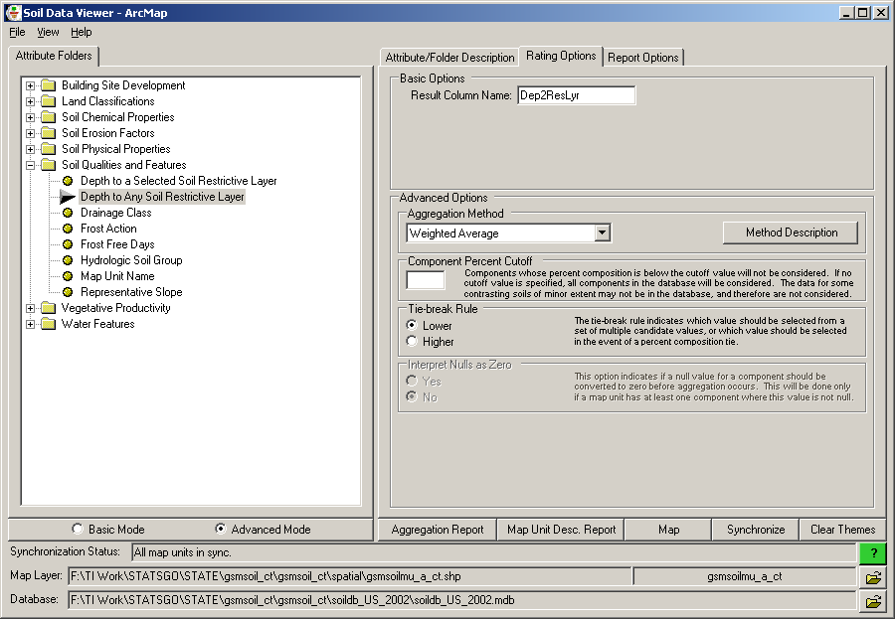

Again, clicking on “Map” will create the map of soil depth (in cm):

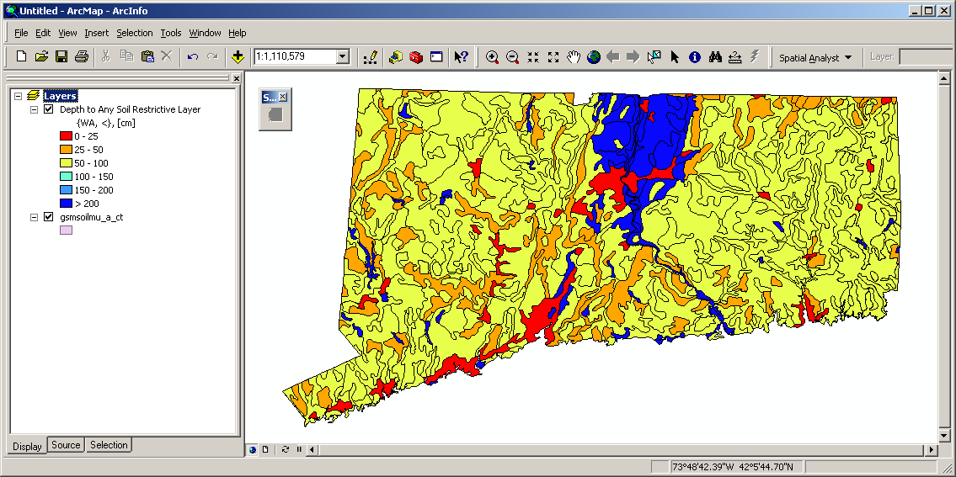

After generating these maps, they should be merged as necessary and clipped using watershed boundary map. Finally, they should be converted to rasters with the same resolution as the original TI map. An example below shows the maps of saturated hydraulic conductivity (left) and soil depth (right) for the Androscoggin watershed:

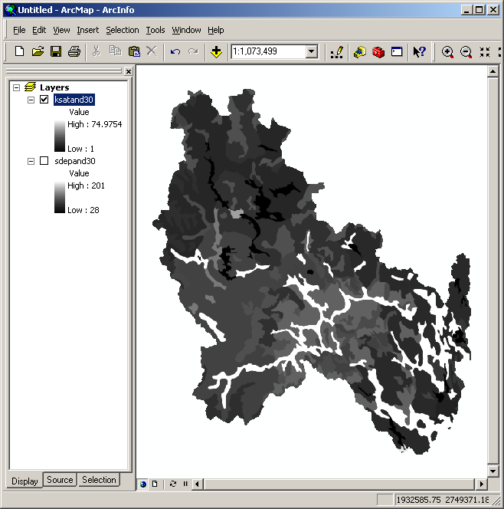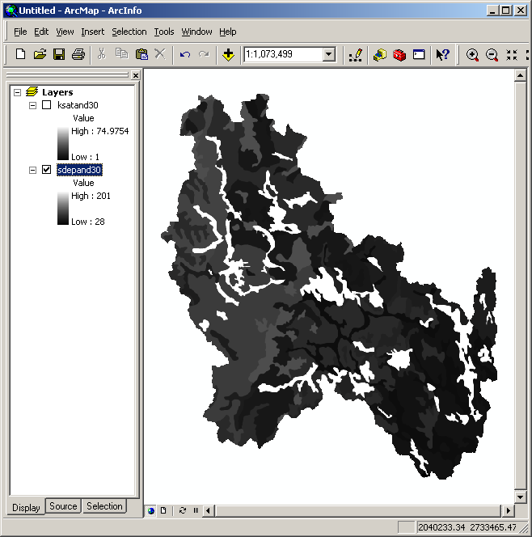

Soil transmissivity (in m²/day) is defined as the product of soil depth (in cm) and saturated hydraulic conductivity (in μm/s). To generate the map of soil transmissivity, use the Raster Calculator to multiply these two maps with the unit conversion factor of 0.000864 (= (1/10⁶) / (1/60/60/24) * (1/100)):

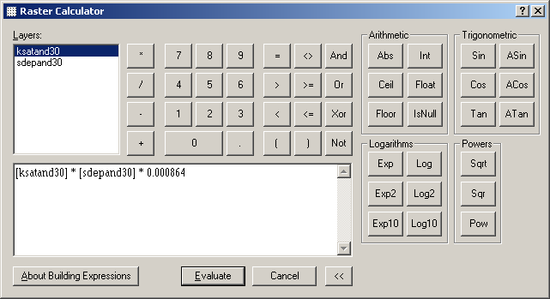

The resulting soil transmissivity map for the Androscoggin watershed is shown below:

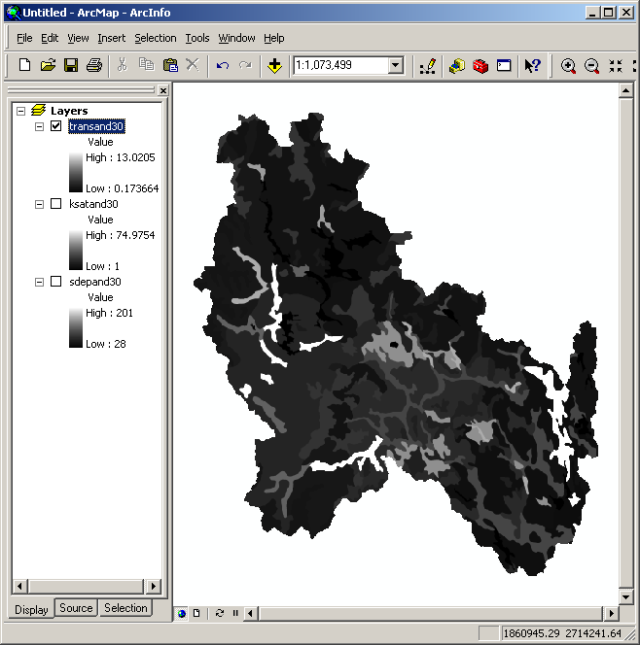

We will generate the STI map using the Equation (2) above. To do this, we need to know $\bar{T}$ (arithmetic mean of log(T_{i})). Open the original TI map and create the map of log(T_{i}) using the Raster Calculator:

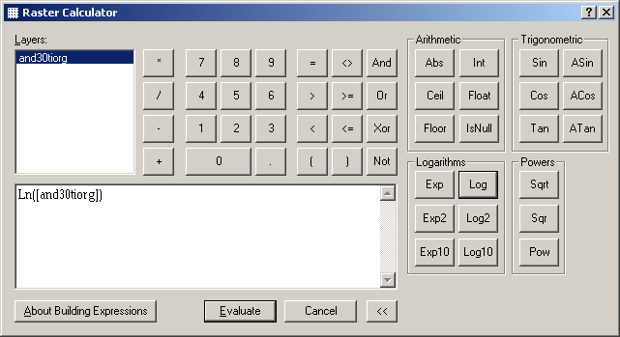

After the calculation is done, right-click on the new map name “Calculation” and select “Properties…”. The “Layer Properties” window will be opened, and you can find the mean of log(T_{i}) at the “Source” tab:

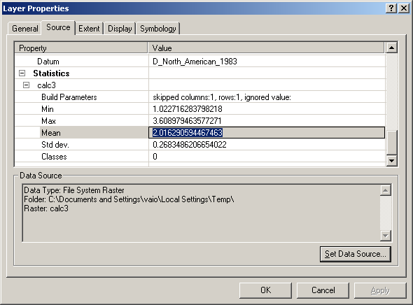

Copy the value into the clipboard. Now we are ready to use the Raster Calculator to type in Equation (2):

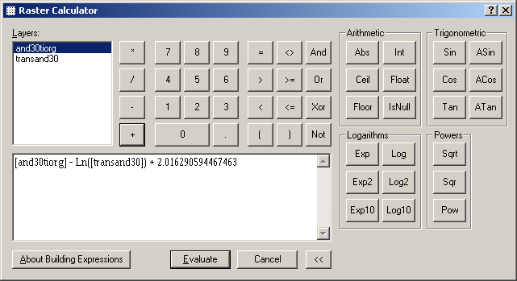

Note that the constant at the end of the equation is the mean of log(T_{i}) obtained above. Clicking “Evaluate” will generate the STI map:

