Creating TI Distribution Table by Land Use Type

June 12, 2006
Bongghi Hong

Previous document describes how the TI map (ti10m) can be obtained from DEM:

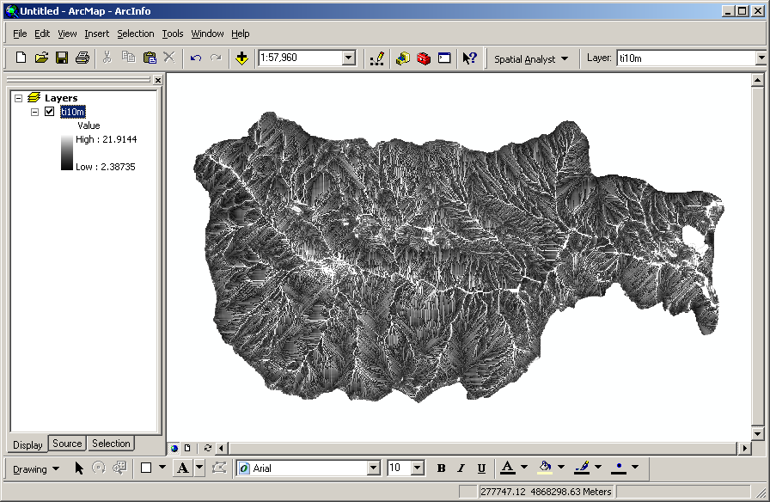

This document describes how the TI distribution can be obtained for each land use type. As an example, we will use the NLCD land use map available on the HBEF website (http://www.hubbardbrook.org/research/gis/gis.htm). Download the “Hubbard Brook National Land Cover Dataset 1992” (nlcd_92.exe), extract the “nlcd_92.e00” interchange file, use ArcToolbox to convert it to coverage file, and add the map to ArcMap:

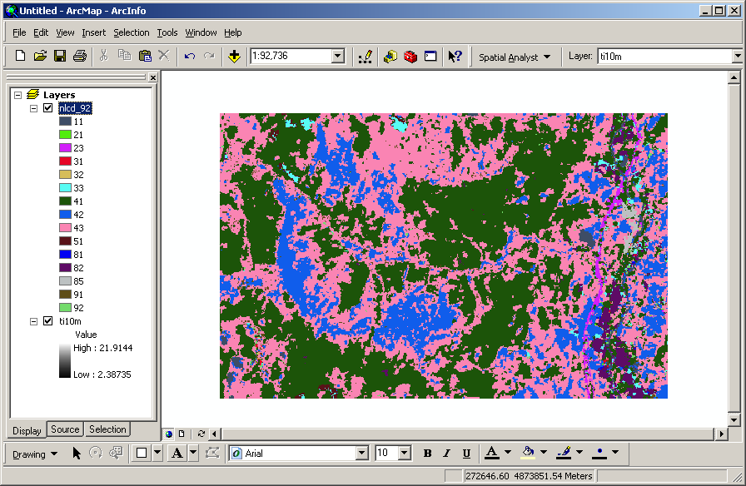

Let’s clip the land use map using the TI map. Follow these steps: (1) Click on “Spatial Analyst > Option…” and specify the analysis mask as “ti10m” in the “General” tab. (2) Click on “Extent” tab and specify the analysis extent as “Same as layer ti10m”. (3) Click on “Cell Size” tab and specify the cell size as “Same as layer ti10m”. (4) Click “OK” and click on “Spatial Analyst > Raster Calculator…” (5) Double-click “nlcd_92” and click “Evaluate”. (6) Right-click the name of resulting raster map (on the left “Display” window), choose “Make Permanent…”, and save the map as “lu10m”:

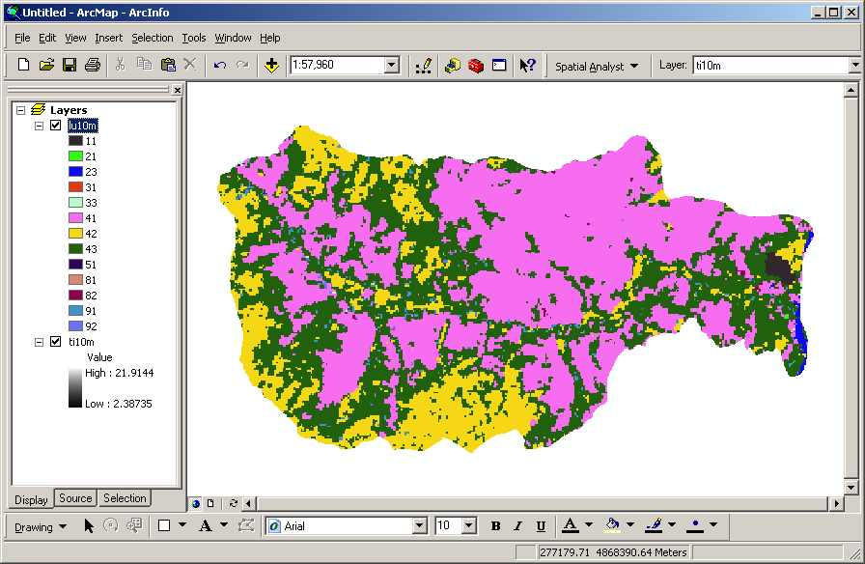

Now we will create a multi-band raster map containing both “ti10m” and “lu10m”. Open the Raster Calculator again and type the following equation:

combine([ti10m],[lu10m])

Click “Evaluate” and make permanent (save) as “combined10m”:

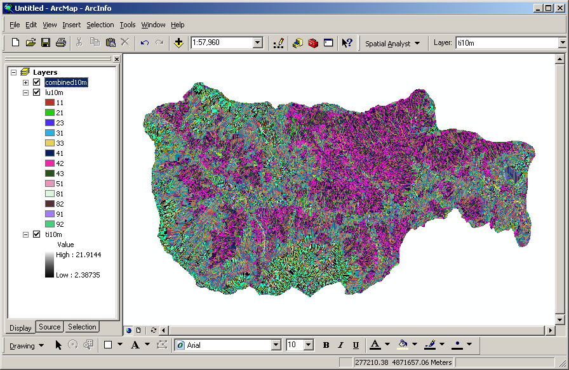

Right-click the “combined10m” and select “Open Attribute Table”:

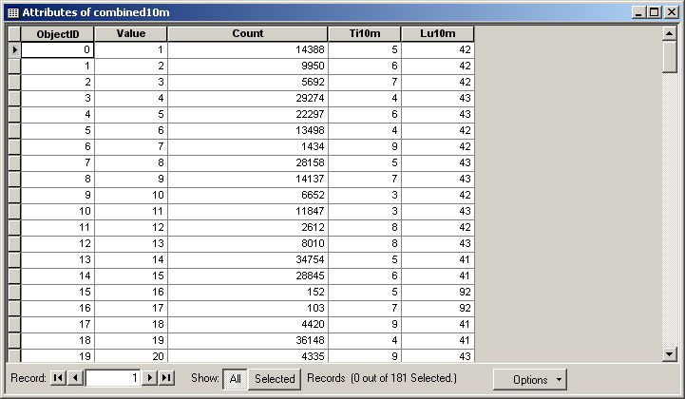

Click “Options > Export…” and save the table as “Combined10m.txt” (text file format). You can open this file using Excel:

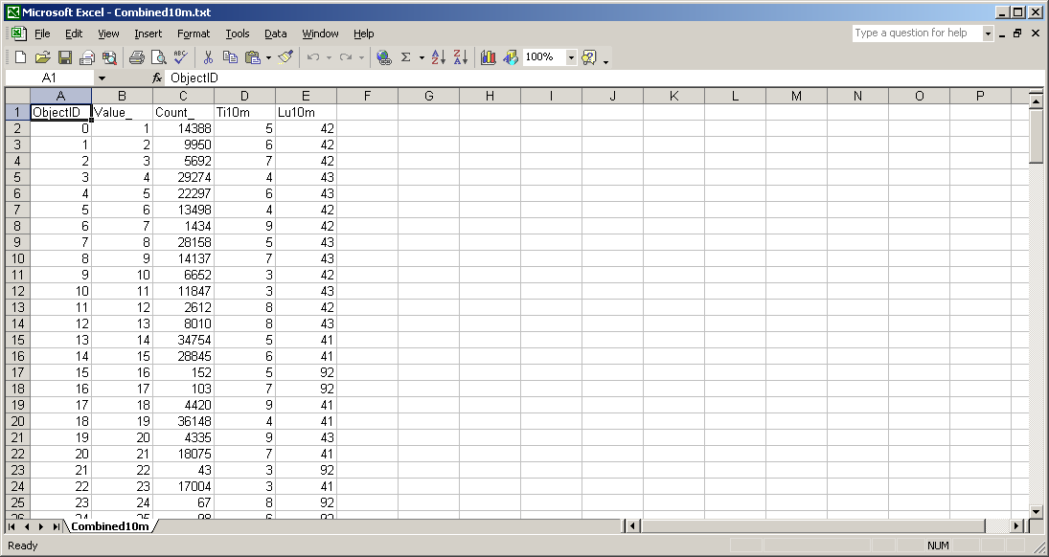

Save the text file as Excel format (Combined10m.xls). Open the Visual Basic Editor (“Tools > Macro > Visual Basic Editor…”) and paste the following code as “CreateTIDistribution” procedure:

Sub CreateTIDistribution()

' Specify Input Sheet Name
InputSheetName = "Combined10m"
Sheets(InputSheetName).Activate

' Obtain Column Heading, Number of Rows, Minimum and Maximum Values
TIName = Cells(1, 4)
LUName = Cells(1, 5)
RowCount = Sheets(InputSheetName).UsedRange.Rows.Count
TIRange = Range(Cells(2, 4), Cells(RowCount, 4))
LURange = Range(Cells(2, 5), Cells(RowCount, 5))
MinTI = Application.WorksheetFunction.Min(TIRange)
MaxTI = Application.WorksheetFunction.Max(TIRange)
MinLU = Application.WorksheetFunction.Min(LURange)
MaxLU = Application.WorksheetFunction.Max(LURange)

' Add New Sheet for TI Distribution Table
Worksheets.Add Before:=Worksheets(1)
Sheets(1).Activate

' Set Up the TI Distribution Table
Cells(2, 1) = TIName
Cells(1, 2) = LUName
CountTIRow = 2
For i = MinTI To MaxTI
CountTIRow = CountTIRow + 1
Cells(CountTIRow, 1) = i
Next i
CountLUCol = 1
For i = MinLU To MaxLU
Set FindLU = Sheets(InputSheetName).Range( _
Sheets(InputSheetName).Cells(2, 5), _
Sheets(InputSheetName).Cells(RowCount, 5)) _
.Find(i, LookAt:=xlWhole)
If Not FindLU Is Nothing Then
CountLUCol = CountLUCol + 1
Cells(2, CountLUCol) = i
End If
Next i
Range(Cells(1, 1), Cells(CountTIRow, 1)).Font.Bold = True
Range(Cells(1, 1), Cells(2, CountLUCol)).Font.Bold = True
Range(Cells(1, 1), Cells(CountTIRow, 1)).Font.Color = RGB(0, 0, 255)
Range(Cells(1, 1), Cells(2, CountLUCol)).Font.Color = RGB(0, 0, 255)

' Fill the TI Distribution Table with Zeros Values
For i = 3 To CountTIRow
For j = 2 To CountLUCol
Cells(i, j) = 0
Next j
Next i

' Read the Count Values and Write to the Table
For i = 2 To RowCount
GetCellCount = Sheets(InputSheetName).Cells(i, 3)
GetTI = Sheets(InputSheetName).Cells(i, 4)
GetLU = Sheets(InputSheetName).Cells(i, 5)
Set FindTI = Range(Cells(3, 1), Cells(CountTIRow, 1)). _
Find(GetTI, LookAt:=xlWhole)
Set FindLU = Range(Cells(2, 2), Cells(2, CountLUCol)). _
Find(GetLU, LookAt:=xlWhole)
Cells(FindTI.Row, FindLU.Column) = GetCellCount
Next i

End Sub

After running the Macro, you will get the following table reporting TI distributions by land use tpye:

