Procedure for Obtaining the Frequency Distribution of a Variable Over a Watershed from raster data in ArcMap

Dennis Swaney

July 26, 2006

Here we describe how to obtain the frequency distribution for spatially distributed data from a raster gis coverage. In this example, the variable of interest is the topographic index (TI) which was previously calculated.

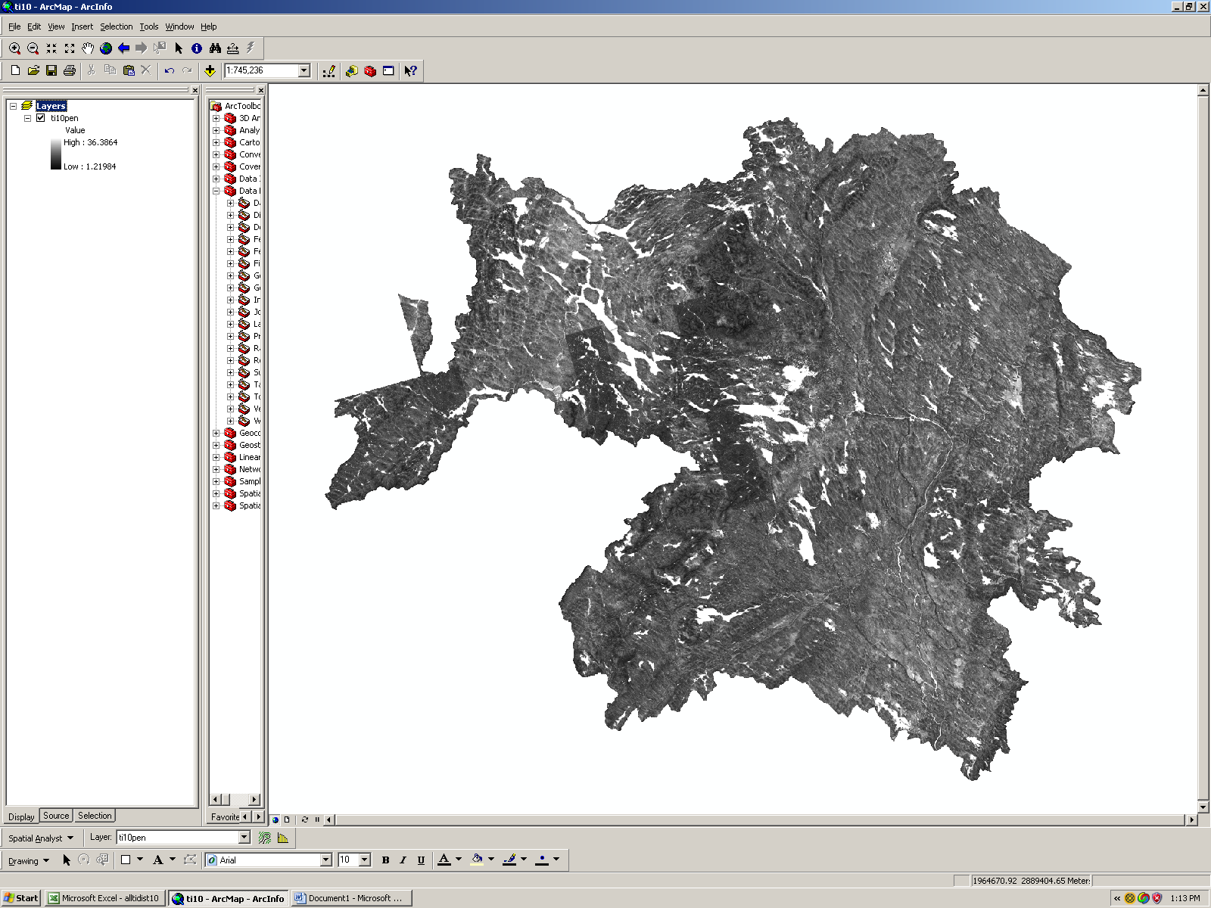
1. Open ArcMap and select the layer of interest (a TI raster previously created – here, the example is ti10pen, the 10 m resolution map of TI for the Penobscot.

2. Open spatial analyst and select Reclassify.

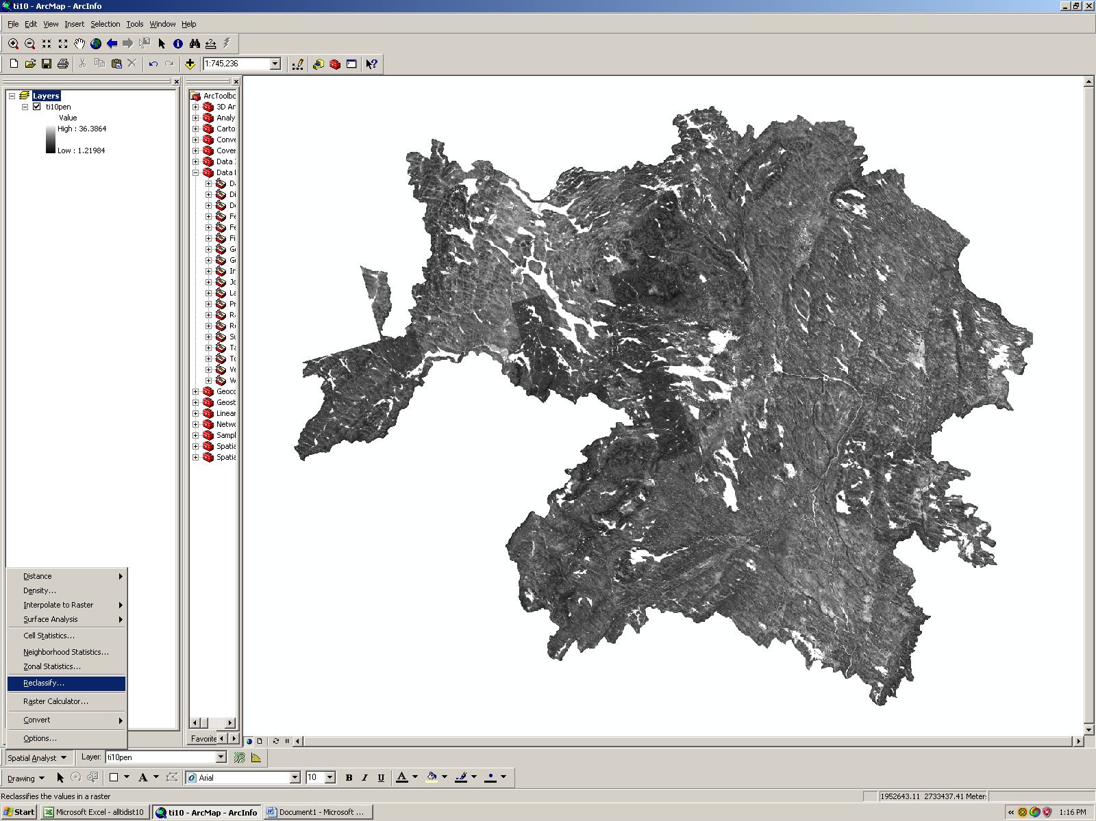

3. Press the ‘classify button’ to select the classification parameters.

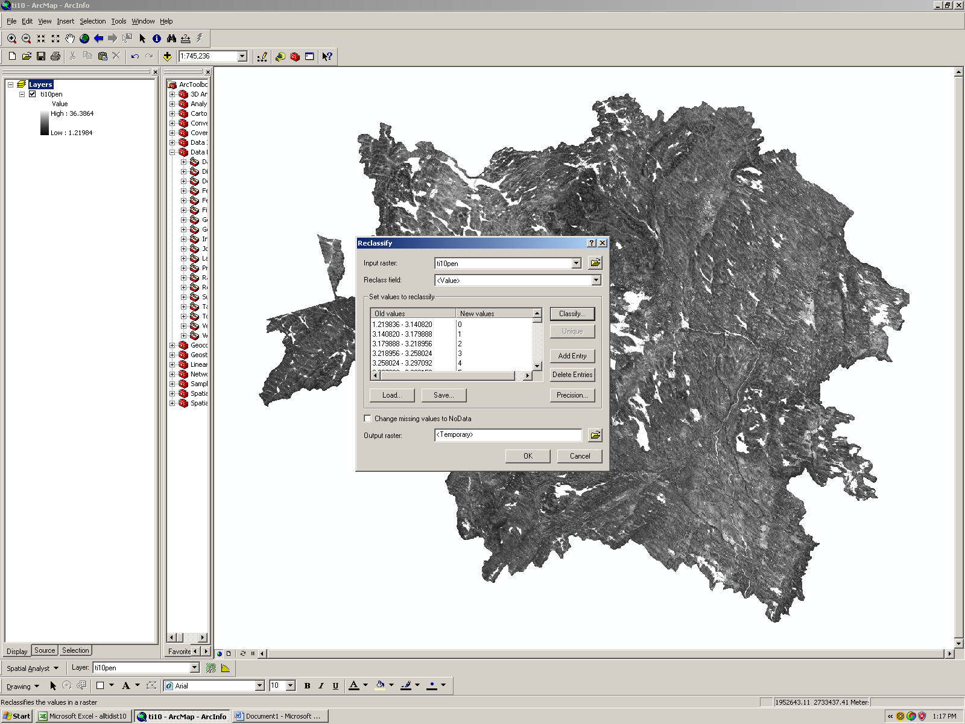
4. Read the classification statistics from the window in the upper right hand side (count, min, max, mean, standard deviation) and make note of them (they are independent of the classification method).

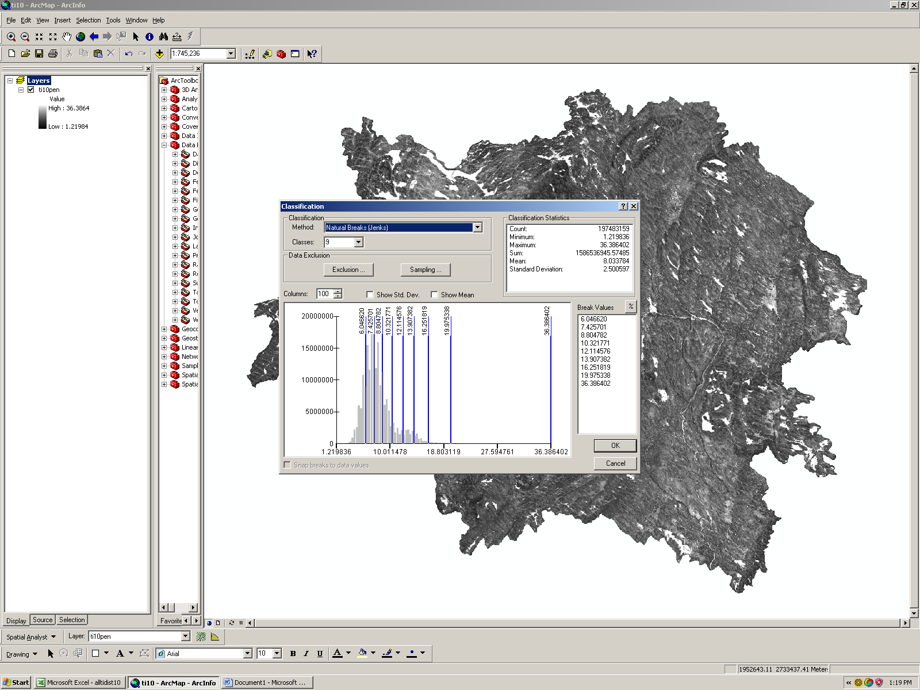

5. Select the classification method (equal interval) and number of classes (30) from the pulldown menu under “Classification” …this will change the appearance of the histogram and its divisions….and hit OK to close the window.

6. Hit “OK” again on the reclassify window to initiate the reclassification process…This will create a new (temporary) layer containing the reclassified data. The process may take several minutes.

7. When the process is complete, a new layer will appear in the left side of the screen (reclass of ti10pen). Right-click on the name of this layer to obtain a pulldown menu of options.

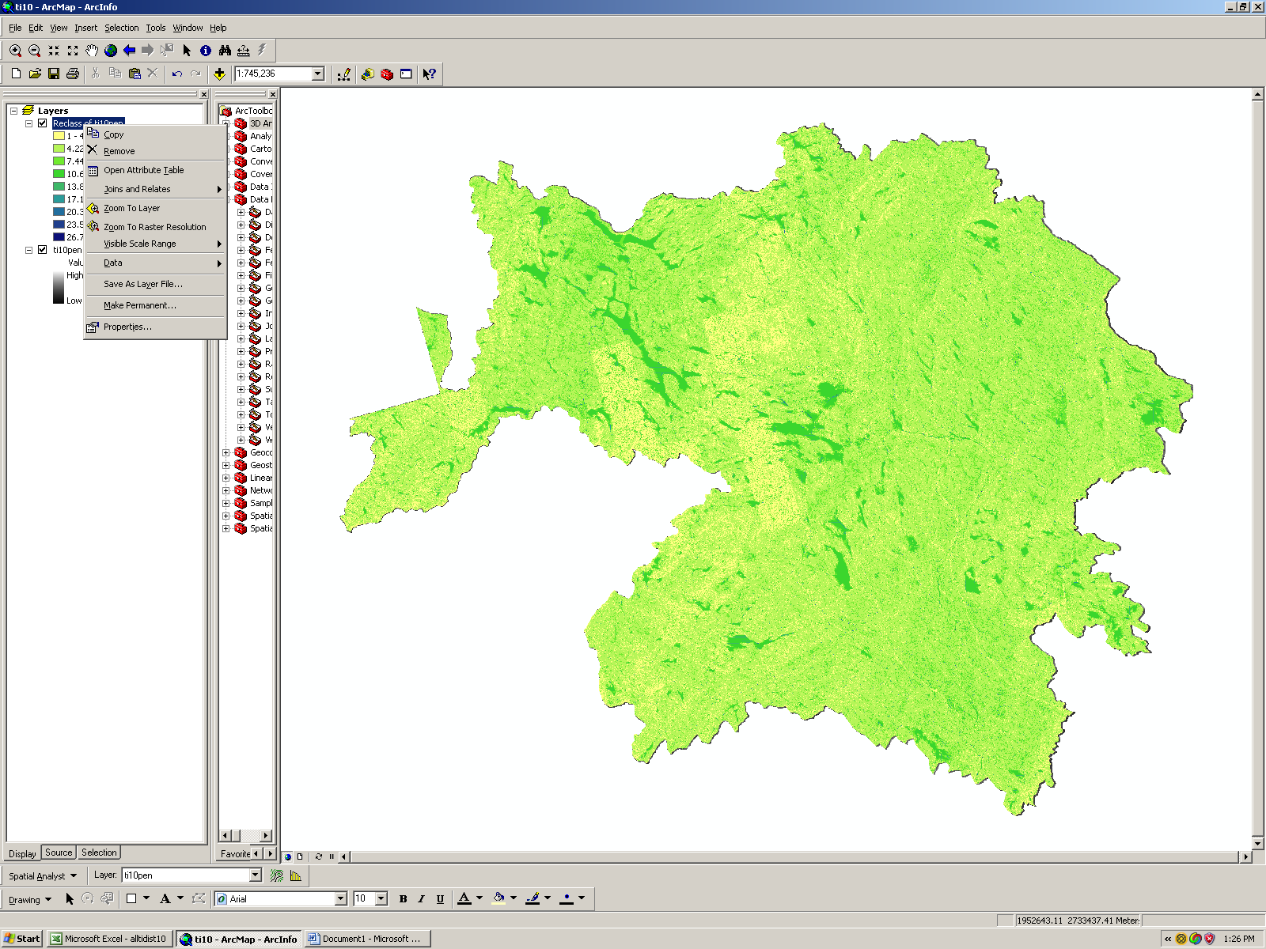

8. From the menu, select “open attribute table”.

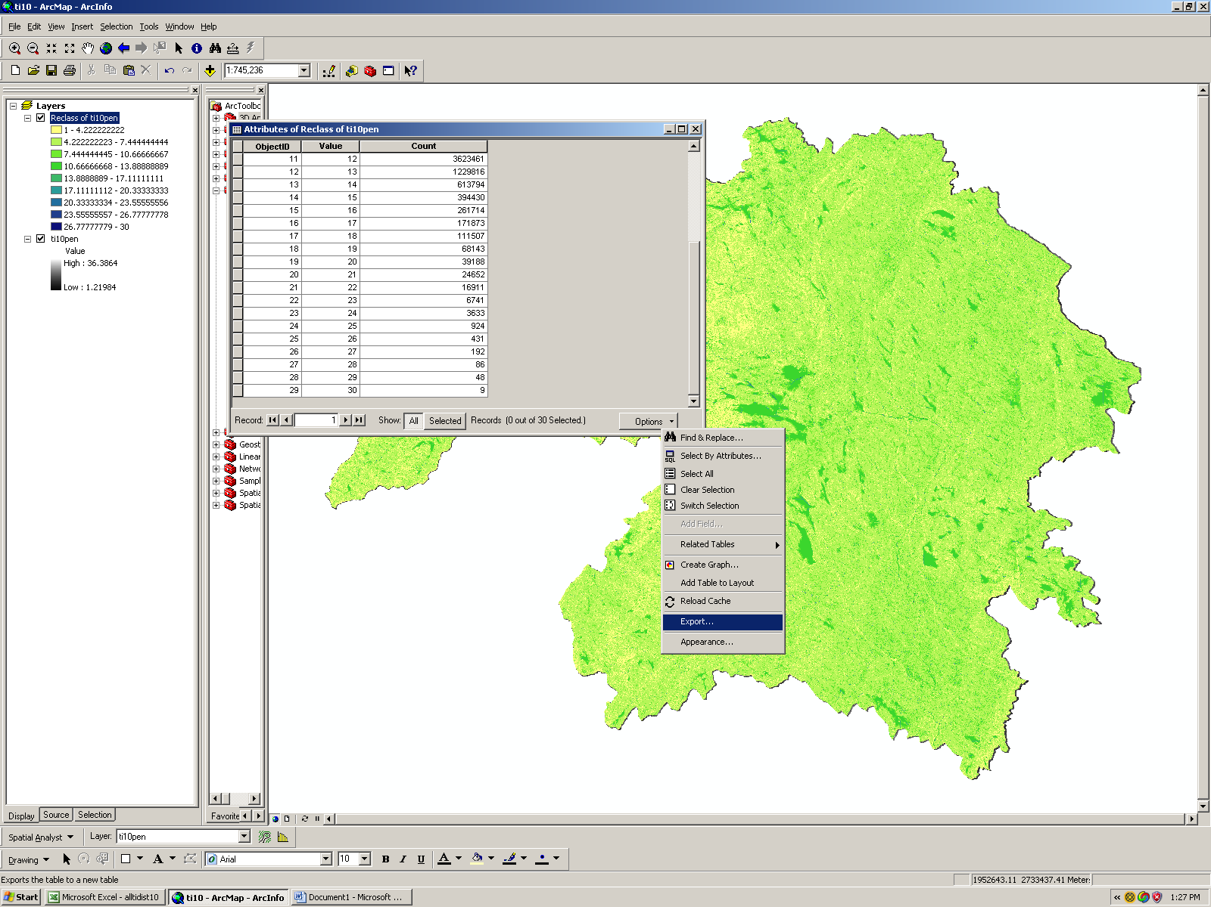

9. The attribute table should contain 30 rows of data corresponding to the histogram of the distribution. (Unfortunately it does not contain info on the correct values of the histogram, but we’ll obtain that later). Click on the Options button and select Export from the pulldown menu. The default file type is dbf, but we want a text file, so click on the folder icon next to the filename box to change the default file type.

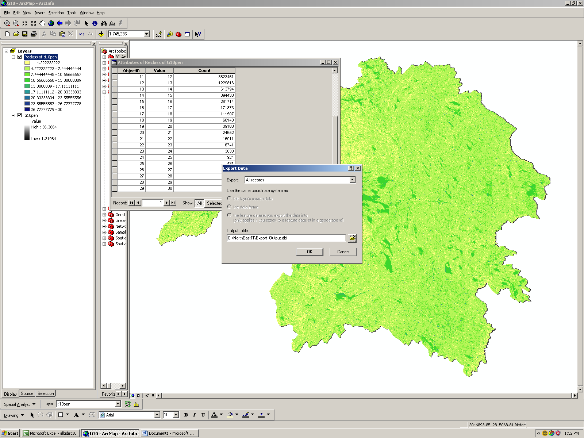

10. Then select “text file” from the list of options, provide the desired filename, and “save”. This will create a text file with the distribution info that can be imported into excel.

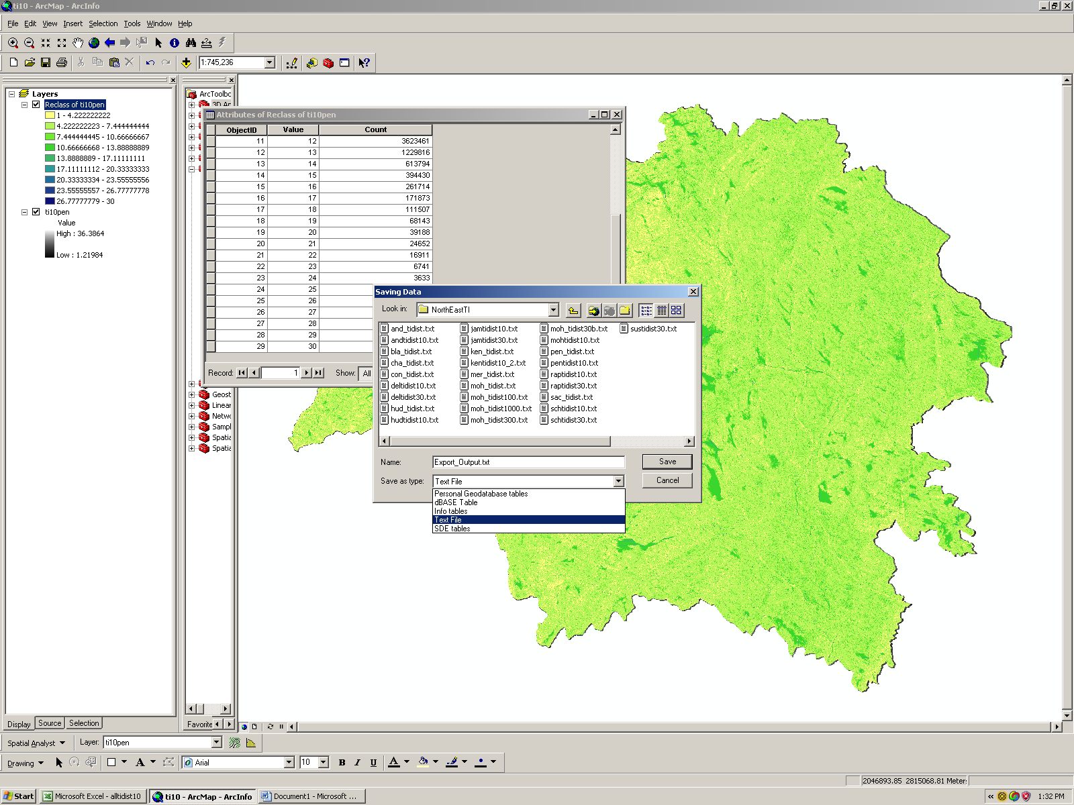
11. To obtain the correct values for the histogram range, rightclick on the original ti layer (not the reclassed layer), ie ti10pen, and select ‘properties” from the pulldown menu. This should open the ‘layer properties’ window. Select ‘symbology” from the tabs at the top, which should yield something like this:

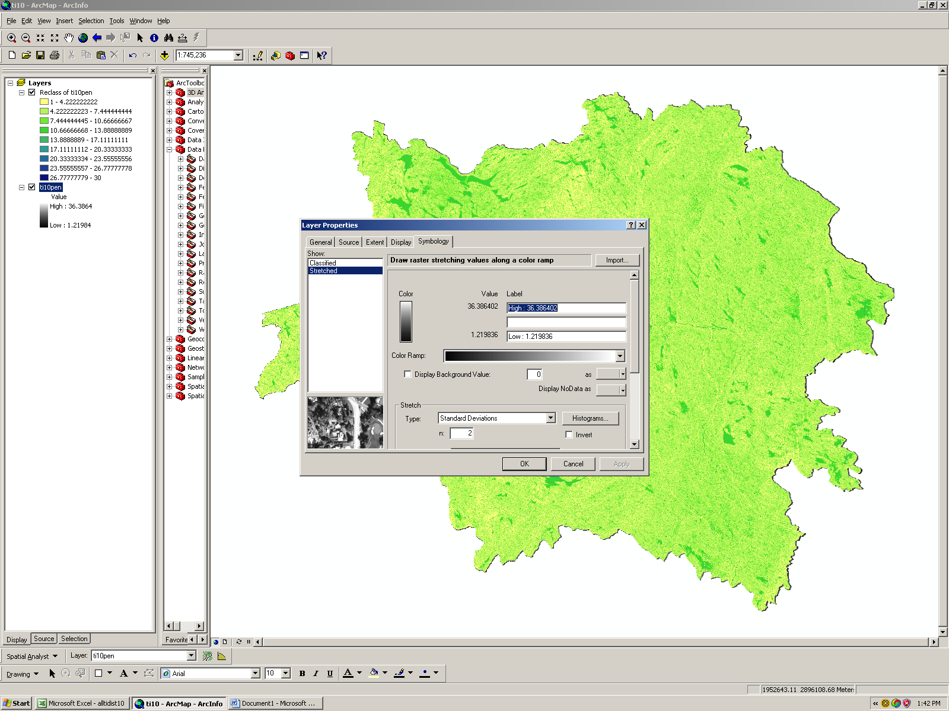
12. Select “classified” (not “stretched” from the show options”, then press the ‘classify’ button to go to the classification window again, where you again select the classification parameters (equal interval and 30 classes).

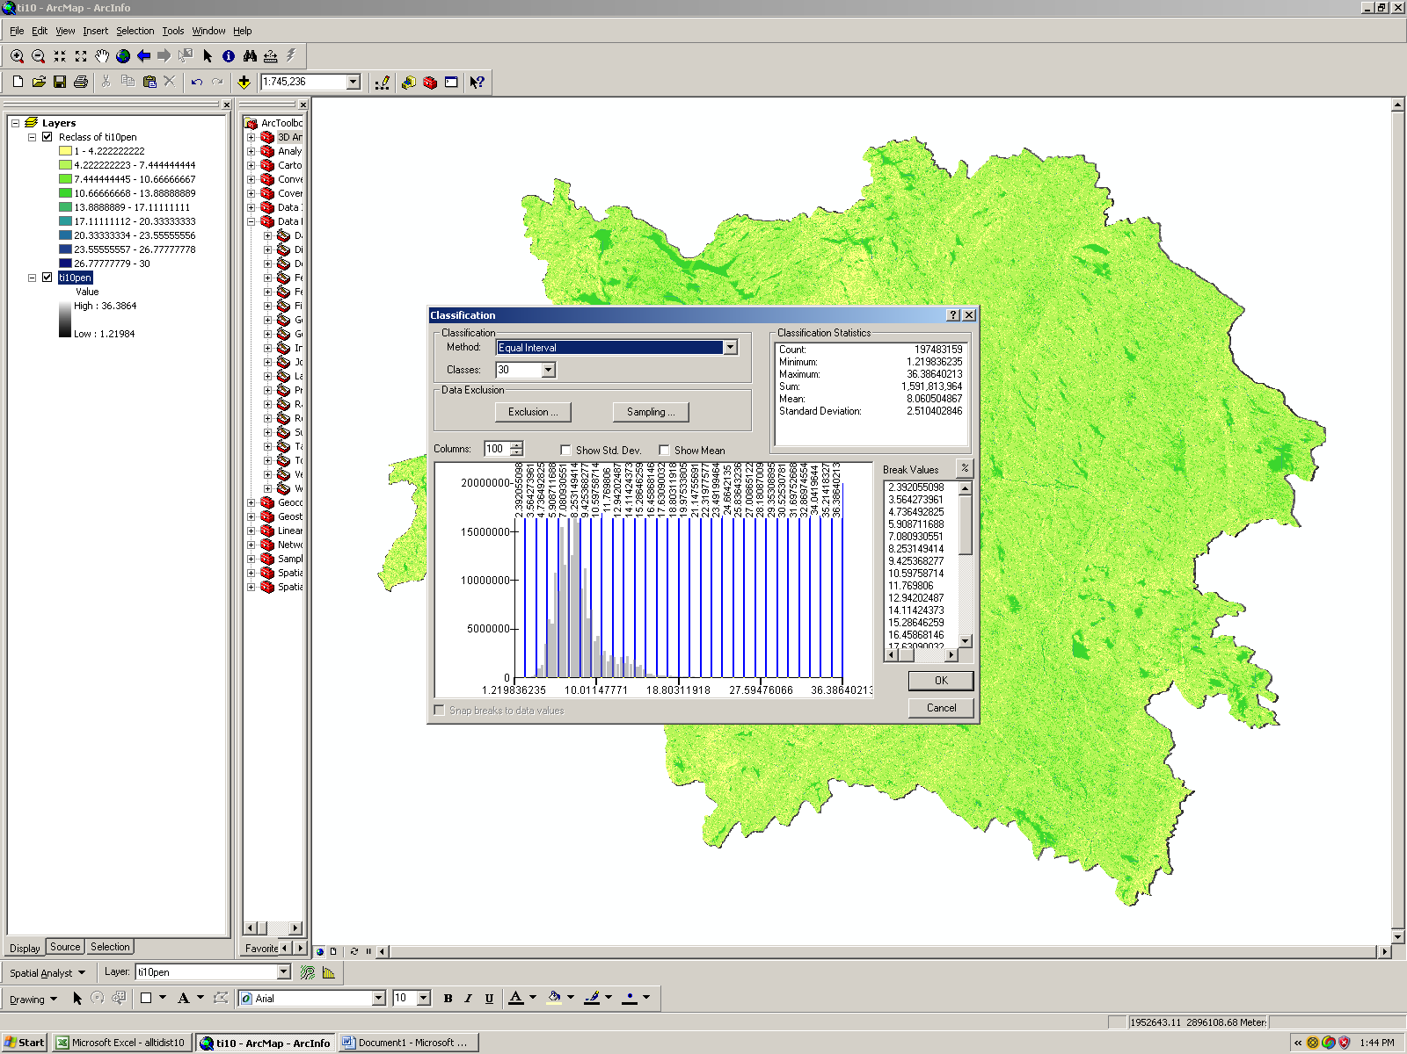
13. Now hit OK to close the window, but DO NOT close the Layer properties window. Instead, place your cursor anywhere in the’ symbol, range, label ‘ field and right click to bring up a pulldown menu.

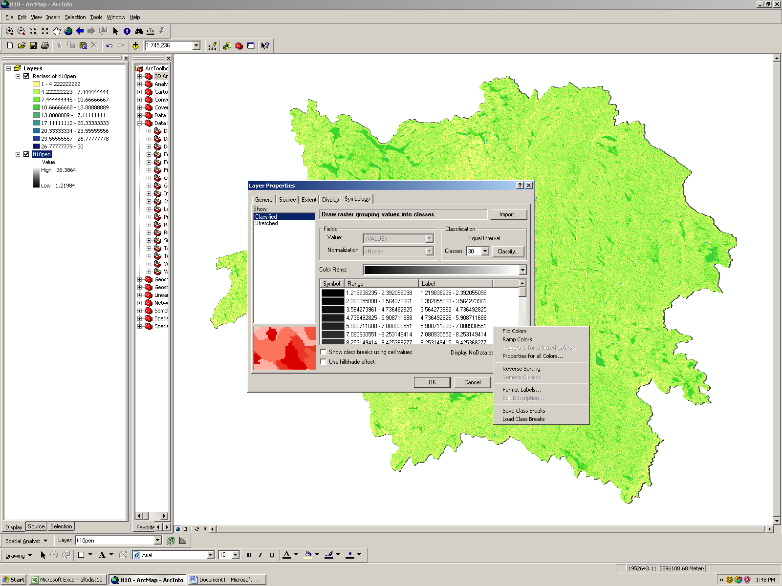

14. Select ‘save class breaks’ and save the file as an xml file (this contains the appropriate histogram info corresponding to the distribution, and can be opened in excel…If the same classification parameters are selected as in the reclassify option used to save the distribution information, these data can be used to define the boundaries of each element of the histogram.

