Creating a Map of Topographic Index using AML Script

19 May 2006
Bongghi Hong

This document describes a step by step process for creating a map of topographic index from DEM (Digital Elevation Model). As an example, DEM of HBEF (Hubbard Brook Experimental Forest) was used (30 by 30 meters). It is assumed that the user has ArcGIS 9.1 as well as ArcInfo Workstation.

Step 1.
Create temporal working directory, in this example, C:\TempArcGIS\HBEF30M. (Note that you should not include space in the directory name.)

Step 2.
Download the HBEF DEM data from http://www.hubbardbrook.org/research/gis/gis.htm. Click on “Hubbard Brook 30m DEM” (hb30mdem.exe) and save the file to working directory. Double-click the hb30mdem.exe file and you will have two files extracted (hb30mdem.e00 and hb30mdem_fgdc.htm).

Step 3.
Convert the DEM in an interchange file format (hb30mdem.e00) to raster. Open ArcMap, then click on ArcToolbox icon () to open ArcToolbox. Click on Coverage Tools > Conversion > To Coverage > Import From Interchange File. Specify the file location for “Input Interchange File” and click “OK”. The HBEF DEM (hb30mdem) can now be added () to ArcMap:

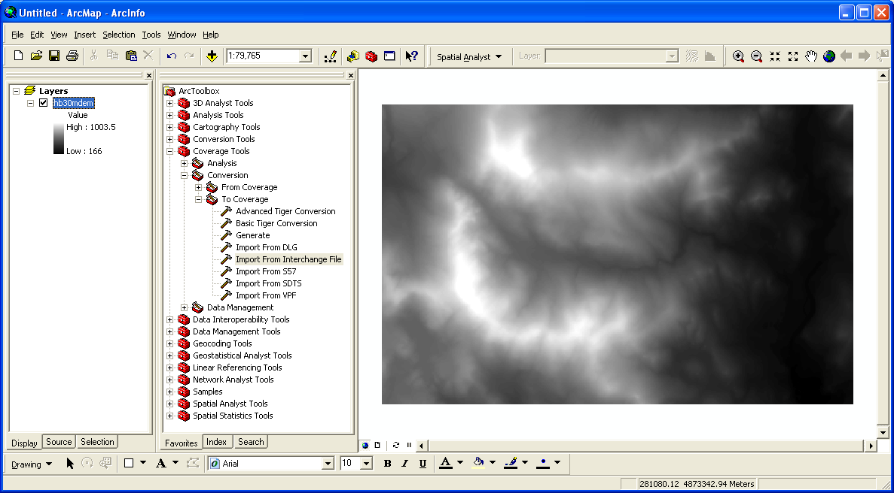

Step 4.
Download the AML (Arc Macro Language) script for calculating topographic index from ESRI ArcScripts database (http://arcscripts.esri.com/). Search for “Topographic Index” and click on “Compound Topographic Index”, which is written with AML language. AML script can be run using ArcInfo Workstation. Note that another available script, “Calculate compound topographic (wetness) index”, is written with Avenue (.ave) language, which can only be run using ArcView 3.x and not ArcGIS 8.x or 9.x. The file that you download to your working directory will have the name of “AS11863.aml”. Rename it to “CTI.aml”.

Step 5.
Run the script using ArcInfo Workstation. From the taskbar, click on “Start > All Programs > ArcGIS > ArcInfo Workstation > Arc” to open the Arc program. At the arc prompt, change the current directory to your working directory by typing “w C:\TempArcGIS\HBEF30M”. Run the script by typing “&r CTI.aml hb30mdem ti30m” creating the map of topographic index (ti30m):

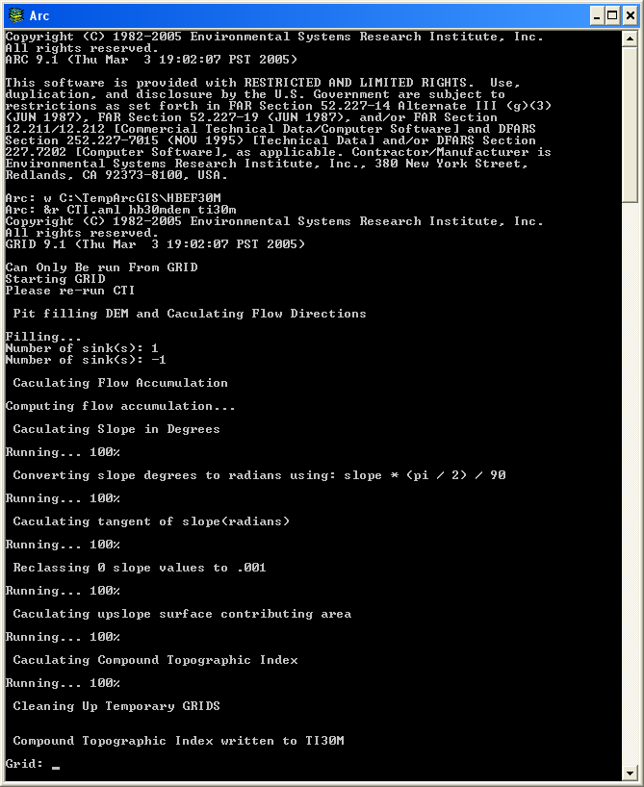

Step 6.
Type “quit” twice to exit the Arc program. Now the map of topographic index for HBEF (ti30m) can be added () to ArcMap:

