Creating a Map of Topographic Index using ArcToolbox

Bongghi Hong
18 July 2006

(1) Start with DEM:

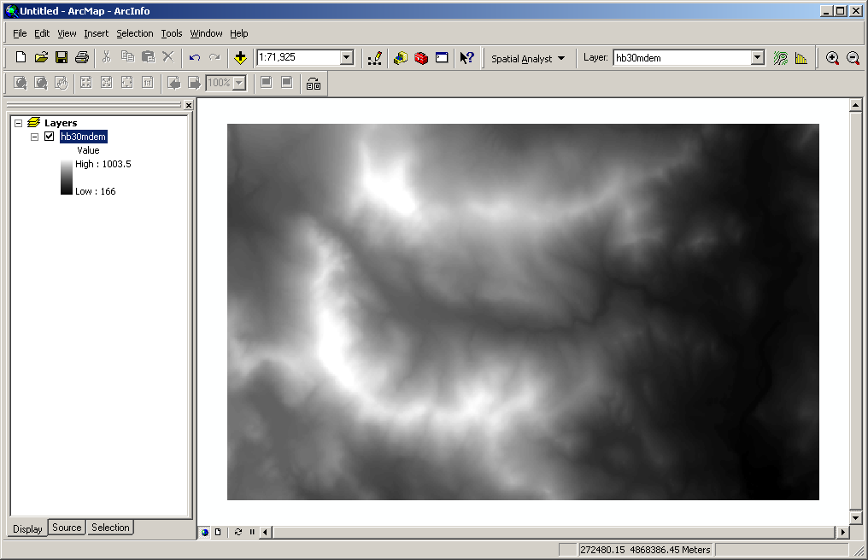

(2) Fill the sinks:

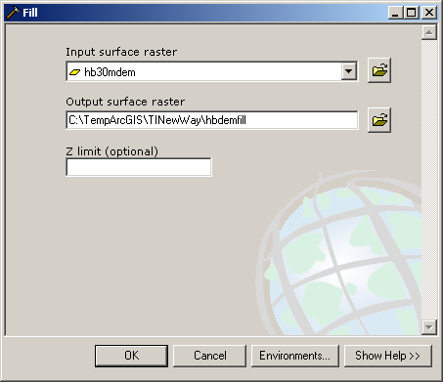

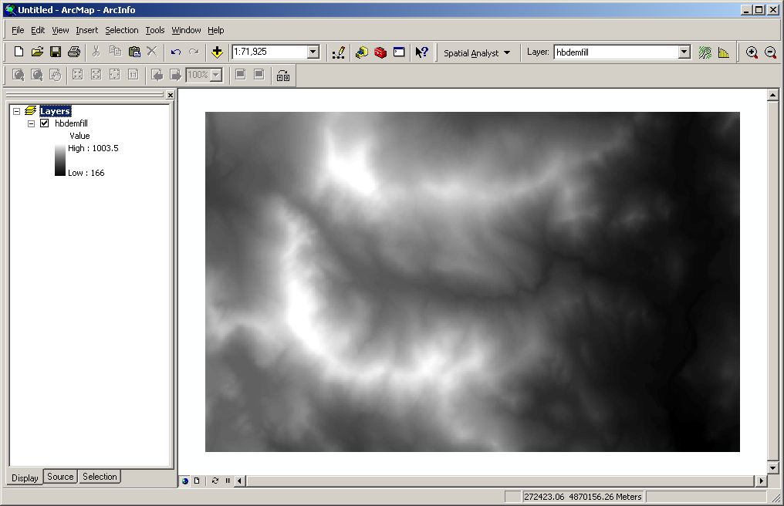

(3) Obtain flow direction map:

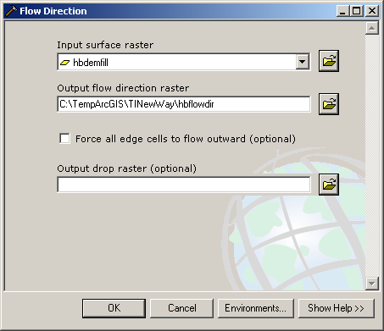

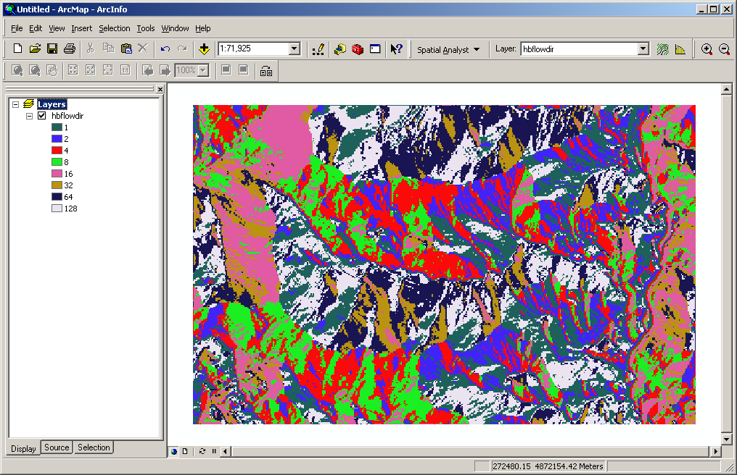

(4) Calculate flow accumulation:

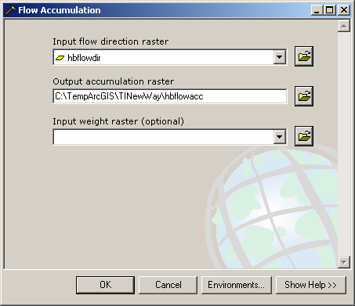

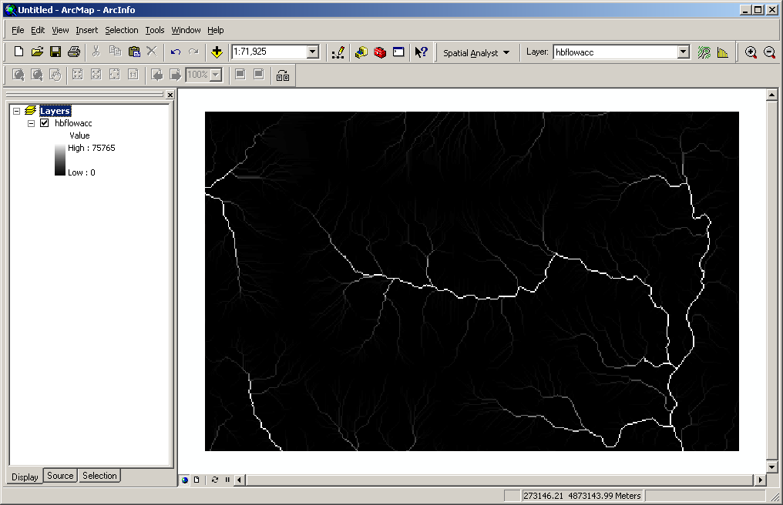

(5) Obtain slope map in degrees (from filled DEM):

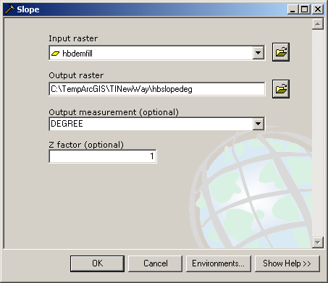

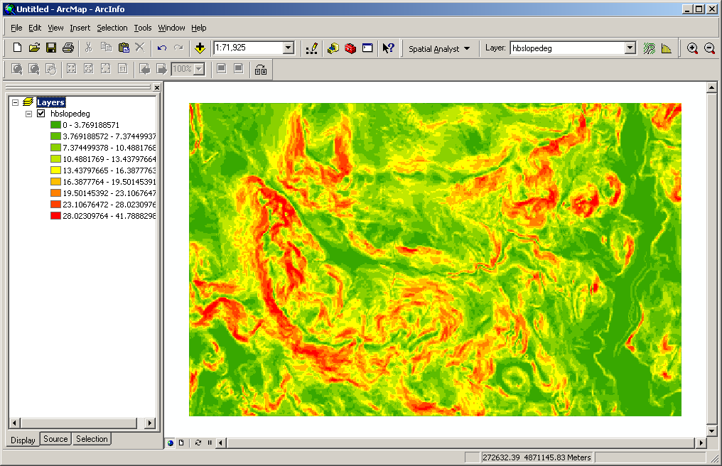

(6) Calculate tangent of slope (radians), by typing “Tan(([hbslopedeg] * 1.570796) / 90)” in Raster Calculator:

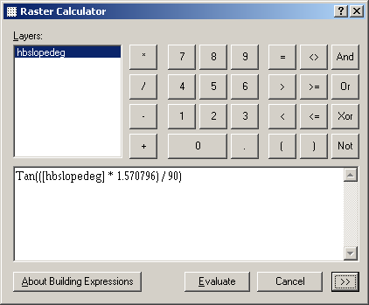

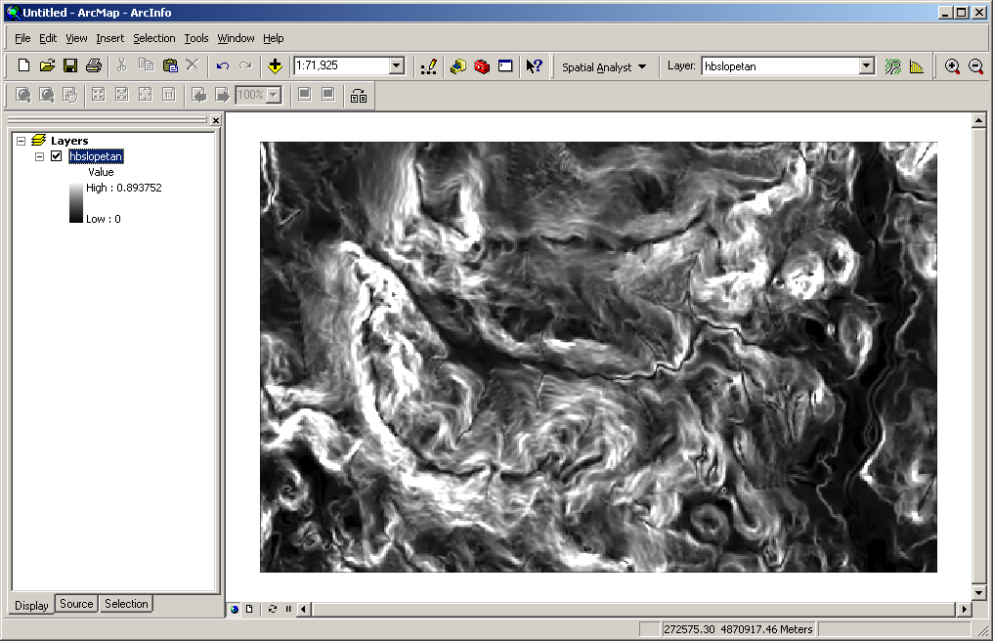

(7) Remove zeros values by typing “con([hbslopetan] == 0, 0.001, [hbslopetan])” in Raster Calculator:

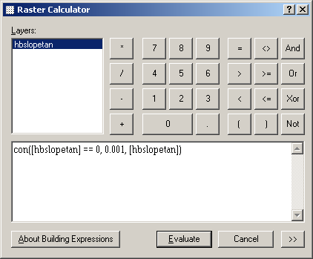

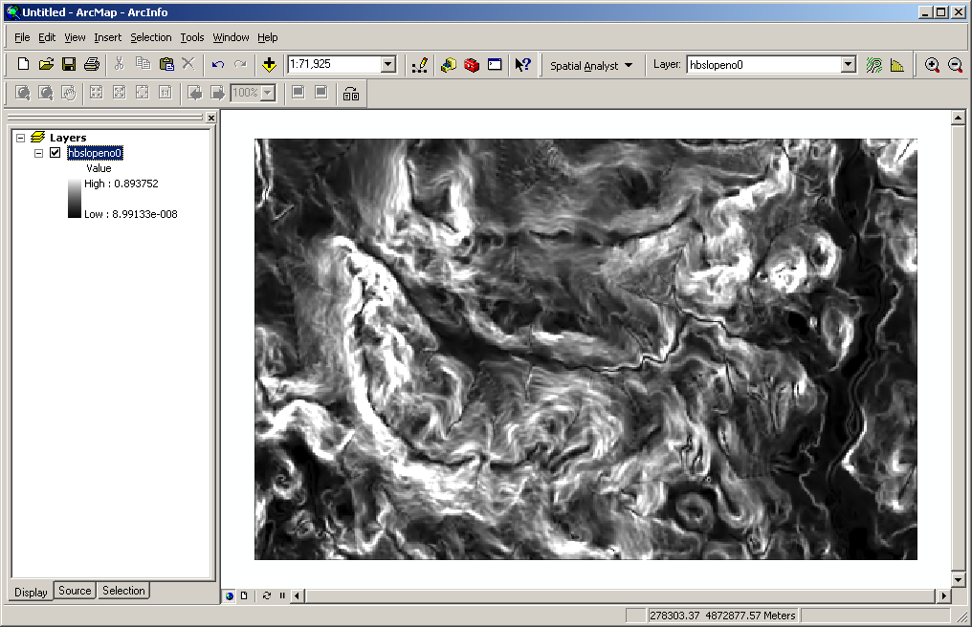

(7) Calculate TI by typing “Ln((([hbflowacc] + 1) * 30) / [hbslopeno0] )” in Raster Calculator (note that 30 is cell size in meters):

