Projecting DEMs in ArcGIS

Bongghi Hong
June 12, 2006

According to ArcGIS Help: “To make a surface model suitable for volume, slope and accurate visibility analysis, the ground units in the 1-degree USGS DEM must be projected to a nonangular unit of measure, such as UTM or Lambert. As well, the surface ZUnits should be expressed in the same units of measure as the ground Units. Use the Define Projection tool or Project Raster tool (with a BILINEAR or CUBIC resampling technique) to convert a raster dataset to the desired projection or to change datums.”

As an example, let’s assume that you downloaded a DEM map with a geographic coordinate system:

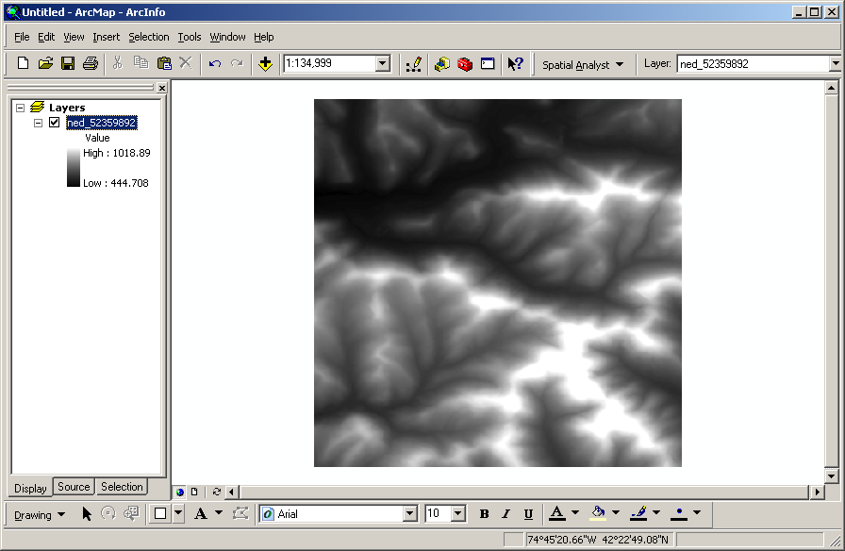

Opening properties window (right click the name of DEM “ned_52359892” and select “Properties…”), you found out that the map has an angular unit of “degree” and datum of “D_North_American_1983”.

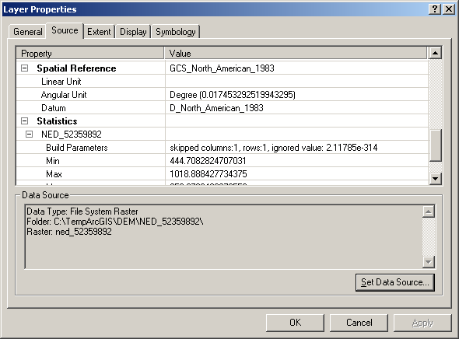

Now, let’s assume that you have a map with the projected coordinate system that you want to use for the projection of the DEM, in this example the New York State map:

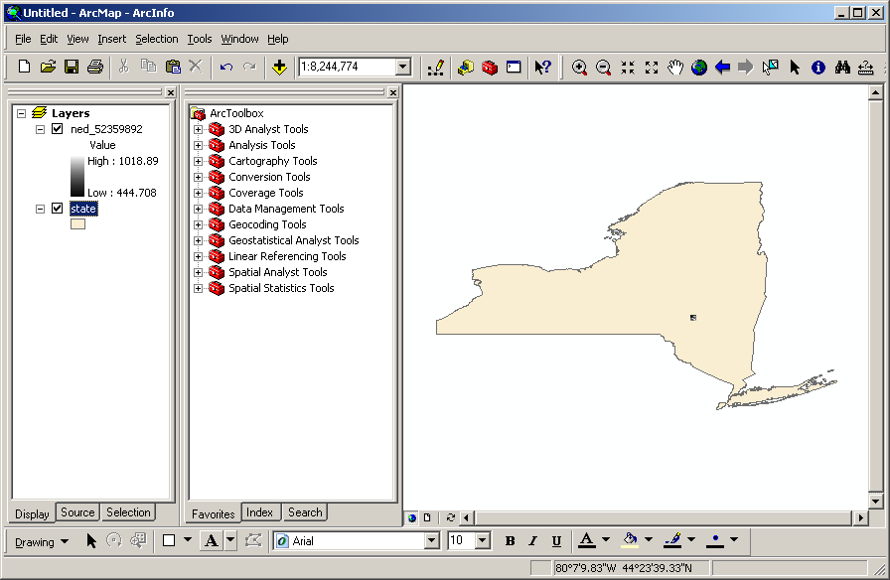

Opening the New York State map properties window, you found out that the map has the projected coordinate system of “NAD_1983_UTM_Zone_18N” and datum of “D_North_American_1983”. It is important to make sure that these two maps have the same datum.

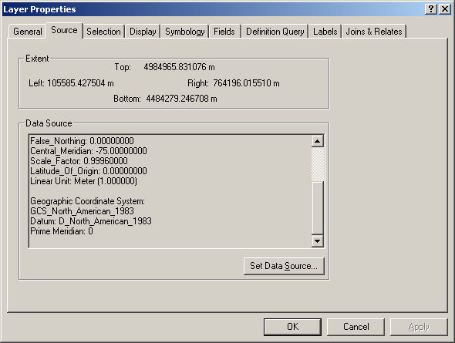

Open the ArcToolbox, click on “Data Management Tools > Projections and Transformations > Raster > Project Raster”. The Project Raster window will be opened:

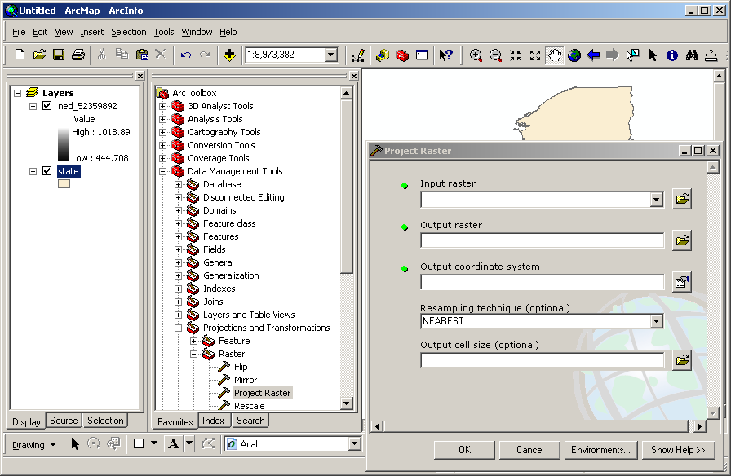

Select input raster as “ned_52359892” from dropdown menu. Click on the icon for the “Output coordinate system” and “Spatial Reference Properties” window will be opened:

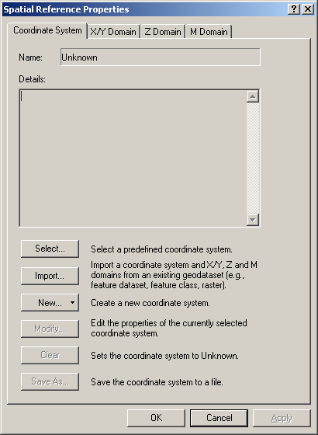

Click “Import” and select New York State map. The coordinate system information will be imported from the New York State map:

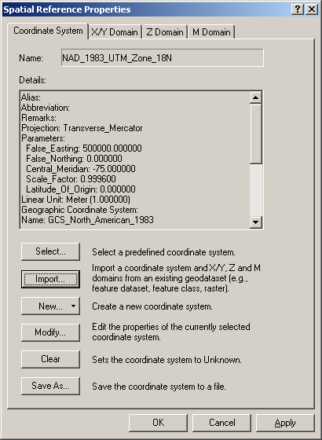

Click “OK”. For the resampling technique, select bilinear resampling method. (Land use data such as NLCD datasets, on the other hand, should be resampled with the nearest neighbor method.) Specify output cell size if desired. Click “OK”:

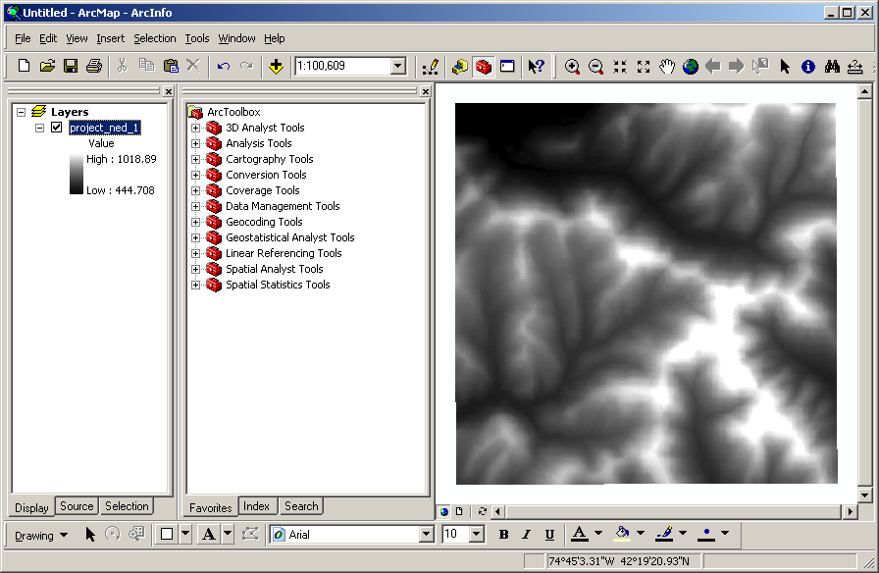

If you do not have any existing map with desired projected coordinate system, you can select the predefined coordinate system from the “Spatial Reference Properties” window. Click “Select” and Choose “Projected Coordinate Systems > Utm > Nad 1983 > NAD 1983 UTM Zone 18N.prj”. To find out the appropriate UTM zone number, consult the below map available at http://www.gsd.harvard.edu/gis/manual/dem/utmworld.gif:

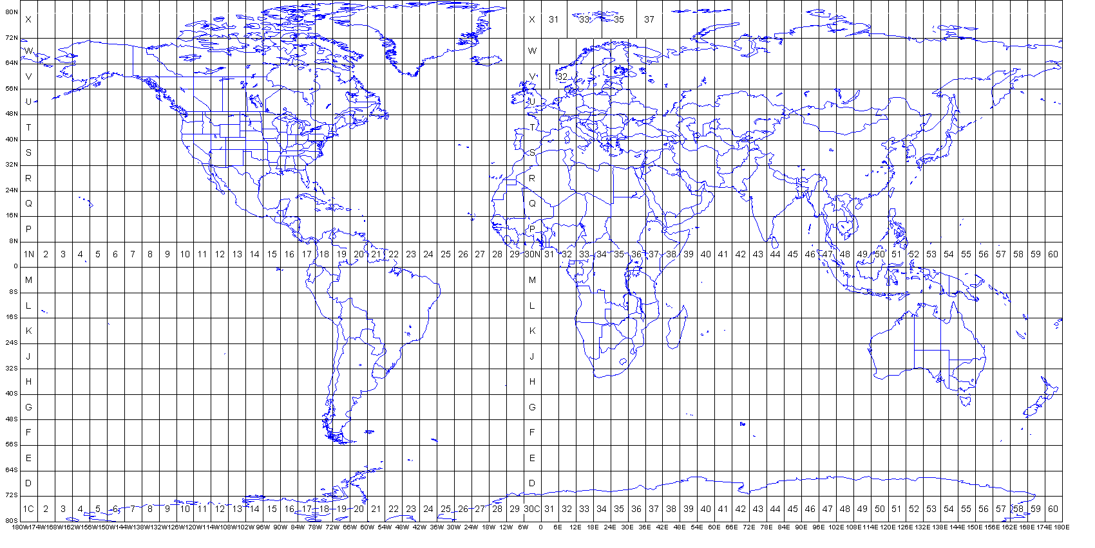

Again, select bilinear resampling method and click “OK”. You will again have the same projected map:

